UNITED STATES
SECURITIES AND EXCHANGE COMMISSION
Washington, D.C. 20549

FORM 8-K

CURRENT REPORT
PURSUANT TO SECTION 13 OR 15(d) OF THE
SECURITIES EXCHANGE ACT OF 1934

Date of Report (Date of earliest event reported): July 27, 2026

CAPITAL BANCORP, INC.
(Exact name of registrant as specified in its charter)

Maryland |  |  | 001-38671 |  |  | 52-2083046
(State or other jurisdiction of incorporation or organization) |  |  | (Commission file number) |  |  | (IRS Employer Identification No.)
2275 Research Boulevard, Suite 600, Rockville, Maryland 20850
(Address of principal executive offices) (Zip Code)
(301) 468-8848
Registrant’s telephone number, including area code

Not Applicable
(Former Name or Former Address, if Changed Since Last Report)

Check the appropriate box below if the Form 8-K filing is intended to simultaneously satisfy the filing obligations of the registrant under any of the following provisions:

☐ Written communications pursuant to Rule 425 under the Securities Act (17 CFR 230.425)

☐ Soliciting material pursuant to Rule 14a-12 under the Exchange Act (17 CFR 240.14a-12)

☐ Pre-commencement communications pursuant to Rule 14d-2(b) under the Exchange Act (17 CFR 240.14d-2(b))

☐ Pre-commencement communications pursuant to Rule 13e-4(c) under the Exchange Act (17 CFR 240.13e-4(c))
Securities registered pursuant to Section 12(b) of the Act:
Title of Each Class |  |  | Trading Symbol |  |  | Name of Each Exchange on Which Registered
Common Stock, par value $0.01 per share |  |  | CBNK |  |  | NASDAQ Stock Market

Indicate by check mark whether the registrant is an emerging growth company as defined in Rule 405 of the Securities Act of 1933 (§230.405 of this chapter) or Rule 12b-2 of the Securities Exchange Act of 1934 (§240.12b-2 of this chapter).
Emerging growth company ☐
If an emerging growth company, indicate by check mark if the registrant has elected not to use the extended transition period for complying with any new or revised financial accounting standards provided pursuant to Section 13(a) of the Exchange Act. ☐

Item 2.02 Results of Operations and Financial Disclosure
On July 27, 2026, Capital Bancorp, Inc. (the “Company”) issued a press release announcing the Company’s unaudited financial results for the three and six months ended June 30, 2026. A copy of the press release is furnished as Exhibit 99.1 to this Current Report on Form 8-K and hereby incorporated by reference. A presentation regarding the Company's financial results for the three and six months ended June 30, 2026 is furnished as Exhibit 99.2 and incorporated herein by reference.

The information furnished under Item 2.02 and Item 9.01 of this Current Report on Form 8-K, including Exhibit 99.1 and Exhibit 99.2 to this Current Report on Form 8-K, shall not be deemed “filed” for purposes of Section 18 of the Securities Exchange Act of 1934, as amended, or otherwise subject to liabilities under that Section, nor shall it be deemed incorporated by reference in any registration statement or other filings of the Company under the Securities Act of 1933, as amended, except as shall be set forth by specific reference in such filing.

Item 8.01. Other Events
On July 24, 2026, the Company's Board of Directors declared a $0.14 per share dividend, a 16.7% increase from the prior quarterly dividend. The dividend is payable on August 26, 2026 to stockholders of record on August 10, 2026.

Item 9.01. Financial Statements and Exhibits
(d) Exhibits
99.1 |  |  | Press Release, dated July 27, 2026.
99.2 |  |  | Investor Presentation June 2026.
104 |  |  | Cover Page Interactive Data File (embedded within the Inline XBRL document)

2

SIGNATURES

Pursuant to the requirements of the Securities Exchange Act of 1934, the Registrant has duly caused this report to be signed on its behalf by the undersigned hereunto duly authorized.
 |  |  | CAPITAL BANCORP, INC.
Date: July 27, 2026 |  |  | By: /s/ Jacob Dalaya
 |  |  | Name: Jacob Dalaya
 |  |  | Title: Chief Financial Officer


3
CBNK Reports 2Q ROA of 1.52% and EPS of $0.87
Delivers Strong Balance Sheet and Revenue Growth, Positive Operating Leverage
Rockville, Maryland, July 27, 2026 (GLOBE NEWSWIRE) – Capital Bancorp, Inc. (the "Company") (NASDAQ: CBNK), the holding company for Capital Bank, N.A. (the "Bank"), today reported:
 |  |  | Quarter Ended |  |  |  |  |  |  |  |  |  |  |  |  |  |  |  |  |  | % Change (Annualized)
(in millions, except per share data) |  |  | 2Q26 |  |  |  |  |  | 1Q26 |  |  |  |  |  | 2Q25 |  |  |  |  |  | 2Q26 vs 1Q26 |  |  |  |  |  | 2Q26 vs 2Q25
Balance Sheet Summary
Gross Loans (1) |  |  | $3,086 |  |  |  |  |  | $3,026 |  |  |  |  |  | $2,740 |  |  |  |  |  | 7.9% |  |  |  |  |  | 12.6%
Total Deposits |  |  | 3,371 |  |  |  |  |  | 3,292 |  |  |  |  |  | 2,941 |  |  |  |  |  | 9.6% |  |  |  |  |  | 14.6%
Customer Deposits(2) |  |  | 3,140 |  |  |  |  |  | 2,989 |  |  |  |  |  | 2,671 |  |  |  |  |  | 20.3% |  |  |  |  |  | 17.6%
Tangible Book Value per share(3) |  |  | $23.45 |  |  |  |  |  | $22.62 |  |  |  |  |  | $20.64 |  |  |  |  |  | 14.7% |  |  |  |  |  | 13.6%
 |  |  | GAAP |  |  |  |  |  |  |  |  |  |  |  |  |  |  |  |  |  |  |  |  |  |  |  |  |  |  |  |  |  | Core(3)
 |  |  | Quarter Ended |  |  |  |  |  |  |  |  |  |  |  |  |  |  |  |  |  | Change |  |  |  |  |  |  |  |  |  |  |  | Quarter Ended |  |  |  |  |  |  |  |  |  |  |  |  |  |  |  |  |  | Change
(in millions, except per share data) |  |  | 2Q26 |  |  |  |  |  | 1Q26 |  |  |  |  |  | 2Q25 |  |  |  |  |  | 2Q26 vs 1Q26 |  |  |  |  |  | 2Q26 vs 2Q25 |  |  |  |  |  | 2Q26 |  |  |  |  |  | 1Q26 |  |  |  |  |  | 2Q25 |  |  |  |  |  | 2Q26 vs 1Q26 |  |  |  |  |  | 2Q26 vs 2Q25
Earnings Summary
Net Income |  |  | $14.3 |  |  |  |  |  | $12.0 |  |  |  |  |  | $13.1 |  |  |  |  |  | 18.6% |  |  |  |  |  | 8.5% |  |  |  |  |  | $14.3 |  |  |  |  |  | $12.0 |  |  |  |  |  | $14.2 |  |  |  |  |  | 18.6% |  |  |  |  |  | 0.3%
Earnings per share - diluted |  |  | $0.87 |  |  |  |  |  | $0.73 |  |  |  |  |  | $0.78 |  |  |  |  |  | 19.2% |  |  |  |  |  | 11.5% |  |  |  |  |  | $0.87 |  |  |  |  |  | $0.73 |  |  |  |  |  | $0.85 |  |  |  |  |  | 19.2% |  |  |  |  |  | 2.4%
ROA |  |  | 1.52% |  |  |  |  |  | 1.33% |  |  |  |  |  | 1.60% |  |  |  |  |  | 19 bps |  |  |  |  |  | (8) bps |  |  |  |  |  | 1.52% |  |  |  |  |  | 1.33% |  |  |  |  |  | 1.73% |  |  |  |  |  | 19 bps |  |  |  |  |  | (21) bps
ROTCE(3) |  |  | 15.51% |  |  |  |  |  | 13.58% |  |  |  |  |  | 16.10% |  |  |  |  |  | 193 bps |  |  |  |  |  | (59) bps |  |  |  |  |  | 15.51% |  |  |  |  |  | 13.58% |  |  |  |  |  | 17.39% |  |  |  |  |  | 193 bps |  |  |  |  |  | (188) bps
 |  |  | Including Card |  |  |  |  |  |  |  |  |  |  |  |  |  |  |  |  |  |  |  |  |  |  |  |  |  |  |  |  |  | Excluding Card
NIM |  |  | 5.64% |  |  |  |  |  | 5.71% |  |  |  |  |  | 6.04% |  |  |  |  |  | (7) bps |  |  |  |  |  | (40) bps |  |  |  |  |  | 4.04% |  |  |  |  |  | 4.15% |  |  |  |  |  | 4.42% |  |  |  |  |  | (11) bps |  |  |  |  |  | (38) bps
 |  |  | GAAP |  |  |  |  |  |  |  |  |  |  |  |  |  | Core(3)
 |  |  | Six Months Ended |  |  |  |  |  |  |  |  |  |  |  |  |  | Change |  | Six Months Ended |  |  |  |  |  |  |  |  |  |  |  |  |  | Change
(in millions, except per share data) |  |  | 2Q26 |  |  |  |  |  |  |  | 2Q25 |  |  |  |  |  |  |  | 2Q26 vs 2Q25 |  |  |  |  |  | 2Q26 |  |  |  |  |  |  |  | 2Q25 |  |  |  |  |  |  |  | 2Q26 vs 2Q25
Earnings Summary
Net Income |  |  | $26.3 |  |  |  |  |  |  |  | $27.1 |  |  |  |  |  |  |  | (3.0)% |  |  |  |  |  | $26.3 |  |  |  |  |  |  |  | $29.1 |  |  |  |  |  |  |  | (9.7)%
Earnings per share - diluted |  |  | $1.60 |  |  |  |  |  |  |  | $1.60 |  |  |  |  |  |  |  | —% |  |  |  |  |  | $1.60 |  |  |  |  |  |  |  | $1.72 |  |  |  |  |  |  |  | (7.0)%
ROA |  |  | 1.43% |  |  |  |  |  |  |  | 1.68% |  |  |  |  |  |  |  | (25) bps |  |  |  |  |  | 1.43% |  |  |  |  |  |  |  | 1.80% |  |  |  |  |  |  |  | (37) bps
ROTCE(3) |  |  | 14.57% |  |  |  |  |  |  |  | 16.82% |  |  |  |  |  |  |  | (225) bps |  |  |  |  |  | 14.57% |  |  |  |  |  |  |  | 18.07% |  |  |  |  |  |  |  | (350) bps
 |  |  | Including Card |  |  |  |  |  |  |  |  |  |  |  |  |  |  |  | Excluding Card
NIM |  |  | 5.68% |  |  |  |  |  |  |  | 6.04% |  |  |  |  |  |  |  | (36) bps |  |  |  |  |  | 4.09% |  |  |  |  |  |  |  | 4.39% |  |  |  |  |  |  |  | (30) bps
(1) Gross loans represent portfolio loans receivable, net of deferred fees and costs.
(2) Customer deposits represents total deposits excluding brokered deposits.
(3) As used in this press release, Core net income, Core earnings per share - diluted, Core ROA, Core ROTCE, Tangible Book Value per share are non-GAAP financial measures. These non-GAAP financial metrics exclude the impact of merger-related expenses and certain other pre-tax adjustments which are not indicative of operating performance and the tax impacts of such adjustments. Reconciliations of this and other non–GAAP measures to their comparable GAAP measures are set forth in the Appendix at the end of this press release.

“The Board is very pleased that we were able to deliver another quarter of strong operating performance, highlighted by solid loan and deposit growth, diversified fee income generation, and continued growth in tangible book value per share,” said Steven J. Schwartz, Chairman of the Company. “The increase in non-interest expenses year-over-year reflects our continued investment in strategic initiatives, including our unsecured card platform, the expansion of our targeted C&I verticals, and our customer-facing and back-office technology infrastructure. We believe these investments strengthen our franchise and will continue to reduce our exposure to cyber risks, credit losses at OpenSky™, enhance our customers' experience, and, ultimately, improve our operating efficiency, all while supporting our robust, organic, long-term growth goals.”
Second Quarter 2026 Highlights
•Continued to strengthen the funding base, with total deposits, including brokered deposits, increasing 9.6% (annualized) from 1Q 2026; Excluding a $15.0 million reduction associated with the same single customer relationship noted in 1Q 2026, total deposits grew 11.5% (annualized) while reducing brokered deposits by 23.8%
•Sustained strong customer deposit momentum, with customer deposits increasing 20.3% (annualized) from 1Q 2026, or 27.0% (annualized) excluding the relationship referenced above
1
•Generated 7.9% (annualized) growth in gross loans from 1Q 2026, driven by broad-based production across the portfolio; Through July 15th(1), loan growth totaled $159.2 million, representing an implied annualized growth rate of 10.0%
•Continued tangible book value compounding, with tangible book value(2) per share increasing 14.7% (annualized) from 1Q 2026
•Delivered diluted earnings per share of $0.87, up 19.2% from 1Q 2026, supported by an 18.6% increase in net income
•Produced 29.6% (annualized) fee income growth, with contributions from nearly every major fee category, led by higher USDA volume, continued production from the new SBA team, significant growth in Windsor revenue and increased mortgage production. Fee revenue represented 22.0% of total revenue
•Continued to execute on strategic growth initiatives while maintaining strong expense discipline, with noninterest expense remaining flat despite ongoing investments in unsecured card, card partnerships, data infrastructure and personnel
•The Company also declared a cash dividend on its common stock of $0.14 per share, a 16.7% increase from the prior quarterly dividend. The dividend is payable on August 26, 2026 to shareholders of record on August 10, 2026.
“We continue to execute on our growth strategy across the franchise, delivering strong customer deposit growth, solid loan production and broad-based fee income expansion" said Ed Barry, CEO of the Company. "The breadth of our performance reflects the strength of our diversified business model and positions us well to continue expanding customer relationships, growing the balance sheet and delivering sustainable long-term growth."
(1) Balances through July 15th are preliminary and unaudited. They have not been subject to customary reconciliations or closing procedures and may not be indicative of final balances at quarter end.
(2) As used in this press release, Core net income, Core earnings per share - diluted, Core ROA, Core ROTCE, Tangible Book Value per share are non-GAAP financial measures. These non-GAAP financial metrics exclude the impact of merger-related expenses and certain other pre-tax adjustments which are not indicative of operating performance and the tax impacts of such adjustments. Reconciliations of this and other non–GAAP measures to their comparable GAAP measures are set forth in the Appendix at the end of this press release.
Consolidated financial performance
2
Net income of $14.3 million increased $2.2 million compared to 1Q 2026, and earnings per share - diluted of $0.87 increased $0.14 per share from 1Q 2026. Net income increased $1.1 million, or 8.5%, compared to $13.1 million, or $0.78 per diluted share, for 2Q 2025. 2Q 2026 Core net income(1) of $14.3 million, or $0.87 per diluted share, increased $2.2 million, or 18.6%, from 1Q 2026 Core net income of $12.0 million, or $0.73 per diluted share. 2Q 2026 Core net income increased $0.1 million from 2Q 2025 Core net income of $14.2 million. 2Q 2026 Core net income excluding purchase accounting accretion ("PAA") was $14.0 million, an increase of $0.8 million from 2Q 2025 Core net income excluding PAA of $13.2 million.
Quarterly net interest income:
•Net interest income of $50.9 million increased $1.5 million, or 3.1% (not annualized), compared to 1Q 2026, and increased $3.3 million, or 6.9%, year-over-year.
◦Interest income of $70.0 million increased $2.0 million, or 2.9% (not annualized), compared to 1Q 2026, and increased $5.4 million, or 8.3%, year-over-year. The increase from 1Q 2026 was primarily driven by a $0.9 million increase from OpenSky™ due to higher balances and higher yields, $1.0 million from the Commercial Bank driven by $0.5 million from interest bearing cash income, $0.4 million from investment securities, and $0.2 million from loan growth. The increase year-over-year was primarily driven by $3.8 million from the Commercial Bank due to strong organic loan growth, and $1.5 million from OpenSky™ due to strong growth from the unsecured loan product.
▪Interest income included $0.2 million from net PAA in 2Q 2026, compared to $0.3 million in 1Q 2026 and $0.4 million in net PAA in 2Q 2025.
◦Interest expense of $19.0 million increased $0.5 million, or 2.5% (not annualized), compared to 1Q 2026, and increased $2.1 million, or 12.3%, year-over-year. The increase of $0.5 million compared to 1Q 2026, was primarily driven by growth in the deposit portfolio, and a shift in deposit mix to money markets accounts. The increase of $2.1 million year-over-year was driven by $1.0 million from higher balances and a shift in deposit mix, $0.8 million of lower PAA, and $0.3 million of higher borrowing costs.
▪Interest expense included a $0.1 million benefit from net PAA in 2Q 2026, compared to a $0.1 million benefit in 1Q 2026. There was a $0.9 million benefit from net PAA in 2Q 2025.
Quarterly provision:
•The 2Q 2026 provision for credit losses was $3.6 million, an increase of $0.6 million from 1Q 2026. Net charge-offs totaled $3.8 million, or 0.50% of portfolio loans (annualized), up from $3.0 million or 0.40% of portfolio loans (annualized), in 1Q 2026.
◦Net charge-offs in the quarter include $2.9 million from OpenSky™ loans and $0.9 million from Commercial Bank loans. Net charge-offs for the Commercial Bank increased $1.0 million quarter-over-quarter primarily due to a $0.7 million recovery in 1Q 2026. OpenSky™ net charge-offs amounted to $2.9 million in 2Q 2026 compared to $3.1 million in 1Q 2026.
◦At June 30, 2026, the ACL Coverage Ratio was 1.76%, down 5 bps from March 31, 2026.

(1) As used in this press release, Core net income and Core noninterest expense are non-GAAP financial measures. These non-GAAP financial metrics exclude the impact of merger-related expenses and certain other pre-tax adjustments which are not indicative of operating performance and the tax impacts of such adjustments. Reconciliations of this and other non–GAAP measures to their comparable GAAP measures are set forth in the Appendix at the end of this press release.
Consolidated financial performance (Continued)
3
Quarterly fee revenue:
•Fee Revenue of $14.4 million increased $1.0 million, compared to 1Q 2026 and increased $1.3 million year-over-year. The increase of $1.0 million during 2Q 2026 was the result primarily of a $1.0 million increase in government loan servicing and packaging revenue (Windsor™), a $0.4 million increase in mortgage banking revenue, and a $0.3 million increase in government lending revenue, offset by a $0.3 million decrease in credit card fees and a $0.2 million decrease in loan servicing rights. The year-over-year fee revenue increase of $1.3 million was primarily due to an increase in government loan servicing and packaging revenue (Windsor™). Fee revenue mix(1) was 22.0% of total revenue for 2Q 2026, compared to 21.3% during 1Q 2026, and 21.6% during 2Q 2025.
Quarterly noninterest expense:
•Noninterest expense of $43.2 million decreased $0.5 million compared to 1Q 2026 and increased $3.6 million compared to 2Q 2025. Core noninterest expense(2) of $43.2 million decreased $0.5 million compared to 1Q 2026 and increased $5.0 million compared to 2Q 2025. Core comparisons include:
◦The decrease of $0.5 million quarter-over-quarter was primarily driven by the following:
▪$0.8 million lower professional fees, attributable to a decrease in consulting expenses and lower audit and accounting related fees; partially offset by a $0.4 million increase in occupancy and costs associated with software upgrades.
◦Year-over-year expense growth of $5.0 million was driven by increases in professional fees associated with investments in shared services areas and OpenSky™, expense associated with headcount growth, increased occupancy and equipment costs and an increase in loan processing costs.
Quarterly income taxes:
•Income tax expense of $4.2 million, or 22.8% of pre-tax income for 2Q 2026, increased $0.4 million from $3.9 million, or 24.3% of pre-tax income for 1Q 2026. The effective income tax rate change quarter-over-quarter primarily reflects refinement of the quarterly tax provision following an updated estimate related to the deferred tax liability associated with fixed assets acquired in the IFH acquisition.
Total assets:
Total assets of $3.9 billion at June 30, 2026 increased $81.5 million, or 8.6% (annualized) from March 31, 2026. Total assets growth year-over-year was $501.3 million, or 14.8%. The growth quarter-over-quarter, and year-over-year, was primarily driven by increases in portfolio loans, and cash balances.
Gross Loans:
•Gross Loans of $3.1 billion at June 30, 2026 increased $59.5 million, or 7.9% (annualized), from March 31, 2026 and increased $346.1 million, or 12.6%, year-over-year.
◦Compared to March 31, 2026, growth was primarily driven by $34.8 million from commercial real estate, $10.5 million from credit cards, and $5.0 million from construction real estate.
◦Gross loan growth through July 15th(3) of $159.2 million brings year-to-date loan growth to 10.0% (annualized).
◦C&l loans, plus owner-occupied CRE loans, totaled 37.4% of total portfolio loans at June 30, 2026, 38.3% at March 31, 2026, and 37.6% at June 30, 2025.

(1) Fee revenue mix equals fee revenue divided by the sum of fee revenue and net interest income before provision for credit losses.
(2) As used in this press release, Core net income, Core earnings per share - diluted, Core ROA, Core ROTCE, Tangible Book Value per share are non-GAAP financial measures. These non-GAAP financial metrics exclude the impact of merger-related expenses and certain other pre-tax adjustments which are not indicative of operating performance and the tax impacts of such adjustments. Reconciliations of this and other non–GAAP measures to their comparable GAAP measures are set forth in the Appendix at the end of this press release.
(3) Balances through July 15th are preliminary and unaudited. They have not been subject to customary reconciliations or closing procedures and may not be indicative of final balances at quarter end.
Consolidated financial performance (Continued)
4
Deposits:
•Total deposits of $3.4 billion at June 30, 2026 increased $79.1 million, or 9.6% (annualized), from March 31, 2026, and increased $430.4 million, or 14.6% from June 30, 2025.
◦Excluding a $72.1 million decrease in brokered time deposits, customer deposits increased $151.1 million or 20.3% (annualized), including $114.7 million of growth in customer money market deposits, $49.8 million of growth in interest-bearing demand accounts, $25.7 million of growth in noninterest-bearing deposits, and $1.6 million of growth in savings accounts, partially offset by a decrease of $40.7 million in customer time deposits.
◦The increase in total deposits of $430.4 million year-over-year was driven by $430.5 million in growth from customer money market deposits with offsetting activity across other deposit products.
◦Total deposit growth through July 15th(1) of $165.3 million brings year-to-date deposit growth to 10.0% (annualized).
◦Insured and protected(2) deposits were approximately $2.2 billion as of June 30, 2026 representing 66.6% of the Company's deposit portfolio.
◦Low interest(3) and noninterest-bearing demand deposit account ("DDA") deposits totaled $1.3 billion, or 38.9% of deposits, an increase of $77.1 million, or 25.0% (annualized) from 1Q 2026, and an increase of $142.7 million, or 12.2% year-over-year.
▪The average rate on the low interest and noninterest-bearing deposits was 0.29% for 2Q 2026, which increased 13 bps compared to 1Q 2026 and increased 15 bps year-over-year.
•The average portfolio loans-to-deposit ratio was 94.3% for 2Q 2026, compared to 96.1% for 1Q 2026, and 96.2% for 2Q 2025.
Investment securities:
•The investment securities portfolio continues to be classified as available-for-sale and had a fair market value of $219.9 million, or 5.7% of total assets, and an effective duration of 2.5 years, with U.S. Treasury Securities representing 60% of the overall investment portfolio at June 30, 2026. The accumulated other comprehensive income (loss) on the investment securities portfolio declined $0.1 million during the quarter to $6.3 million after-tax as of June 30, 2026, which represents 1.5% of total stockholders' equity. The Company does not have a held-to-maturity investment securities portfolio.
Liquidity:
•The Company maintains stable and diversified sources of contingent liquidity, generally consistent with prior quarter. Total available borrowing capacity as of June 30, 2026 was $801.6 million, compared to $809.5 million as of March 31, 2026, consisting of $699.4 million of available collateralized borrowing capacity, $96.0 million of unsecured lines of credit with other banks, and $6.2 million of unpledged investment securities available to collateralize potential additional borrowings. Including cash and cash equivalents of $418.3 million, total liquidity was approximately $1.2 billion.
Capital:
•As of June 30, 2026, the Company reported a Common Equity Tier-1 capital ratio of 13.14% and a Tier 1 leverage ratio of 10.59%, compared to 12.92% and 10.48%, respectively, at March 31, 2026. At June 30, 2026, the Company and the Bank maintained regulatory capital ratios that exceed all capital adequacy requirements.
•Shares repurchased and retired during the three months ended June 30, 2026, as part of the Company's stock repurchase program, totaled 1,213 shares at an average price of $30.03, for a total cost of $36 thousand. As of June 30, 2026, there was $12.4 million remaining to be repurchased under the current $15.0 million authorization repurchase program, which will expire on December 31, 2026.
(1) Balances through July 15th are preliminary and unaudited. They have not been subject to customary reconciliations or closing procedures and may not be indicative of final balances at quarter end.
(2) Protected deposits include deposits that are indirectly protected under the product terms.
(3) Low interest deposits include interest-bearing demand and savings accounts.
Financial Metrics
5
Net Interest Margin:
NIM of 5.64% for 2Q 2026, decreased 7 bps compared to the prior quarter, and decreased 40 bps year-over-year. Core NIM(1) of 4.04% decreased 11 bps (but decreased 9 bps when excluding PAA) compared to the prior quarter, and decreased 38 bps year-over-year. Net PAA for 2Q 2026 was 3 bps for NIM and 4 bps for Core NIM(1). The decrease quarter-over-quarter in Core NIM includes 3 bps from lower deferred origination fees and net PAA and 3 bps from one non-performing loan relationship.
•The average yield on interest earning assets of 7.75% decreased 11 bps compared to the prior quarter and decreased 44 bps year-over-year. The decrease quarter-over-quarter was primarily due to the Commercial Bank loan portfolio. The decrease year-over-year was primarily due to the impact of changes in the rate environment to the Commercial Bank and OpenSky™ portfolios, as well as lower loan PAA for the Commercial Bank.
◦The Core Loan Yield(1) of 6.77% for 2Q 2026 decreased 16 bps compared to 1Q 2026, and decreased 37 bps year-over-year. The decrease quarter-over-quarter includes 5 bps from lower deferred origination fees and loan PAA, and 4 bps from one non-performing loan relationship. The decrease year-over-year was primarily a result of changes in the rate environment offsetting organic portfolio growth.
•The total cost of deposits of 2.29% for 2Q 2026 decreased 5 bps compared to the prior quarter and decreased 7 bps year-over-year. The decrease quarter-over-quarter was primarily due to a shift in product mix, and the decrease year-over-year was primarily due to a shift in product mix as well as changes in the rate environment.
•The total cost of interest-bearing deposits of 3.09% for 2Q 2026 decreased 8 bps quarter-over-quarter, and decreased 20 bps year-over-year. The decrease quarter-over-quarter was primarily due to a shift in product mix, and the decrease year-over-year was primarily due to a shift in product mix as well as changes in the rate environment.
•Net PAA of $0.3 million, or 3 bps of NIM and 4 bps of Core NIM(1), during 2Q 2026, decreased $0.1 million from 1Q 2026 due to a loan that paid off during 1Q 2026. There was $1.3 million from net PAA during 2Q 2025.
Credit Metrics and Asset Quality:
Nonperforming assets were $60.8 million, or 1.56% of total assets, at June 30, 2026, an increase of $1.6 million from March 31, 2026, while remaining unchanged as a percentage of total assets. The increase in nonperforming assets from 1Q 2026 was primarily driven by a $5.3 million net increase in nonaccrual loans from the legacy CBNK portfolio, slightly offset by a $3.7 million net decrease from the acquired IFH portfolio. The legacy CBNK increase reflected $10.6 million of new nonaccruals, primarily attributable to one $9.7 million legacy bank loan relationship, partially offset by $5.3 million of nonaccrual resolutions. The acquired IFH portfolio decrease reflected $4.7 million of nonaccrual loan resolutions, partially offset by $1.0 million of new nonaccruals. Nonperforming assets increased $24.7 million or 49 bps year-over-year, mainly due to the $15.9 million increase during 3Q 2025 from two loan relationships acquired as part of the IFH transaction and the $9.7 million increase during 2Q 2026 related to the legacy bank loan relationship referenced above. At June 30, 2026, substandard loans totaled $70.6 million, or 2.3% of total portfolio loans, compared to $71.8 million, or 2.4% of total portfolio loans, at March 31, 2026 and $44.6 million, or 1.7% of total portfolio loans, at June 30, 2025. The $26.1 million year-over-year increase in substandard loans was primarily driven by $15.9 million from two loan relationships acquired as part of the IFH transaction, and $9.7 million from the legacy bank relationship that is referenced above. At June 30, 2026, special mention loans totaled $61.5 million, or 2.0% of total portfolio loans, compared to $60.3 million, or 2.0% of total portfolio loans, at March 31, 2026, and $54.2 million, or 2.0% of total portfolio loans, at June 30, 2025.
Through July 15, 2026, management did not identify any significant changes in nonperforming assets, special mention loans, or substandard loans from June 30, 2026.

(1) As used in this press release, Core NIM, Core Loan Yield, and Core efficiency ratio are non-GAAP financial measures. These non-GAAP financial metrics exclude the impact of merger-related expenses and certain other pre-tax adjustments which are not indicative of operating performance and the tax impacts of such adjustments. Reconciliations of these and other non–GAAP measures to their comparable GAAP measures are set forth in the Appendix at the end of this press release.
Financial Metrics (continued)
6
Efficiency Ratio:
The efficiency ratio was 66.1% for 2Q 2026, compared to 69.6% for 1Q 2026 and 65.1% for 2Q 2025. The core efficiency ratio(1) was 66.1% for 2Q 2026, which decreased from 69.6% compared to the prior quarter, and increased from 62.8% for 2Q 2025.
Returns:
ROA was 1.52% for 2Q 2026, compared to 1.33% for 1Q 2026, and 1.60% for 2Q 2025. Core ROA(1) for 2Q 2026 was 1.52%, compared to 1.33% for 1Q 2026, and 1.73% for 2Q 2025.
•ROE was 13.80% for 2Q 2026, compared to 12.03% for 1Q 2026, and 14.17% for 2Q 2025. Core ROE(1) was 13.80% for 2Q 2026, compared to 12.03% for 1Q 2026, and 15.33% for 2Q 2025.
•ROTCE(1) was 15.51% for 2Q 2026, compared to 13.58% for 1Q 2026, and 16.10% for 2Q 2025. Core ROTCE(1) for 2Q 2026 was 15.51%, compared to 13.58% for 1Q 2026, and 17.39% for 2Q 2025.
Book Value:
Book value per common share of $25.92 at June 30, 2026, increased $0.82 when compared to March 31, 2026, and increased $3.00 when compared to June 30, 2025. Tangible book value per common share(1) increased $0.83, or 3.7% (not annualized), to $23.45 at June 30, 2026 when compared to March 31, 2026, and increased $2.81, or 13.6%, when compared to June 30, 2025.

(1) As used in this press release, Core ROA, Core ROE, ROTCE, Core ROTCE, and Tangible Book Value are non-GAAP financial measures. These non-GAAP financial metrics exclude the impact of merger-related expenses and certain other pre-tax adjustments which are not indicative of operating performance and the tax impacts of such adjustments. Reconciliations of these and other non–GAAP measures to their comparable GAAP measures are set forth in the Appendix at the end of this press release.
Reportable Segments
7
Commercial Bank
Loan Growth – Portfolio loans(1) increased $49.0 million at June 30, 2026 compared to March 31, 2026, driven by $34.8 million from CRE, $5.0 million from construction real estate, $2.2 million from residential real estate, and $1.0 million from C&I. Portfolio loans increased $327.6 million at June 30, 2026 compared to June 30, 2025, driven by $138.3 million from C&I, $87.0 million from residential real estate, and $54.2 million from CRE. [C&I loans grew an additional 2.5% through July 15, 2026(2).] Historical gross portfolio loan balances are disclosed in the Composition of Loans table within the Historical Financial Highlights.
Net Interest Income – Interest income of $53.7 million increased $1.0 million from the prior quarter, $0.5 million from interest bearing cash income, $0.4 million from investment securities, and $0.2 million from loan growth. Interest expense of $18.9 million increased $0.4 million, driven by growth and a mix shift in the deposit portfolio.
Credit Metrics – Nonperforming assets increased 1 bp to 1.65% of total assets at June 30, 2026 compared to March 31, 2026. Total nonaccrual loans at June 30, 2026 were $57.0 million, an increase of $1.6 million or 2.8% compared to $55.4 million at March 31, 2026.
Classified and Criticized Loans – At June 30, 2026, special mention loans totaled $61.5 million, or 2.0% of total portfolio loans, compared to $60.3 million, or 2.0% of total portfolio loans, at March 31, 2026. At June 30, 2026, substandard loans totaled $70.6 million, or 2.3% of total portfolio loans, compared to $71.8 million, or 2.4% of total portfolio loans, at March 31, 2026.
OpenSky™
OpenSky™ results reflected continued loan balance growth, stable account levels, lower operating expenses and credit performance consistent with management expectations. Higher net interest income from loan growth was partially offset by lower fee revenue and a higher provision for credit losses primarily related to portfolio growth.
Accounts – During 2Q 2026, credit card accounts grew to 588.6 thousand, increasing 0.4 thousand, or 0.1% (not annualized) from March 31, 2026, and increasing 3.2 thousand, or 0.6% year-over-year.
Loan and Deposit Balances – Secured and unsecured loan balances, net of reserves for interest and fees, of $145.3 million at June 30, 2026 increased by $10.5 million, or 7.8% (not annualized), compared to March 31, 2026 and increased $14.2 million, or 10.9%, year-over-year. Deposit balances of $166.2 million at June 30, 2026 increased $0.7 million compared to March 31, 2026 and decreased $2.8 million, or 1.6% year-over-year. Gross unsecured loan balances of $51.2 million at June 30, 2026 increased $4.7 million, or 10.0% (not annualized), compared to $46.6 million at March 31, 2026, and increased $18.5 million, or 56.6% (not annualized), year-over-year. Gross secured loan balances of $96.0 million at June 30, 2026 increased $6.0 million, or 6.7% (not annualized), compared to $90.0 million at March 31, 2026, and decreased $4.0 million, or 4.0% (not annualized) year-over-year.
Net Interest Income – Interest income of $16.0 million increased $0.9 million compared to 1Q 2026, supported by higher average OpenSky™ credit card loan balances. Average OpenSky™ credit card loan balances, net of reserves and deferred fees of $137.1 million for 2Q 2026, increased $3.3 million, or 2.5% (not annualized), compared to 1Q 2026.
Fee Revenue – Total fee revenue of $4.4 million decreased $0.3 million from the prior quarter primarily driven by lower credit-card fees from the unsecured product. The decline was partially offset by continued growth in net interest income as loan balances increased.
Noninterest Expense – Total noninterest expense of $15.4 million decreased $0.8 million compared to 1Q 2026, driven by savings from professional fees, lower depreciation of capitalized assets related to OpenSky™ technology, lower data processing costs, and lower marketing spend.
OpenSky™ Credit – Portfolio credit metrics continued to be generally consistent with modeled expectations during 2Q 2026. The provision for credit losses of $4.0 million increased $1.3 million when compared to the prior quarter, primarily due to the growth of $10.5 million in the loan portfolio. Net charge-offs remained generally stable, decreasing $0.2 million to $2.9 million in 2Q 2026 from $3.1 million in 1Q 2026. The majority of OpenSky's™ unsecured loan product is offered to current and former secured card customers, where the Company has historical customer
(1) Portfolio loans represents portfolio loans receivable excluding deferred origination fees, net.
(2) Balances through July 15th are preliminary and unaudited. They have not been subject to customary reconciliations or closing procedures and may not be indicative of final balances at quarter end.
performance data. Unsecured loans have been offered by OpenSky™ since the fourth quarter of 2021 and have generally performed in alignment with management expectations over that time period. OpenSky™ has begun testing limited offers to new customers; however, this activity remains insignificant to the overall unsecured loan portfolio and total accounts, and balances are expected to remain de minimis through year-end as management monitors performance.
8
Capital Bank Home Loans
Originations of loans held for sale totaled $106.9 million during 2Q 2026 (46.6% growth in volume compared to 1Q 2026 on an unannualized basis), with $87.1 million of mortgage loans sold resulting in a gain on sale of loans of $2.4 million, representing a 2.71% gain on sale as a percentage of total loans sold. Originations of loans held for sale totaled $72.9 million during 1Q 2026, with $52.4 million of mortgage loans sold resulting in a gain on sale of loans of $1.5 million, representing a 2.85% gain on sale as a percentage of total loans sold.
Windsor Advantage™
Gross government loan servicing revenue totaled $6.6 million, including $1.3 million of Capital Bank related servicing fees, during 2Q 2026. Gross government loan servicing revenue totaled $5.6 million, including $1.3 million of Capital Bank related servicing fees, during 1Q 2026. Windsor's™ total servicing portfolio was $3.4 billion at June 30, 2026, and $3.2 billion at March 31, 2026. In 2Q 2026, Windsor processed the closing of $223.6 million of government guaranteed loans, an 84.3% increase from $121.4 million in 1Q 2026 and a 142.7% increase from $92.1 million in 2Q 2025.

9
COMPARATIVE FINANCIAL HIGHLIGHTS - Unaudited
 |  |  | Quarter Ended |  |  |  |  |  |  |  |  |  |  |  |  |  |  |  |  |  | 2Q26 vs 1Q26 |  |  |  |  |  |  |  |  |  |  |  | 2Q26 vs 2Q25
(in thousands, except per share data) |  |  | June 30, 2026 |  |  |  |  |  | March 31, 2026 |  |  |  |  |  | June 30, 2025 |  |  |  |  |  | $ Change |  |  |  |  |  | % Change |  |  |  |  |  | $ Change |  |  |  |  |  | % Change
Earnings Summary
Interest income |  |  | $ | 69,959 |  |  |  |  | $ | 67,970 |  |  |  |  | $ | 64,586 |  |  |  |  | $ | 1,989 |  |  |  |  | 2.9 |  | % |  |  |  | $ | 5,373 |  |  |  |  | 8.3 |  | %
Interest expense |  |  | 19,030 |  |  |  |  |  | 18,572 |  |  |  |  |  | 16,940 |  |  |  |  |  | 458 |  |  |  |  |  | 2.5 |  | % |  |  |  | 2,090 |  |  |  |  |  | 12.3 |  | %
Net interest income |  |  | 50,929 |  |  |  |  |  | 49,398 |  |  |  |  |  | 47,646 |  |  |  |  |  | 1,531 |  |  |  |  |  | 3.1 |  | % |  |  |  | 3,283 |  |  |  |  |  | 6.9 |  | %
Provision for credit losses |  |  | 3,585 |  |  |  |  |  | 3,014 |  |  |  |  |  | 4,081 |  |  |  |  |  | 571 |  |  |  |  |  | 18.9 |  | % |  |  |  | (496) |  |  |  |  |  | (12.2) |  | %
Provision for credit losses on unfunded commitments |  |  | 65 |  |  |  |  |  | 205 |  |  |  |  |  | — |  |  |  |  |  | (140) |  |  |  |  |  | (68.3) |  | % |  |  |  | 65 |  |  |  |  |  | — |  | %
Noninterest income |  |  | 14,361 |  |  |  |  |  | 13,373 |  |  |  |  |  | 13,106 |  |  |  |  |  | 988 |  |  |  |  |  | 7.4 |  | % |  |  |  | 1,255 |  |  |  |  |  | 9.6 |  | %
Noninterest expense |  |  | 43,186 |  |  |  |  |  | 43,681 |  |  |  |  |  | 39,572 |  |  |  |  |  | (495) |  |  |  |  |  | (1.1) |  | % |  |  |  | 3,614 |  |  |  |  |  | 9.1 |  | %
Income before income taxes |  |  | 18,454 |  |  |  |  |  | 15,871 |  |  |  |  |  | 17,099 |  |  |  |  |  | 2,583 |  |  |  |  |  | 16.3 |  | % |  |  |  | 1,355 |  |  |  |  |  | 7.9 |  | %
Income tax expense |  |  | 4,204 |  |  |  |  |  | 3,853 |  |  |  |  |  | 3,963 |  |  |  |  |  | 351 |  |  |  |  |  | 9.1 |  | % |  |  |  | 241 |  |  |  |  |  | 6.1 |  | %
Net income |  |  | $ | 14,250 |  |  |  |  | $ | 12,018 |  |  |  |  | $ | 13,136 |  |  |  |  | $ | 2,232 |  |  |  |  | 18.6 |  | % |  |  |  | $ | 1,114 |  |  |  |  | 8.5 |  | %
Pre-tax pre-provision net revenue ("PPNR") (1) |  |  | $ | 22,104 |  |  |  |  | $ | 19,090 |  |  |  |  | $ | 21,180 |  |  |  |  | $ | 3,014 |  |  |  |  | 15.8 |  | % |  |  |  | $ | 924 |  |  |  |  | 4.4 |  | %
Core PPNR(1) |  |  | $ | 22,104 |  |  |  |  | $ | 19,090 |  |  |  |  | $ | 22,578 |  |  |  |  | $ | 3,014 |  |  |  |  | 15.8 |  | % |  |  |  | $ | (474) |  |  |  |  | (2.1) |  | %
Common Share Data
Earnings per share - Basic |  |  | $ | 0.87 |  |  |  |  | $ | 0.74 |  |  |  |  | $ | 0.79 |  |  |  |  | $ | 0.13 |  |  |  |  | 17.6 |  | % |  |  |  | $ | 0.08 |  |  |  |  | 10.1 |  | %
Earnings per share - Diluted |  |  | $ | 0.87 |  |  |  |  | $ | 0.73 |  |  |  |  | $ | 0.78 |  |  |  |  | $ | 0.14 |  |  |  |  | 19.2 |  | % |  |  |  | $ | 0.09 |  |  |  |  | 11.5 |  | %
Core earnings per share - Diluted(1) |  |  | $ | 0.87 |  |  |  |  | $ | 0.73 |  |  |  |  | $ | 0.85 |  |  |  |  | $ | 0.14 |  |  |  |  | 19.2 |  | % |  |  |  | $ | 0.02 |  |  |  |  | 2.4 |  | %
Weighted average common shares - Basic |  |  | 16,288 |  |  |  |  |  | 16,345 |  |  |  |  |  | 16,584
Weighted average common shares - Diluted |  |  | 16,373 |  |  |  |  |  | 16,441 |  |  |  |  |  | 16,802
Return Ratios
Return on average assets (annualized) |  |  | 1.52 |  | % |  |  |  | 1.33 |  | % |  |  |  | 1.60 |  | %
Core return on average assets (annualized)(1) |  |  | 1.52 |  | % |  |  |  | 1.33 |  | % |  |  |  | 1.73 |  | %
Return on average equity (annualized) |  |  | 13.80 |  | % |  |  |  | 12.03 |  | % |  |  |  | 14.17 |  | %
Core return on average equity (annualized)(1) |  |  | 13.80 |  | % |  |  |  | 12.03 |  | % |  |  |  | 15.33 |  | %
Return on average tangible common equity (annualized)(1) |  |  | 15.51 |  | % |  |  |  | 13.58 |  | % |  |  |  | 16.10 |  | %
Core return on average tangible common equity (annualized)(1) |  |  | 15.51 |  | % |  |  |  | 13.58 |  | % |  |  |  | 17.39 |  | %
_______________
(1)Refer to Appendix for reconciliation of non-GAAP measures.
10
COMPARATIVE FINANCIAL HIGHLIGHTS - Unaudited (Continued)
 |  |  |  |  |  | Six Months Ended
 |  |  |  |  |  | June 30,
(in thousands, except per share data) |  |  |  |  |  | 2026 |  |  |  |  |  | 2025 |  |  |  |  |  | $ Change |  |  |  |  |  | % Change
Earnings Summary
Interest income |  |  |  |  |  | $ | 137,929 |  |  |  |  | $ | 127,346 |  |  |  |  | $ | 10,583 |  |  |  |  | 8.3 |  | %
Interest expense |  |  |  |  |  | 37,602 |  |  |  |  |  | 33,653 |  |  |  |  |  | 3,949 |  |  |  |  |  | 11.7 |  | %
Net interest income |  |  |  |  |  | 100,327 |  |  |  |  |  | 93,693 |  |  |  |  |  | 6,634 |  |  |  |  |  | 7.1 |  | %
Provision for credit losses |  |  |  |  |  | 6,599 |  |  |  |  |  | 6,327 |  |  |  |  |  | 272 |  |  |  |  |  | 4.3 |  | %
Provision for credit losses on unfunded commitments |  |  |  |  |  | 270 |  |  |  |  |  | — |  |  |  |  |  | 270 |  |  |  |  |  | — |  | %
Noninterest income |  |  |  |  |  | 27,734 |  |  |  |  |  | 25,655 |  |  |  |  |  | 2,079 |  |  |  |  |  | 8.1 |  | %
Noninterest expense |  |  |  |  |  | 86,867 |  |  |  |  |  | 77,625 |  |  |  |  |  | 9,242 |  |  |  |  |  | 11.9 |  | %
Income before income taxes |  |  |  |  |  | 34,325 |  |  |  |  |  | 35,396 |  |  |  |  |  | (1,071) |  |  |  |  |  | (3.0) |  | %
Income tax expense |  |  |  |  |  | 8,057 |  |  |  |  |  | 8,328 |  |  |  |  |  | (271) |  |  |  |  |  | (3.3) |  | %
Net income |  |  |  |  |  | $ | 26,268 |  |  |  |  | $ | 27,068 |  |  |  |  | $ | (800) |  |  |  |  | (3.0) |  | %
Pre-tax pre-provision net revenue ("PPNR") (1) |  |  |  |  |  | $ | 41,194 |  |  |  |  | $ | 41,723 |  |  |  |  | $ | (529) |  |  |  |  | (1.3) |  | %
Core PPNR(1) |  |  |  |  |  | $ | 41,194 |  |  |  |  | $ | 44,387 |  |  |  |  | $ | (3,193) |  |  |  |  | (7.2) |  | %
Common Share Data
Earnings per share - Basic |  |  |  |  |  | $ | 1.61 |  |  |  |  | $ | 1.63 |  |  |  |  | $ | (0.02) |  |  |  |  | (1.2) |  | %
Earnings per share - Diluted |  |  |  |  |  | $ | 1.60 |  |  |  |  | $ | 1.60 |  |  |  |  | $ | — |  |  |  |  | — |  | %
Core earnings per share - Diluted(1) |  |  |  |  |  | $ | 1.60 |  |  |  |  | $ | 1.72 |  |  |  |  | $ | (0.12) |  |  |  |  | (7.0) |  | %
Weighted average common shares - Basic |  |  |  |  |  | 16,316 |  |  |  |  |  | 16,624
Weighted average common shares - Diluted |  |  |  |  |  | 16,404 |  |  |  |  |  | 16,872
Return Ratios
Return on average assets (annualized) |  |  |  |  |  | 1.43 |  | % |  |  |  | 1.68 |  | %
Core return on average assets (annualized)(1) |  |  |  |  |  | 1.43 |  | % |  |  |  | 1.80 |  | %
Return on average equity (annualized) |  |  |  |  |  | 12.93 |  | % |  |  |  | 14.85 |  | %
Core return on average equity (annualized) (1) |  |  |  |  |  | 12.93 |  | % |  |  |  | 15.97 |  | %
Return on average tangible common equity (annualized)(1) |  |  |  |  |  | 14.57 |  | % |  |  |  | 16.82 |  | %
Core return on average tangible common equity (annualized)(1) |  |  |  |  |  | 14.57 |  | % |  |  |  | 18.07 |  | %
_______________
(1)Refer to Appendix for reconciliation of non-GAAP measures.
11
COMPARATIVE FINANCIAL HIGHLIGHTS - Unaudited (Continued)
 |  |  | Quarter Ended |  |  |  |  |  |  |  |  |  |  |  |  |  |  |  |  |  | Quarter Ended
 |  |  | June 30, |  |  |  |  |  |  |  |  |  |  |  |  |  |  |  |  |  | March 31, |  |  |  |  |  | December 31, |  |  |  |  |  |  | September 30,
(in thousands, except per share data) |  |  | 2026 |  |  |  |  |  | 2025 |  |  |  |  |  | % Change |  |  |  |  |  | 2026 |  |  |  |  |  | 2025 |  |  |  |  |  |  | 2025
Balance Sheet Highlights
Assets |  |  | $ | 3,889,938 |  |  |  |  | $ | 3,388,662 |  |  |  |  | 14.8 |  | % |  |  |  | $ | 3,808,467 |  |  |  |  | $ | 3,606,207 |  |  |  |  |  | $ | 3,389,442
Investment securities available-for-sale |  |  | 219,947 |  |  |  |  |  | 228,923 |  |  |  |  |  | (3.9) |  | % |  |  |  | 230,525 |  |  |  |  |  | 230,083 |  |  |  |  |  |  | 232,640
Mortgage loans held for sale |  |  | 22,370 |  |  |  |  |  | 15,933 |  |  |  |  |  | 40.4 |  | % |  |  |  | 13,739 |  |  |  |  |  | 25,828 |  |  |  |  |  |  | 14,146
Portfolio loans receivable (2) |  |  | 3,085,950 |  |  |  |  |  | 2,739,808 |  |  |  |  |  | 12.6 |  | % |  |  |  | 3,026,431 |  |  |  |  |  | 2,959,457 |  |  |  |  |  |  | 2,821,983
Allowance for credit losses |  |  | 54,431 |  |  |  |  |  | 47,447 |  |  |  |  |  | 14.7 |  | % |  |  |  | 54,680 |  |  |  |  |  | 54,660 |  |  |  |  |  |  | 53,045
Goodwill |  |  | 25,969 |  |  |  |  |  | 22,478 |  |  |  |  |  | 15.5 |  | % |  |  |  | 25,969 |  |  |  |  |  | 25,969 |  |  |  |  |  |  | 25,969
Intangible assets |  |  | 14,250 |  |  |  |  |  | 15,295 |  |  |  |  |  | (6.8) |  | % |  |  |  | 14,511 |  |  |  |  |  | 14,771 |  |  |  |  |  |  | 15,033
Deposits |  |  | 3,371,103 |  |  |  |  |  | 2,940,738 |  |  |  |  |  | 14.6 |  | % |  |  |  | 3,292,047 |  |  |  |  |  | 3,093,200 |  |  |  |  |  |  | 2,912,053
FHLB borrowings |  |  | 50,000 |  |  |  |  |  | 22,000 |  |  |  |  |  | 127.3 |  | % |  |  |  | 50,000 |  |  |  |  |  | 50,000 |  |  |  |  |  |  | 22,000
Other borrowed funds |  |  | 2,062 |  |  |  |  |  | 12,062 |  |  |  |  |  | (82.9) |  | % |  |  |  | 2,062 |  |  |  |  |  | 2,062 |  |  |  |  |  |  | 12,062
Total stockholders' equity |  |  | 422,205 |  |  |  |  |  | 380,035 |  |  |  |  |  | 11.1 |  | % |  |  |  | 408,859 |  |  |  |  |  | 401,757 |  |  |  |  |  |  | 394,770
Tangible common equity (1) |  |  | 381,986 |  |  |  |  |  | 342,262 |  |  |  |  |  | 11.6 |  | % |  |  |  | 368,379 |  |  |  |  |  | 361,017 |  |  |  |  |  |  | 353,768
Common shares outstanding |  |  | 16,289 |  |  |  |  |  | 16,582 |  |  |  |  |  | (1.8) |  | % |  |  |  | 16,286 |  |  |  |  |  | 16,373 |  |  |  |  |  |  | 16,589
Book value per share |  |  | $ | 25.92 |  |  |  |  | $ | 22.92 |  |  |  |  | 13.1 |  | % |  |  |  | $ | 25.10 |  |  |  |  | $ | 24.54 |  |  |  |  |  | $ | 23.80
Tangible book value per share (1) |  |  | $ | 23.45 |  |  |  |  | $ | 20.64 |  |  |  |  | 13.6 |  | % |  |  |  | $ | 22.62 |  |  |  |  | $ | 22.05 |  |  |  |  |  | $ | 21.33
Dividends per share |  |  | $ | 0.12 |  |  |  |  | $ | 0.10 |  |  |  |  | 20.0 |  | % |  |  |  | $ | 0.12 |  |  |  |  | $ | 0.12 |  |  |  |  |  | $ | 0.12
_______________
(1)Refer to Appendix for reconciliation of non-GAAP measures.
(2)Loans are reflected net of deferred fees and costs.

12
Consolidated Statements of Income (Unaudited)
 |  |  | Three Months Ended |  |  |  |  |  |  |  |  |  |  |  |  |  |  |  |  |  |  |  |  |  |  |  |  |  |  |  |  |  | Six Months Ended
(in thousands) |  |  | June 30, 2026 |  |  |  |  |  | March 31, 2026 |  |  |  |  |  | December 31, 2025 |  |  |  |  |  | September 30, 2025 |  |  |  |  |  | June 30, 2025 |  |  |  |  |  | June 30, 2026 |  |  |  |  |  | June 30, 2025
Interest income
Loans, including fees |  |  | $ | 65,362 |  |  |  |  | $ | 64,186 |  |  |  |  | $ | 64,933 |  |  |  |  | $ | 60,838 |  |  |  |  | $ | 60,810 |  |  |  |  | $ | 129,548 |  |  |  |  | $ | 119,501
Investment securities available-for-sale |  |  | 1,814 |  |  |  |  |  | 1,459 |  |  |  |  |  | 1,728 |  |  |  |  |  | 1,805 |  |  |  |  |  | 1,582 |  |  |  |  |  | 3,273 |  |  |  |  |  | 3,443
Federal funds sold and other |  |  | 2,783 |  |  |  |  |  | 2,325 |  |  |  |  |  | 1,973 |  |  |  |  |  | 2,248 |  |  |  |  |  | 2,194 |  |  |  |  |  | 5,108 |  |  |  |  |  | 4,402
Total interest income |  |  | 69,959 |  |  |  |  |  | 67,970 |  |  |  |  |  | 68,634 |  |  |  |  |  | 64,891 |  |  |  |  |  | 64,586 |  |  |  |  |  | 137,929 |  |  |  |  |  | 127,346
Interest expense
Deposits |  |  | 18,522 |  |  |  |  |  | 18,070 |  |  |  |  |  | 17,805 |  |  |  |  |  | 12,732 |  |  |  |  |  | 16,722 |  |  |  |  |  | 36,592 |  |  |  |  |  | 33,234
Borrowed funds |  |  | 508 |  |  |  |  |  | 502 |  |  |  |  |  | 550 |  |  |  |  |  | 139 |  |  |  |  |  | 218 |  |  |  |  |  | 1,010 |  |  |  |  |  | 419
Total interest expense |  |  | 19,030 |  |  |  |  |  | 18,572 |  |  |  |  |  | 18,355 |  |  |  |  |  | 12,871 |  |  |  |  |  | 16,940 |  |  |  |  |  | 37,602 |  |  |  |  |  | 33,653
Net interest income |  |  | 50,929 |  |  |  |  |  | 49,398 |  |  |  |  |  | 50,279 |  |  |  |  |  | 52,020 |  |  |  |  |  | 47,646 |  |  |  |  |  | 100,327 |  |  |  |  |  | 93,693
Provision for credit losses |  |  | 3,585 |  |  |  |  |  | 3,014 |  |  |  |  |  | 3,988 |  |  |  |  |  | 4,650 |  |  |  |  |  | 4,081 |  |  |  |  |  | 6,599 |  |  |  |  |  | 6,327
Provision for (release of) credit losses on unfunded commitments |  |  | 65 |  |  |  |  |  | 205 |  |  |  |  |  | (29) |  |  |  |  |  | 217 |  |  |  |  |  | — |  |  |  |  |  | 270 |  |  |  |  |  | —
Net interest income after provision for credit losses |  |  | 47,279 |  |  |  |  |  | 46,179 |  |  |  |  |  | 46,320 |  |  |  |  |  | 47,153 |  |  |  |  |  | 43,565 |  |  |  |  |  | 93,458 |  |  |  |  |  | 87,366
Noninterest income
Service charges on deposits |  |  | 409 |  |  |  |  |  | 403 |  |  |  |  |  | 371 |  |  |  |  |  | 425 |  |  |  |  |  | 262 |  |  |  |  |  | 812 |  |  |  |  |  | 520
Credit card fees |  |  | 4,395 |  |  |  |  |  | 4,692 |  |  |  |  |  | 4,837 |  |  |  |  |  | 4,509 |  |  |  |  |  | 4,298 |  |  |  |  |  | 9,087 |  |  |  |  |  | 8,020
Mortgage banking revenue |  |  | 1,960 |  |  |  |  |  | 1,556 |  |  |  |  |  | 1,960 |  |  |  |  |  | 1,927 |  |  |  |  |  | 1,754 |  |  |  |  |  | 3,516 |  |  |  |  |  | 3,585
Government lending revenue |  |  | 1,207 |  |  |  |  |  | 923 |  |  |  |  |  | — |  |  |  |  |  | 14 |  |  |  |  |  | 3,112 |  |  |  |  |  | 2,130 |  |  |  |  |  | 4,208
Government loan servicing revenue |  |  | 5,303 |  |  |  |  |  | 4,345 |  |  |  |  |  | 4,036 |  |  |  |  |  | 4,265 |  |  |  |  |  | 3,644 |  |  |  |  |  | 9,648 |  |  |  |  |  | 7,212
Loan servicing rights |  |  | 292 |  |  |  |  |  | 497 |  |  |  |  |  | 295 |  |  |  |  |  | 368 |  |  |  |  |  | (590) |  |  |  |  |  | 789 |  |  |  |  |  | (118)
Other income (loss) |  |  | 795 |  |  |  |  |  | 957 |  |  |  |  |  | 965 |  |  |  |  |  | (440) |  |  |  |  |  | 626 |  |  |  |  |  | 1,752 |  |  |  |  |  | 2,228
Total noninterest income |  |  | 14,361 |  |  |  |  |  | 13,373 |  |  |  |  |  | 12,464 |  |  |  |  |  | 11,068 |  |  |  |  |  | 13,106 |  |  |  |  |  | 27,734 |  |  |  |  |  | 25,655
Noninterest expenses
Salaries and employee benefits |  |  | 20,067 |  |  |  |  |  | 20,317 |  |  |  |  |  | 17,914 |  |  |  |  |  | 17,728 |  |  |  |  |  | 18,460 |  |  |  |  |  | 40,384 |  |  |  |  |  | 36,527
Occupancy and equipment |  |  | 3,942 |  |  |  |  |  | 3,562 |  |  |  |  |  | 2,638 |  |  |  |  |  | 2,849 |  |  |  |  |  | 2,995 |  |  |  |  |  | 7,504 |  |  |  |  |  | 5,905
Professional fees |  |  | 4,125 |  |  |  |  |  | 4,965 |  |  |  |  |  | 4,294 |  |  |  |  |  | 2,131 |  |  |  |  |  | 2,422 |  |  |  |  |  | 9,090 |  |  |  |  |  | 4,534
Data processing |  |  | 7,551 |  |  |  |  |  | 7,767 |  |  |  |  |  | 7,502 |  |  |  |  |  | 7,654 |  |  |  |  |  | 7,520 |  |  |  |  |  | 15,318 |  |  |  |  |  | 14,632
Advertising |  |  | 1,816 |  |  |  |  |  | 1,466 |  |  |  |  |  | 1,398 |  |  |  |  |  | 1,714 |  |  |  |  |  | 1,371 |  |  |  |  |  | 3,282 |  |  |  |  |  | 3,150
Loan processing |  |  | 1,475 |  |  |  |  |  | 1,383 |  |  |  |  |  | 1,152 |  |  |  |  |  | 1,114 |  |  |  |  |  | 979 |  |  |  |  |  | 2,858 |  |  |  |  |  | 1,722
Merger-related expenses |  |  | — |  |  |  |  |  | — |  |  |  |  |  | — |  |  |  |  |  | 697 |  |  |  |  |  | 1,398 |  |  |  |  |  | — |  |  |  |  |  | 2,664
Operational and other card fraud related losses |  |  | 690 |  |  |  |  |  | 690 |  |  |  |  |  | 750 |  |  |  |  |  | 923 |  |  |  |  |  | 933 |  |  |  |  |  | 1,380 |  |  |  |  |  | 1,836
Regulatory assessment expenses |  |  | 925 |  |  |  |  |  | 941 |  |  |  |  |  | 858 |  |  |  |  |  | 740 |  |  |  |  |  | 884 |  |  |  |  |  | 1,866 |  |  |  |  |  | 1,773
Other operating |  |  | 2,595 |  |  |  |  |  | 2,590 |  |  |  |  |  | 2,597 |  |  |  |  |  | 2,804 |  |  |  |  |  | 2,610 |  |  |  |  |  | 5,185 |  |  |  |  |  | 4,882
Total noninterest expenses |  |  | 43,186 |  |  |  |  |  | 43,681 |  |  |  |  |  | 39,103 |  |  |  |  |  | 38,354 |  |  |  |  |  | 39,572 |  |  |  |  |  | 86,867 |  |  |  |  |  | 77,625
Income before income taxes |  |  | 18,454 |  |  |  |  |  | 15,871 |  |  |  |  |  | 19,681 |  |  |  |  |  | 19,867 |  |  |  |  |  | 17,099 |  |  |  |  |  | 34,325 |  |  |  |  |  | 35,396
Income tax expense |  |  | 4,204 |  |  |  |  |  | 3,853 |  |  |  |  |  | 4,644 |  |  |  |  |  | 4,802 |  |  |  |  |  | 3,963 |  |  |  |  |  | 8,057 |  |  |  |  |  | 8,328
Net income |  |  | $ | 14,250 |  |  |  |  | $ | 12,018 |  |  |  |  | $ | 15,037 |  |  |  |  | $ | 15,065 |  |  |  |  | $ | 13,136 |  |  |  |  | $ | 26,268 |  |  |  |  | $ | 27,068
13
Consolidated Balance Sheets
 |  |  | (unaudited) |  |  |  |  |  | (unaudited) |  |  |  |  |  | (audited) |  |  |  |  |  | (unaudited) |  |  |  |  |  | (unaudited)
(in thousands, except share data) |  |  | June 30, 2026 |  |  |  |  |  | March 31, 2026 |  |  |  |  |  | December 31, 2025 |  |  |  |  |  | September 30, 2025 |  |  |  |  |  | June 30, 2025
Assets
Cash and due from banks |  |  | $ | 24,771 |  |  |  |  | $ | 20,182 |  |  |  |  | $ | 30,894 |  |  |  |  | $ | 25,724 |  |  |  |  | $ | 26,843
Interest-bearing deposits at other financial institutions |  |  | 393,428 |  |  |  |  |  | 379,069 |  |  |  |  |  | 224,611 |  |  |  |  |  | 163,078 |  |  |  |  |  | 247,704
Federal funds sold |  |  | 60 |  |  |  |  |  | 60 |  |  |  |  |  | 60 |  |  |  |  |  | 59 |  |  |  |  |  | 59
Total cash and cash equivalents |  |  | 418,259 |  |  |  |  |  | 399,311 |  |  |  |  |  | 255,565 |  |  |  |  |  | 188,861 |  |  |  |  |  | 274,606
Investment securities available-for-sale |  |  | 219,947 |  |  |  |  |  | 230,525 |  |  |  |  |  | 230,083 |  |  |  |  |  | 232,640 |  |  |  |  |  | 228,923
Restricted investments |  |  | 8,707 |  |  |  |  |  | 8,691 |  |  |  |  |  | 8,397 |  |  |  |  |  | 7,057 |  |  |  |  |  | 7,043
Loans held for sale |  |  | 22,370 |  |  |  |  |  | 13,739 |  |  |  |  |  | 25,828 |  |  |  |  |  | 14,146 |  |  |  |  |  | 15,933
Portfolio loans receivable, net of deferred fees and costs |  |  | 3,085,950 |  |  |  |  |  | 3,026,431 |  |  |  |  |  | 2,959,457 |  |  |  |  |  | 2,821,983 |  |  |  |  |  | 2,739,808
Less allowance for credit losses |  |  | (54,431) |  |  |  |  |  | (54,680) |  |  |  |  |  | (54,660) |  |  |  |  |  | (53,045) |  |  |  |  |  | (47,447)
Total portfolio loans held for investment, net |  |  | 3,031,519 |  |  |  |  |  | 2,971,751 |  |  |  |  |  | 2,904,797 |  |  |  |  |  | 2,768,938 |  |  |  |  |  | 2,692,361
Premises and equipment, net |  |  | 17,669 |  |  |  |  |  | 17,732 |  |  |  |  |  | 15,072 |  |  |  |  |  | 15,304 |  |  |  |  |  | 14,863
Accrued interest receivable |  |  | 19,429 |  |  |  |  |  | 16,795 |  |  |  |  |  | 16,695 |  |  |  |  |  | 19,011 |  |  |  |  |  | 15,149
Goodwill |  |  | 25,969 |  |  |  |  |  | 25,969 |  |  |  |  |  | 25,969 |  |  |  |  |  | 25,969 |  |  |  |  |  | 22,478
Intangible assets |  |  | 14,250 |  |  |  |  |  | 14,511 |  |  |  |  |  | 14,771 |  |  |  |  |  | 15,033 |  |  |  |  |  | 15,295
Loan servicing assets |  |  | 1,847 |  |  |  |  |  | 1,957 |  |  |  |  |  | 1,816 |  |  |  |  |  | 2,070 |  |  |  |  |  | 2,221
Deferred tax asset |  |  | 16,504 |  |  |  |  |  | 15,187 |  |  |  |  |  | 14,992 |  |  |  |  |  | 14,885 |  |  |  |  |  | 15,667
Bank owned life insurance |  |  | 46,260 |  |  |  |  |  | 45,871 |  |  |  |  |  | 45,488 |  |  |  |  |  | 45,105 |  |  |  |  |  | 44,721
Other assets |  |  | 47,208 |  |  |  |  |  | 46,428 |  |  |  |  |  | 46,734 |  |  |  |  |  | 40,423 |  |  |  |  |  | 39,402
Total assets |  |  | $ | 3,889,938 |  |  |  |  | $ | 3,808,467 |  |  |  |  | $ | 3,606,207 |  |  |  |  | $ | 3,389,442 |  |  |  |  | $ | 3,388,662
Liabilities
Deposits
Noninterest-bearing |  |  | $ | 897,363 |  |  |  |  | $ | 871,677 |  |  |  |  | $ | 852,741 |  |  |  |  | $ | 857,543 |  |  |  |  | $ | 836,979
Interest-bearing |  |  | 2,473,740 |  |  |  |  |  | 2,420,370 |  |  |  |  |  | 2,240,459 |  |  |  |  |  | 2,054,510 |  |  |  |  |  | 2,103,759
Total deposits |  |  | 3,371,103 |  |  |  |  |  | 3,292,047 |  |  |  |  |  | 3,093,200 |  |  |  |  |  | 2,912,053 |  |  |  |  |  | 2,940,738
Federal Home Loan Bank advances |  |  | 50,000 |  |  |  |  |  | 50,000 |  |  |  |  |  | 50,000 |  |  |  |  |  | 22,000 |  |  |  |  |  | 22,000
Other borrowed funds |  |  | 2,062 |  |  |  |  |  | 2,062 |  |  |  |  |  | 2,062 |  |  |  |  |  | 12,062 |  |  |  |  |  | 12,062
Accrued interest payable |  |  | 6,606 |  |  |  |  |  | 8,944 |  |  |  |  |  | 8,745 |  |  |  |  |  | 8,045 |  |  |  |  |  | 8,158
Other liabilities |  |  | 37,962 |  |  |  |  |  | 46,555 |  |  |  |  |  | 50,443 |  |  |  |  |  | 40,512 |  |  |  |  |  | 25,669
Total liabilities |  |  | 3,467,733 |  |  |  |  |  | 3,399,608 |  |  |  |  |  | 3,204,450 |  |  |  |  |  | 2,994,672 |  |  |  |  |  | 3,008,627
Stockholders' equity
Common stock |  |  | 163 |  |  |  |  |  | 163 |  |  |  |  |  | 164 |  |  |  |  |  | 166 |  |  |  |  |  | 166
Additional paid-in capital |  |  | 113,217 |  |  |  |  |  | 112,268 |  |  |  |  |  | 114,604 |  |  |  |  |  | 121,707 |  |  |  |  |  | 121,362
Retained earnings |  |  | 315,103 |  |  |  |  |  | 302,808 |  |  |  |  |  | 292,749 |  |  |  |  |  | 279,693 |  |  |  |  |  | 266,619
Accumulated other comprehensive loss |  |  | (6,278) |  |  |  |  |  | (6,380) |  |  |  |  |  | (5,760) |  |  |  |  |  | (6,796) |  |  |  |  |  | (8,112)
Total stockholders' equity |  |  | 422,205 |  |  |  |  |  | 408,859 |  |  |  |  |  | 401,757 |  |  |  |  |  | 394,770 |  |  |  |  |  | 380,035
Total liabilities and stockholders' equity |  |  | $ | 3,889,938 |  |  |  |  | $ | 3,808,467 |  |  |  |  | $ | 3,606,207 |  |  |  |  | $ | 3,389,442 |  |  |  |  | $ | 3,388,662

The following tables show the average outstanding balance of each principal category of our assets, liabilities and stockholders’ equity, together with the average yields on our assets and the average costs of our liabilities for the periods indicated. Such yields and costs are calculated by dividing the annualized income or expense by the average daily balances of the corresponding assets or liabilities for the same period.
14
 |  |  | Three Months Ended  June 30, 2026 |  |  |  |  |  |  |  |  |  |  |  |  |  |  |  |  |  | Three Months Ended  March 31, 2026 |  |  |  |  |  |  |  |  |  |  |  |  |  |  |  |  |  | Three Months Ended  June 30, 2025
 |  |  | Average  Outstanding  Balance |  |  |  |  |  | Interest Income/  Expense |  |  |  |  |  | Average  Yield/  Rate(1) |  |  |  |  |  | Average  Outstanding  Balance |  |  |  |  |  | Interest Income/  Expense |  |  |  |  |  | Average  Yield/  Rate(1) |  |  |  |  |  | Average  Outstanding  Balance |  |  |  |  |  | Interest Income/  Expense |  |  |  |  |  | Average  Yield/  Rate(1)
 |  |  | (in thousands)
Assets
Interest earning assets:
Interest-bearing deposits |  |  | $ | 295,167 |  |  |  |  | $ | 2,646 |  |  |  |  | 3.60 |  | % |  |  |  | $ | 246,346 |  |  |  |  | $ | 2,200 |  |  |  |  | 3.62 |  | % |  |  |  | $ | 182,192 |  |  |  |  | $ | 2,065 |  |  |  |  | 4.55 |  | %
Federal funds sold |  |  | 60 |  |  |  |  |  | — |  |  |  |  |  | — |  |  |  |  |  | 60 |  |  |  |  |  | 1 |  |  |  |  |  | 6.76 |  |  |  |  |  | 59 |  |  |  |  |  | — |  |  |  |  |  | —
Investment securities available-for-sale |  |  | 240,102 |  |  |  |  |  | 1,814 |  |  |  |  |  | 3.03 |  |  |  |  |  | 233,165 |  |  |  |  |  | 1,459 |  |  |  |  |  | 2.54 |  |  |  |  |  | 230,317 |  |  |  |  |  | 1,582 |  |  |  |  |  | 2.76
Restricted investments |  |  | 8,701 |  |  |  |  |  | 137 |  |  |  |  |  | 6.32 |  |  |  |  |  | 8,441 |  |  |  |  |  | 124 |  |  |  |  |  | 5.96 |  |  |  |  |  | 7,038 |  |  |  |  |  | 129 |  |  |  |  |  | 7.35
Loans held for sale |  |  | 17,381 |  |  |  |  |  | 252 |  |  |  |  |  | 5.82 |  |  |  |  |  | 12,916 |  |  |  |  |  | 177 |  |  |  |  |  | 5.56 |  |  |  |  |  | 9,950 |  |  |  |  |  | 163 |  |  |  |  |  | 6.57
Portfolio loans receivable(2)(3) |  |  | 3,058,476 |  |  |  |  |  | 65,110 |  |  |  |  |  | 8.54 |  |  |  |  |  | 3,008,187 |  |  |  |  |  | 64,009 |  |  |  |  |  | 8.63 |  |  |  |  |  | 2,733,865 |  |  |  |  |  | 60,647 |  |  |  |  |  | 8.90
Total interest earning assets |  |  | 3,619,887 |  |  |  |  |  | 69,959 |  |  |  |  |  | 7.75 |  |  |  |  |  | 3,509,115 |  |  |  |  |  | 67,970 |  |  |  |  |  | 7.86 |  |  |  |  |  | 3,163,421 |  |  |  |  |  | 64,586 |  |  |  |  |  | 8.19
Noninterest earning assets |  |  | 141,624 |  |  |  |  |  |  |  |  |  |  |  |  |  |  |  |  |  | 142,697 |  |  |  |  |  |  |  |  |  |  |  |  |  |  |  |  |  | 129,112
Total assets |  |  | $ | 3,761,511 |  |  |  |  |  |  |  |  |  |  |  |  |  |  |  |  | $ | 3,651,812 |  |  |  |  |  |  |  |  |  |  |  |  |  |  |  |  | $ | 3,292,533
Liabilities and Stockholders’ Equity
Interest-bearing liabilities:
Interest-bearing demand accounts |  |  | $ | 346,671 |  |  |  |  | 816 |  |  |  |  |  | 0.94 |  |  |  |  |  | $ | 263,645 |  |  |  |  | 414 |  |  |  |  |  | 0.64 |  |  |  |  |  | $ | 281,878 |  |  |  |  | 391 |  |  |  |  |  | 0.56
Savings |  |  | 17,790 |  |  |  |  |  | 70 |  |  |  |  |  | 1.58 |  |  |  |  |  | 13,701 |  |  |  |  |  | 30 |  |  |  |  |  | 0.89 |  |  |  |  |  | 13,043 |  |  |  |  |  | 16 |  |  |  |  |  | 0.49
Money market accounts |  |  | 1,315,061 |  |  |  |  |  | 10,797 |  |  |  |  |  | 3.29 |  |  |  |  |  | 1,189,642 |  |  |  |  |  | 9,479 |  |  |  |  |  | 3.23 |  |  |  |  |  | 924,784 |  |  |  |  |  | 8,022 |  |  |  |  |  | 3.48
Time deposits |  |  | 722,144 |  |  |  |  |  | 6,839 |  |  |  |  |  | 3.80 |  |  |  |  |  | 842,137 |  |  |  |  |  | 8,147 |  |  |  |  |  | 3.92 |  |  |  |  |  | 816,809 |  |  |  |  |  | 8,293 |  |  |  |  |  | 4.07
Borrowed funds |  |  | 52,062 |  |  |  |  |  | 508 |  |  |  |  |  | 3.91 |  |  |  |  |  | 52,062 |  |  |  |  |  | 502 |  |  |  |  |  | 3.91 |  |  |  |  |  | 34,062 |  |  |  |  |  | 218 |  |  |  |  |  | 2.57
Total interest-bearing liabilities |  |  | 2,453,728 |  |  |  |  |  | 19,030 |  |  |  |  |  | 3.11 |  |  |  |  |  | 2,361,187 |  |  |  |  |  | 18,572 |  |  |  |  |  | 3.19 |  |  |  |  |  | 2,070,576 |  |  |  |  |  | 16,940 |  |  |  |  |  | 3.28
Noninterest-bearing liabilities:
Noninterest-bearing liabilities |  |  | 51,427 |  |  |  |  |  |  |  |  |  |  |  |  |  |  |  |  |  | 64,056 |  |  |  |  |  |  |  |  |  |  |  |  |  |  |  |  |  | 45,523
Noninterest-bearing deposits |  |  | 842,312 |  |  |  |  |  |  |  |  |  |  |  |  |  |  |  |  |  | 821,267 |  |  |  |  |  |  |  |  |  |  |  |  |  |  |  |  |  | 804,639
Stockholders’ equity |  |  | 414,044 |  |  |  |  |  |  |  |  |  |  |  |  |  |  |  |  |  | 405,302 |  |  |  |  |  |  |  |  |  |  |  |  |  |  |  |  |  | 371,795
Total liabilities and stockholders’ equity |  |  | $ | 3,761,511 |  |  |  |  |  |  |  |  |  |  |  |  |  |  |  |  | $ | 3,651,812 |  |  |  |  |  |  |  |  |  |  |  |  |  |  |  |  | $ | 3,292,533
Net interest spread |  |  |  |  |  |  |  |  |  |  |  |  |  |  | 4.64 |  | % |  |  |  |  |  |  |  |  |  |  |  |  |  |  |  | 4.67 |  | % |  |  |  |  |  |  |  |  |  |  |  |  |  |  |  | 4.91 |  | %
Net interest income |  |  |  |  |  |  |  |  | $ | 50,929 |  |  |  |  |  |  |  |  |  |  |  |  |  |  |  |  | $ | 49,398 |  |  |  |  |  |  |  |  |  |  |  |  |  |  |  |  | $ | 47,646
Net interest margin(4) |  |  |  |  |  |  |  |  |  |  |  |  |  |  | 5.64 |  | % |  |  |  |  |  |  |  |  |  |  |  |  |  |  |  | 5.71 |  | % |  |  |  |  |  |  |  |  |  |  |  |  |  |  |  | 6.04 |  | %
_______________
(1)Annualized.
(2)Includes nonaccrual loans.
(3)For the three months ended June 30, 2026, March 31, 2026, and June 30, 2025, Core Loan Yield was 6.77%, 6.93% and 7.14%, respectively.
(4)For the three months ended June 30, 2026, March 31, 2026, and June 30, 2025, Core Net Interest Margin was 4.04%, 4.15% and 4.42%, respectively.

15
 |  |  | Six Months Ended June 30,
 |  |  | 2026 |  |  |  |  |  |  |  |  |  |  |  |  |  |  |  |  |  | 2025
 |  |  | Average  Outstanding  Balance |  |  |  |  |  | Interest Income/  Expense |  |  |  |  |  | Average  Yield/  Rate |  |  |  |  |  | Average  Outstanding  Balance |  |  |  |  |  | Interest Income/  Expense |  |  |  |  |  | Average  Yield/  Rate(1)
 |  |  | (in thousands)
Assets
Interest earning assets:
Interest-bearing deposits |  |  | $ | 270,892 |  |  |  |  | $ | 4,846 |  |  |  |  | 3.61 |  | % |  |  |  | $ | 192,565 |  |  |  |  | $ | 4,203 |  |  |  |  | 4.40 |  | %
Federal funds sold |  |  | 60 |  |  |  |  |  | 1 |  |  |  |  |  | 3.36 |  |  |  |  |  | 59 |  |  |  |  |  | 1 |  |  |  |  |  | 3.42
Investment securities available-for-sale |  |  | 236,653 |  |  |  |  |  | 3,273 |  |  |  |  |  | 2.79 |  |  |  |  |  | 232,947 |  |  |  |  |  | 3,443 |  |  |  |  |  | 2.98
Restricted investments |  |  | 8,572 |  |  |  |  |  | 261 |  |  |  |  |  | 6.14 |  |  |  |  |  | 6,403 |  |  |  |  |  | 198 |  |  |  |  |  | 6.24
Loans held for sale |  |  | 15,161 |  |  |  |  |  | 429 |  |  |  |  |  | 5.71 |  |  |  |  |  | 9,654 |  |  |  |  |  | 401 |  |  |  |  |  | 8.38
Portfolio loans receivable(1)(2) |  |  | 3,033,470 |  |  |  |  |  | 129,119 |  |  |  |  |  | 8.58 |  |  |  |  |  | 2,684,263 |  |  |  |  |  | 119,100 |  |  |  |  |  | 8.95
Total interest earning assets |  |  | 3,564,808 |  |  |  |  |  | 137,929 |  |  |  |  |  | 7.80 |  |  |  |  |  | 3,125,891 |  |  |  |  |  | 127,346 |  |  |  |  |  | 8.22
Noninterest earning assets |  |  | 142,157 |  |  |  |  |  |  |  |  |  |  |  |  |  |  |  |  |  | 131,552
Total assets |  |  | $ | 3,706,965 |  |  |  |  |  |  |  |  |  |  |  |  |  |  |  |  | $ | 3,257,443
Liabilities and Stockholders’ Equity
Interest-bearing liabilities:
Interest-bearing demand accounts |  |  | $ | 305,388 |  |  |  |  | $ | 1,230 |  |  |  |  | 0.81 |  | % |  |  |  | $ | 262,226 |  |  |  |  | $ | 759 |  |  |  |  | 0.58 |  | %
Savings |  |  | 15,757 |  |  |  |  |  | 100 |  |  |  |  |  | 1.28 |  |  |  |  |  | 13,123 |  |  |  |  |  | 34 |  |  |  |  |  | 0.52
Money market accounts |  |  | 1,252,698 |  |  |  |  |  | 20,276 |  |  |  |  |  | 3.26 |  |  |  |  |  | 897,532 |  |  |  |  |  | 15,421 |  |  |  |  |  | 3.46
Time deposits |  |  | 781,809 |  |  |  |  |  | 14,986 |  |  |  |  |  | 3.87 |  |  |  |  |  | 838,151 |  |  |  |  |  | 17,020 |  |  |  |  |  | 4.09
Borrowed funds |  |  | 52,062 |  |  |  |  |  | 1,010 |  |  |  |  |  | 3.91 |  |  |  |  |  | 34,062 |  |  |  |  |  | 419 |  |  |  |  |  | 2.48
Total interest-bearing liabilities |  |  | 2,407,714 |  |  |  |  |  | 37,602 |  |  |  |  |  | 3.15 |  |  |  |  |  | 2,045,094 |  |  |  |  |  | 33,653 |  |  |  |  |  | 3.32
Noninterest-bearing liabilities:
Noninterest-bearing liabilities |  |  | 57,707 |  |  |  |  |  |  |  |  |  |  |  |  |  |  |  |  |  | 50,982
Noninterest-bearing deposits |  |  | 831,847 |  |  |  |  |  |  |  |  |  |  |  |  |  |  |  |  |  | 793,888
Stockholders’ equity |  |  | 409,697 |  |  |  |  |  |  |  |  |  |  |  |  |  |  |  |  |  | 367,479
Total liabilities and stockholders’ equity |  |  | $ | 3,706,965 |  |  |  |  |  |  |  |  |  |  |  |  |  |  |  |  | $ | 3,257,443
Net interest spread |  |  |  |  |  |  |  |  |  |  |  |  |  |  | 4.65 |  | % |  |  |  |  |  |  |  |  |  |  |  |  |  |  |  | 4.90 |  | %
Net interest income |  |  |  |  |  |  |  |  | $ | 100,327 |  |  |  |  |  |  |  |  |  |  |  |  |  |  |  |  | $ | 93,693
Net interest margin(3) |  |  |  |  |  |  |  |  |  |  |  |  |  |  | 5.68 |  | % |  |  |  |  |  |  |  |  |  |  |  |  |  |  |  | 6.04 |  | %
_______________
(1)Includes nonaccrual loans.
(2)For the six months ended June 30, 2026 and 2025, collectively. Core Loan Yield was 6.85% and 7.14%, respectively.
(3)For the six months ended June 30, 2026 and 2025, collectively. Core Net Interest Margin was 4.09% and 4.39%, respectively.

The Company’s reportable segments represent business units with discrete financial information whose results are regularly reviewed by management. The four segments include Commercial Banking, OpenSky™ (the Company’s credit card division), Windsor Advantage™ and Capital Bank Home Loans (the Company’s mortgage loan division).
16

The following schedules reported internally for performance assessment by the chief operating decision maker presents financial information for each reportable segment for the periods indicated. Total assets are presented as of June 30, 2026, March 31, 2026, and June 30, 2025.

Segments
For the three months ended June 30, 2026
(in thousands) |  |  |  |  |  | Commercial Bank |  |  |  |  |  | OpenSky™ |  |  |  |  |  | Windsor Advantage™ |  |  |  |  |  | CBHL |  |  |  |  |  |  |  |  |  | Consolidated
Interest income |  |  |  |  |  | $ | 53,712 |  |  |  |  | $ | 15,995 |  |  |  |  | $ | — |  |  |  |  | $ | 252 |  |  |  |  |  |  |  |  | $ | 69,959
Interest expense |  |  |  |  |  | 18,894 |  |  |  |  |  | — |  |  |  |  |  | — |  |  |  |  |  | 136 |  |  |  |  |  |  |  |  |  | 19,030
Net interest income |  |  |  |  |  | 34,818 |  |  |  |  |  | 15,995 |  |  |  |  |  | — |  |  |  |  |  | 116 |  |  |  |  |  |  |  |  |  | 50,929
Provision for (release of) credit losses |  |  |  |  |  | (432) |  |  |  |  |  | 4,017 |  |  |  |  |  | — |  |  |  |  |  | — |  |  |  |  |  |  |  |  |  | 3,585
Provision for credit losses on unfunded commitments |  |  |  |  |  | 65 |  |  |  |  |  | — |  |  |  |  |  | — |  |  |  |  |  | — |  |  |  |  |  |  |  |  |  | 65
Net interest income after provision |  |  |  |  |  | 35,185 |  |  |  |  |  | 11,978 |  |  |  |  |  | — |  |  |  |  |  | 116 |  |  |  |  |  |  |  |  |  | 47,279
Noninterest income
Service charges on deposits |  |  |  |  |  | 409 |  |  |  |  |  | — |  |  |  |  |  | — |  |  |  |  |  | — |  |  |  |  |  |  |  |  |  | 409
Credit card fees |  |  |  |  |  | — |  |  |  |  |  | 4,395 |  |  |  |  |  | — |  |  |  |  |  | — |  |  |  |  |  |  |  |  |  | 4,395
Mortgage banking revenue |  |  |  |  |  | 278 |  |  |  |  |  | — |  |  |  |  |  | — |  |  |  |  |  | 1,682 |  |  |  |  |  |  |  |  |  | 1,960
Government lending revenue |  |  |  |  |  | 1,207 |  |  |  |  |  | — |  |  |  |  |  | — |  |  |  |  |  | — |  |  |  |  |  |  |  |  |  | 1,207
Government loan servicing revenue(1) |  |  |  |  |  | (1,256) |  |  |  |  |  | — |  |  |  |  |  | 6,559 |  |  |  |  |  | — |  |  |  |  |  |  |  |  |  | 5,303
Loan servicing rights |  |  |  |  |  | 292 |  |  |  |  |  | — |  |  |  |  |  | — |  |  |  |  |  | — |  |  |  |  |  |  |  |  |  | 292
Other income |  |  |  |  |  | 618 |  |  |  |  |  | 30 |  |  |  |  |  | — |  |  |  |  |  | 147 |  |  |  |  |  |  |  |  |  | 795
Total noninterest income |  |  |  |  |  | 1,548 |  |  |  |  |  | 4,425 |  |  |  |  |  | 6,559 |  |  |  |  |  | 1,829 |  |  |  |  |  |  |  |  |  | 14,361
Noninterest expenses
Salaries and employee benefits |  |  |  |  |  | 12,048 |  |  |  |  |  | 3,792 |  |  |  |  |  | 2,625 |  |  |  |  |  | 1,602 |  |  |  |  |  |  |  |  |  | 20,067
Occupancy and equipment |  |  |  |  |  | 2,315 |  |  |  |  |  | 1,047 |  |  |  |  |  | 391 |  |  |  |  |  | 189 |  |  |  |  |  |  |  |  |  | 3,942
Professional fees |  |  |  |  |  | 2,233 |  |  |  |  |  | 1,228 |  |  |  |  |  | 271 |  |  |  |  |  | 393 |  |  |  |  |  |  |  |  |  | 4,125
Data processing |  |  |  |  |  | 452 |  |  |  |  |  | 6,983 |  |  |  |  |  | 67 |  |  |  |  |  | 49 |  |  |  |  |  |  |  |  |  | 7,551
Advertising |  |  |  |  |  | 765 |  |  |  |  |  | 598 |  |  |  |  |  | 297 |  |  |  |  |  | 156 |  |  |  |  |  |  |  |  |  | 1,816
Loan processing |  |  |  |  |  | 927 |  |  |  |  |  | 271 |  |  |  |  |  | 9 |  |  |  |  |  | 268 |  |  |  |  |  |  |  |  |  | 1,475
Merger-related expenses |  |  |  |  |  | — |  |  |  |  |  | — |  |  |  |  |  | — |  |  |  |  |  | — |  |  |  |  |  |  |  |  |  | —
Operational and other card fraud related losses |  |  |  |  |  | 72 |  |  |  |  |  | 618 |  |  |  |  |  | — |  |  |  |  |  | — |  |  |  |  |  |  |  |  |  | 690
Regulatory assessment expenses |  |  |  |  |  | 583 |  |  |  |  |  | 214 |  |  |  |  |  | 64 |  |  |  |  |  | 64 |  |  |  |  |  |  |  |  |  | 925
Other operating |  |  |  |  |  | 1,277 |  |  |  |  |  | 639 |  |  |  |  |  | 558 |  |  |  |  |  | 121 |  |  |  |  |  |  |  |  |  | 2,595
Total noninterest expenses |  |  |  |  |  | 20,672 |  |  |  |  |  | 15,390 |  |  |  |  |  | 4,282 |  |  |  |  |  | 2,842 |  |  |  |  |  |  |  |  |  | 43,186
Net income (loss) before taxes |  |  |  |  |  | $ | 16,061 |  |  |  |  | $ | 1,013 |  |  |  |  | $ | 2,277 |  |  |  |  | $ | (897) |  |  |  |  |  |  |  |  | $ | 18,454
Total assets |  |  |  |  |  | $ | 3,689,273 |  |  |  |  | $ | 143,716 |  |  |  |  | $ | 27,818 |  |  |  |  | $ | 29,131 |  |  |  |  |  |  |  |  | $ | 3,889,938
_______________
(1)Gross government loan servicing revenue totaled $6.6 million, including $1.3 million of servicing fees earned from the Commercial Bank by WindsorTM, for the three months ended June 30, 2026.
17
Segments
For the three months ended March 31, 2026
(in thousands) |  |  |  |  |  | Commercial Bank |  |  |  |  |  | OpenSky™ |  |  |  |  |  | Windsor Advantage™ |  |  |  |  |  | CBHL |  |  |  |  |  |  |  |  |  | Consolidated
Interest income |  |  |  |  |  | $ | 52,732 |  |  |  |  | $ | 15,061 |  |  |  |  | $ | — |  |  |  |  | $ | 177 |  |  |  |  |  |  |  |  | $ | 67,970
Interest expense |  |  |  |  |  | 18,472 |  |  |  |  |  | — |  |  |  |  |  | — |  |  |  |  |  | 100 |  |  |  |  |  |  |  |  |  | 18,572
Net interest income |  |  |  |  |  | 34,260 |  |  |  |  |  | 15,061 |  |  |  |  |  | — |  |  |  |  |  | 77 |  |  |  |  |  |  |  |  |  | 49,398
Provision for credit losses |  |  |  |  |  | 344 |  |  |  |  |  | 2,670 |  |  |  |  |  | — |  |  |  |  |  | — |  |  |  |  |  |  |  |  |  | 3,014
Provision for credit losses on unfunded commitments |  |  |  |  |  | 205 |  |  |  |  |  | — |  |  |  |  |  | — |  |  |  |  |  | — |  |  |  |  |  |  |  |  |  | 205
Net interest income after provision |  |  |  |  |  | 33,711 |  |  |  |  |  | 12,391 |  |  |  |  |  | — |  |  |  |  |  | 77 |  |  |  |  |  |  |  |  |  | 46,179
Noninterest income
Service charges on deposits |  |  |  |  |  | 403 |  |  |  |  |  | — |  |  |  |  |  | — |  |  |  |  |  | — |  |  |  |  |  |  |  |  |  | 403
Credit card fees |  |  |  |  |  | — |  |  |  |  |  | 4,692 |  |  |  |  |  | — |  |  |  |  |  | — |  |  |  |  |  |  |  |  |  | 4,692
Mortgage banking revenue |  |  |  |  |  | 416 |  |  |  |  |  | — |  |  |  |  |  | — |  |  |  |  |  | 1,140 |  |  |  |  |  |  |  |  |  | 1,556
Government lending revenue |  |  |  |  |  | 923 |  |  |  |  |  | — |  |  |  |  |  | — |  |  |  |  |  | — |  |  |  |  |  |  |  |  |  | 923
Government loan servicing revenue(1) |  |  |  |  |  | (1,262) |  |  |  |  |  | — |  |  |  |  |  | 5,607 |  |  |  |  |  | — |  |  |  |  |  |  |  |  |  | 4,345
Loan servicing rights |  |  |  |  |  | 497 |  |  |  |  |  | — |  |  |  |  |  | — |  |  |  |  |  | — |  |  |  |  |  |  |  |  |  | 497
Other income |  |  |  |  |  | 707 |  |  |  |  |  | 12 |  |  |  |  |  | — |  |  |  |  |  | 238 |  |  |  |  |  |  |  |  |  | 957
Total noninterest income |  |  |  |  |  | 1,684 |  |  |  |  |  | 4,704 |  |  |  |  |  | 5,607 |  |  |  |  |  | 1,378 |  |  |  |  |  |  |  |  |  | 13,373
Noninterest expenses
Salaries and employee benefits |  |  |  |  |  | 12,090 |  |  |  |  |  | 3,887 |  |  |  |  |  | 2,664 |  |  |  |  |  | 1,676 |  |  |  |  |  |  |  |  |  | 20,317
Occupancy and equipment |  |  |  |  |  | 1,870 |  |  |  |  |  | 1,118 |  |  |  |  |  | 392 |  |  |  |  |  | 182 |  |  |  |  |  |  |  |  |  | 3,562
Professional fees |  |  |  |  |  | 2,468 |  |  |  |  |  | 1,861 |  |  |  |  |  | 278 |  |  |  |  |  | 358 |  |  |  |  |  |  |  |  |  | 4,965
Data processing |  |  |  |  |  | 545 |  |  |  |  |  | 7,107 |  |  |  |  |  | 59 |  |  |  |  |  | 56 |  |  |  |  |  |  |  |  |  | 7,767
Advertising |  |  |  |  |  | 718 |  |  |  |  |  | 592 |  |  |  |  |  | 60 |  |  |  |  |  | 96 |  |  |  |  |  |  |  |  |  | 1,466
Loan processing |  |  |  |  |  | 1,076 |  |  |  |  |  | 47 |  |  |  |  |  | 22 |  |  |  |  |  | 238 |  |  |  |  |  |  |  |  |  | 1,383
Merger-related expenses |  |  |  |  |  | — |  |  |  |  |  | — |  |  |  |  |  | — |  |  |  |  |  | — |  |  |  |  |  |  |  |  |  | —
Operational and other card fraud related losses |  |  |  |  |  | 65 |  |  |  |  |  | 625 |  |  |  |  |  | — |  |  |  |  |  | — |  |  |  |  |  |  |  |  |  | 690
Regulatory assessment expenses |  |  |  |  |  | 598 |  |  |  |  |  | 215 |  |  |  |  |  | 66 |  |  |  |  |  | 62 |  |  |  |  |  |  |  |  |  | 941
Other operating |  |  |  |  |  | 1,140 |  |  |  |  |  | 715 |  |  |  |  |  | 605 |  |  |  |  |  | 130 |  |  |  |  |  |  |  |  |  | 2,590
Total noninterest expenses |  |  |  |  |  | 20,570 |  |  |  |  |  | 16,167 |  |  |  |  |  | 4,146 |  |  |  |  |  | 2,798 |  |  |  |  |  |  |  |  |  | 43,681
Net income (loss) before taxes |  |  |  |  |  | $ | 14,825 |  |  |  |  | $ | 928 |  |  |  |  | $ | 1,461 |  |  |  |  | $ | (1,343) |  |  |  |  |  |  |  |  | $ | 15,871
Total assets |  |  |  |  |  | $ | 3,624,207 |  |  |  |  | $ | 135,414 |  |  |  |  | $ | 28,535 |  |  |  |  | $ | 20,311 |  |  |  |  |  |  |  |  | $ | 3,808,467
_______________
(1) Gross government loan servicing revenue totaled $5.6 million, including $1.3 million of servicing fees earned from the Commercial Bank by WindsorTM, for the three months ended March 31, 2026.

18
Segments
For the three months ended June 30, 2025
(in thousands) |  |  |  |  |  | Commercial Bank |  |  |  |  |  | OpenSky™ |  |  |  |  |  | Windsor Advantage™ |  |  |  |  |  | CBHL |  |  |  |  |  |  |  |  |  | Consolidated
Interest income |  |  |  |  |  | $ | 49,929 |  |  |  |  | $ | 14,494 |  |  |  |  | $ | — |  |  |  |  | $ | 163 |  |  |  |  |  |  |  |  | $ | 64,586
Interest expense |  |  |  |  |  | 16,856 |  |  |  |  |  | — |  |  |  |  |  | — |  |  |  |  |  | 84 |  |  |  |  |  |  |  |  |  | 16,940
Net interest income |  |  |  |  |  | 33,073 |  |  |  |  |  | 14,494 |  |  |  |  |  | — |  |  |  |  |  | 79 |  |  |  |  |  |  |  |  |  | 47,646
Provision for credit losses |  |  |  |  |  | 1,159 |  |  |  |  |  | 2,922 |  |  |  |  |  | — |  |  |  |  |  | — |  |  |  |  |  |  |  |  |  | 4,081
Provision for credit losses on unfunded commitments |  |  |  |  |  | — |  |  |  |  |  | — |  |  |  |  |  | — |  |  |  |  |  | — |  |  |  |  |  |  |  |  |  | —
Net interest income after provision |  |  |  |  |  | 31,914 |  |  |  |  |  | 11,572 |  |  |  |  |  | — |  |  |  |  |  | 79 |  |  |  |  |  |  |  |  |  | 43,565
Noninterest income
Service charges on deposits |  |  |  |  |  | 262 |  |  |  |  |  | — |  |  |  |  |  | — |  |  |  |  |  | — |  |  |  |  |  |  |  |  |  | 262
Credit card fees |  |  |  |  |  | — |  |  |  |  |  | 4,298 |  |  |  |  |  | — |  |  |  |  |  | — |  |  |  |  |  |  |  |  |  | 4,298
Mortgage banking revenue |  |  |  |  |  | 465 |  |  |  |  |  | — |  |  |  |  |  | — |  |  |  |  |  | 1,289 |  |  |  |  |  |  |  |  |  | 1,754
Government lending revenue |  |  |  |  |  | 3,112 |  |  |  |  |  | — |  |  |  |  |  | — |  |  |  |  |  | — |  |  |  |  |  |  |  |  |  | 3,112
Government loan servicing revenue(1) |  |  |  |  |  | (1,052) |  |  |  |  |  | — |  |  |  |  |  | 4,696 |  |  |  |  |  | — |  |  |  |  |  |  |  |  |  | 3,644
Loan servicing rights(2) |  |  |  |  |  | (590) |  |  |  |  |  | — |  |  |  |  |  | — |  |  |  |  |  | — |  |  |  |  |  |  |  |  |  | (590)
Other income |  |  |  |  |  | 349 |  |  |  |  |  | 25 |  |  |  |  |  | — |  |  |  |  |  | 252 |  |  |  |  |  |  |  |  |  | 626
Total noninterest income |  |  |  |  |  | 2,546 |  |  |  |  |  | 4,323 |  |  |  |  |  | 4,696 |  |  |  |  |  | 1,541 |  |  |  |  |  |  |  |  |  | 13,106
Noninterest expenses
Salaries and employee benefits |  |  |  |  |  | 11,090 |  |  |  |  |  | 3,403 |  |  |  |  |  | 2,509 |  |  |  |  |  | 1,458 |  |  |  |  |  |  |  |  |  | 18,460
Occupancy and equipment |  |  |  |  |  | 1,903 |  |  |  |  |  | 573 |  |  |  |  |  | 368 |  |  |  |  |  | 151 |  |  |  |  |  |  |  |  |  | 2,995
Professional fees |  |  |  |  |  | 1,572 |  |  |  |  |  | 552 |  |  |  |  |  | 71 |  |  |  |  |  | 227 |  |  |  |  |  |  |  |  |  | 2,422
Data processing |  |  |  |  |  | 454 |  |  |  |  |  | 6,897 |  |  |  |  |  | 133 |  |  |  |  |  | 36 |  |  |  |  |  |  |  |  |  | 7,520
Advertising |  |  |  |  |  | 795 |  |  |  |  |  | 470 |  |  |  |  |  | 35 |  |  |  |  |  | 71 |  |  |  |  |  |  |  |  |  | 1,371
Loan processing |  |  |  |  |  | 650 |  |  |  |  |  | 24 |  |  |  |  |  | 54 |  |  |  |  |  | 251 |  |  |  |  |  |  |  |  |  | 979
Merger-related expenses |  |  |  |  |  | 1,398 |  |  |  |  |  | — |  |  |  |  |  | — |  |  |  |  |  | — |  |  |  |  |  |  |  |  |  | 1,398
Operational and other card fraud related losses |  |  |  |  |  | 100 |  |  |  |  |  | 833 |  |  |  |  |  | — |  |  |  |  |  | — |  |  |  |  |  |  |  |  |  | 933
Regulatory assessment expenses |  |  |  |  |  | 860 |  |  |  |  |  | 15 |  |  |  |  |  | 6 |  |  |  |  |  | 3 |  |  |  |  |  |  |  |  |  | 884
Other operating |  |  |  |  |  | 1,817 |  |  |  |  |  | 338 |  |  |  |  |  | 354 |  |  |  |  |  | 101 |  |  |  |  |  |  |  |  |  | 2,610
Total noninterest expenses |  |  |  |  |  | 20,639 |  |  |  |  |  | 13,105 |  |  |  |  |  | 3,530 |  |  |  |  |  | 2,298 |  |  |  |  |  |  |  |  |  | 39,572
Net income (loss) before taxes |  |  |  |  |  | $ | 13,821 |  |  |  |  | $ | 2,790 |  |  |  |  | $ | 1,166 |  |  |  |  | $ | (678) |  |  |  |  |  |  |  |  | $ | 17,099
Total assets |  |  |  |  |  | $ | 3,211,421 |  |  |  |  | $ | 129,397 |  |  |  |  | $ | 25,936 |  |  |  |  | $ | 21,908 |  |  |  |  |  |  |  |  | $ | 3,388,662
_______________
(1) Gross government loan servicing revenue totaled $4.7 million, including $1.1 million of servicing fees earned from the Commercial Bank by WindsorTM, for the three months ended June 30, 2025.
(2) Loan servicing rights of negative $0.6 million for the Commercial Bank includes a $1.1 million negative fair value adjustment associated with loan servicing portfolio.

19
Segments
For the six months ended June 30, 2026
(in thousands) |  |  |  |  |  | Commercial Bank |  |  |  |  |  | OpenSky™ |  |  |  |  |  | Windsor Advantage™ |  |  |  |  |  | CBHL |  |  |  |  |  |  |  |  |  | Consolidated
Interest income |  |  |  |  |  | $ | 106,444 |  |  |  |  | $ | 31,056 |  |  |  |  | $ | — |  |  |  |  | $ | 429 |  |  |  |  |  |  |  |  | $ | 137,929
Interest expense |  |  |  |  |  | 37,366 |  |  |  |  |  | — |  |  |  |  |  | — |  |  |  |  |  | 236 |  |  |  |  |  |  |  |  |  | 37,602
Net interest income |  |  |  |  |  | 69,078 |  |  |  |  |  | 31,056 |  |  |  |  |  | — |  |  |  |  |  | 193 |  |  |  |  |  |  |  |  |  | 100,327
Provision for (release of) credit losses |  |  |  |  |  | (88) |  |  |  |  |  | 6,687 |  |  |  |  |  | — |  |  |  |  |  | — |  |  |  |  |  |  |  |  |  | 6,599
Provision for credit losses on unfunded commitments |  |  |  |  |  | 270 |  |  |  |  |  | — |  |  |  |  |  | — |  |  |  |  |  | — |  |  |  |  |  |  |  |  |  | 270
Net interest income after provision |  |  |  |  |  | 68,896 |  |  |  |  |  | 24,369 |  |  |  |  |  | — |  |  |  |  |  | 193 |  |  |  |  |  |  |  |  |  | 93,458
Noninterest income
Service charges on deposits |  |  |  |  |  | 812 |  |  |  |  |  | — |  |  |  |  |  | — |  |  |  |  |  | — |  |  |  |  |  |  |  |  |  | 812
Credit card fees |  |  |  |  |  | — |  |  |  |  |  | 9,087 |  |  |  |  |  | — |  |  |  |  |  | — |  |  |  |  |  |  |  |  |  | 9,087
Mortgage banking revenue |  |  |  |  |  | 694 |  |  |  |  |  | — |  |  |  |  |  | — |  |  |  |  |  | 2,822 |  |  |  |  |  |  |  |  |  | 3,516
Government lending revenue |  |  |  |  |  | 2,130 |  |  |  |  |  | — |  |  |  |  |  | — |  |  |  |  |  | — |  |  |  |  |  |  |  |  |  | 2,130
Government loan servicing revenue(1) |  |  |  |  |  | (2,518) |  |  |  |  |  | — |  |  |  |  |  | 12,166 |  |  |  |  |  | — |  |  |  |  |  |  |  |  |  | 9,648
Loan servicing rights (government guaranteed) |  |  |  |  |  | 789 |  |  |  |  |  | — |  |  |  |  |  | — |  |  |  |  |  | — |  |  |  |  |  |  |  |  |  | 789
Other income |  |  |  |  |  | 1,325 |  |  |  |  |  | 42 |  |  |  |  |  | — |  |  |  |  |  | 385 |  |  |  |  |  |  |  |  |  | 1,752
Total noninterest income |  |  |  |  |  | 3,232 |  |  |  |  |  | 9,129 |  |  |  |  |  | 12,166 |  |  |  |  |  | 3,207 |  |  |  |  |  |  |  |  |  | 27,734
Noninterest expenses
Salaries and employee benefits |  |  |  |  |  | 24,138 |  |  |  |  |  | 7,679 |  |  |  |  |  | 5,289 |  |  |  |  |  | 3,278 |  |  |  |  |  |  |  |  |  | 40,384
Occupancy and equipment |  |  |  |  |  | 4,185 |  |  |  |  |  | 2,165 |  |  |  |  |  | 783 |  |  |  |  |  | 371 |  |  |  |  |  |  |  |  |  | 7,504
Professional fees |  |  |  |  |  | 4,701 |  |  |  |  |  | 3,089 |  |  |  |  |  | 549 |  |  |  |  |  | 751 |  |  |  |  |  |  |  |  |  | 9,090
Data processing |  |  |  |  |  | 997 |  |  |  |  |  | 14,090 |  |  |  |  |  | 126 |  |  |  |  |  | 105 |  |  |  |  |  |  |  |  |  | 15,318
Advertising |  |  |  |  |  | 1,483 |  |  |  |  |  | 1,190 |  |  |  |  |  | 357 |  |  |  |  |  | 252 |  |  |  |  |  |  |  |  |  | 3,282
Loan processing |  |  |  |  |  | 2,003 |  |  |  |  |  | 318 |  |  |  |  |  | 31 |  |  |  |  |  | 506 |  |  |  |  |  |  |  |  |  | 2,858
Merger-related expenses |  |  |  |  |  | — |  |  |  |  |  | — |  |  |  |  |  | — |  |  |  |  |  | — |  |  |  |  |  |  |  |  |  | —
Operational and other card fraud related losses |  |  |  |  |  | 137 |  |  |  |  |  | 1,243 |  |  |  |  |  | — |  |  |  |  |  | — |  |  |  |  |  |  |  |  |  | 1,380
Regulatory assessment expenses |  |  |  |  |  | 1,181 |  |  |  |  |  | 429 |  |  |  |  |  | 130 |  |  |  |  |  | 126 |  |  |  |  |  |  |  |  |  | 1,866
Other operating |  |  |  |  |  | 2,417 |  |  |  |  |  | 1,354 |  |  |  |  |  | 1,163 |  |  |  |  |  | 251 |  |  |  |  |  |  |  |  |  | 5,185
Total noninterest expenses |  |  |  |  |  | 41,242 |  |  |  |  |  | 31,557 |  |  |  |  |  | 8,428 |  |  |  |  |  | 5,640 |  |  |  |  |  |  |  |  |  | 86,867
Net income (loss) before taxes |  |  |  |  |  | $ | 30,886 |  |  |  |  | $ | 1,941 |  |  |  |  | $ | 3,738 |  |  |  |  | $ | (2,240) |  |  |  |  |  |  |  |  | $ | 34,325
Total assets |  |  |  |  |  | $ | 3,689,273 |  |  |  |  | $ | 143,716 |  |  |  |  | $ | 27,818 |  |  |  |  | $ | 29,131 |  |  |  |  |  |  |  |  | $ | 3,889,938
_______________
(1) Gross government loan servicing revenue totaled $12.2 million, including $2.5 million of servicing fees earned from the Commercial Bank by WindsorTM, for the six months ended June 30, 2026.

20
Segments
For the six months ended June 30, 2025
(in thousands) |  |  |  |  |  | Commercial Bank |  |  |  |  |  | OpenSky™ |  |  |  |  |  | Windsor Advantage™ |  |  |  |  |  | CBHL |  |  |  |  |  |  |  |  |  | Consolidated
Interest income |  |  |  |  |  | $ | 98,093 |  |  |  |  | $ | 28,938 |  |  |  |  | $ | — |  |  |  |  | $ | 315 |  |  |  |  |  |  |  |  | $ | 127,346
Interest expense |  |  |  |  |  | 33,505 |  |  |  |  |  | — |  |  |  |  |  | — |  |  |  |  |  | 148 |  |  |  |  |  |  |  |  |  | 33,653
Net interest income |  |  |  |  |  | 64,588 |  |  |  |  |  | 28,938 |  |  |  |  |  | — |  |  |  |  |  | 167 |  |  |  |  |  |  |  |  |  | 93,693
Provision for credit losses |  |  |  |  |  | 1,605 |  |  |  |  |  | 4,722 |  |  |  |  |  | — |  |  |  |  |  | — |  |  |  |  |  |  |  |  |  | 6,327
Provision for credit losses on unfunded commitments |  |  |  |  |  | — |  |  |  |  |  | — |  |  |  |  |  | — |  |  |  |  |  | — |  |  |  |  |  |  |  |  |  | —
Net interest income after provision |  |  |  |  |  | 62,983 |  |  |  |  |  | 24,216 |  |  |  |  |  | — |  |  |  |  |  | 167 |  |  |  |  |  |  |  |  |  | 87,366
Noninterest income
Service charges on deposits |  |  |  |  |  | 520 |  |  |  |  |  | — |  |  |  |  |  | — |  |  |  |  |  | — |  |  |  |  |  |  |  |  |  | 520
Credit card fees |  |  |  |  |  | — |  |  |  |  |  | 8,020 |  |  |  |  |  | — |  |  |  |  |  | — |  |  |  |  |  |  |  |  |  | 8,020
Mortgage banking revenue |  |  |  |  |  | 728 |  |  |  |  |  | — |  |  |  |  |  | — |  |  |  |  |  | 2,857 |  |  |  |  |  |  |  |  |  | 3,585
Government lending revenue |  |  |  |  |  | 4,208 |  |  |  |  |  | — |  |  |  |  |  | — |  |  |  |  |  | — |  |  |  |  |  |  |  |  |  | 4,208
Government loan servicing revenue(1) |  |  |  |  |  | (2,090) |  |  |  |  |  | — |  |  |  |  |  | 9,302 |  |  |  |  |  | — |  |  |  |  |  |  |  |  |  | 7,212
Loan servicing rights (government guaranteed) |  |  |  |  |  | (118) |  |  |  |  |  | — |  |  |  |  |  | — |  |  |  |  |  | — |  |  |  |  |  |  |  |  |  | (118)
Other income |  |  |  |  |  | 1,772 |  |  |  |  |  | 36 |  |  |  |  |  | — |  |  |  |  |  | 420 |  |  |  |  |  |  |  |  |  | 2,228
Total noninterest income |  |  |  |  |  | 5,020 |  |  |  |  |  | 8,056 |  |  |  |  |  | 9,302 |  |  |  |  |  | 3,277 |  |  |  |  |  |  |  |  |  | 25,655
Noninterest expenses
Salaries and employee benefits |  |  |  |  |  | 21,716 |  |  |  |  |  | 6,748 |  |  |  |  |  | 4,915 |  |  |  |  |  | 3,148 |  |  |  |  |  |  |  |  |  | 36,527
Occupancy and equipment |  |  |  |  |  | 3,480 |  |  |  |  |  | 1,061 |  |  |  |  |  | 1,079 |  |  |  |  |  | 285 |  |  |  |  |  |  |  |  |  | 5,905
Professional fees |  |  |  |  |  | 2,723 |  |  |  |  |  | 1,143 |  |  |  |  |  | 191 |  |  |  |  |  | 477 |  |  |  |  |  |  |  |  |  | 4,534
Data processing |  |  |  |  |  | 894 |  |  |  |  |  | 13,479 |  |  |  |  |  | 186 |  |  |  |  |  | 73 |  |  |  |  |  |  |  |  |  | 14,632
Advertising |  |  |  |  |  | 1,513 |  |  |  |  |  | 1,344 |  |  |  |  |  | 139 |  |  |  |  |  | 154 |  |  |  |  |  |  |  |  |  | 3,150
Loan processing |  |  |  |  |  | 1,127 |  |  |  |  |  | 43 |  |  |  |  |  | 61 |  |  |  |  |  | 491 |  |  |  |  |  |  |  |  |  | 1,722
Merger-related expenses |  |  |  |  |  | 2,664 |  |  |  |  |  | — |  |  |  |  |  | — |  |  |  |  |  | — |  |  |  |  |  |  |  |  |  | 2,664
Operational and other card fraud related losses |  |  |  |  |  | 131 |  |  |  |  |  | 1,705 |  |  |  |  |  | — |  |  |  |  |  | — |  |  |  |  |  |  |  |  |  | 1,836
Regulatory assessment expenses |  |  |  |  |  | 1,725 |  |  |  |  |  | 30 |  |  |  |  |  | 11 |  |  |  |  |  | 7 |  |  |  |  |  |  |  |  |  | 1,773
Other operating |  |  |  |  |  | 3,226 |  |  |  |  |  | 854 |  |  |  |  |  | 608 |  |  |  |  |  | 194 |  |  |  |  |  |  |  |  |  | 4,882
Total noninterest expenses |  |  |  |  |  | 39,199 |  |  |  |  |  | 26,407 |  |  |  |  |  | 7,190 |  |  |  |  |  | 4,829 |  |  |  |  |  |  |  |  |  | 77,625
Net income (loss) before taxes |  |  |  |  |  | $ | 28,804 |  |  |  |  | $ | 5,865 |  |  |  |  | $ | 2,112 |  |  |  |  | $ | (1,385) |  |  |  |  |  |  |  |  | $ | 35,396
Total assets |  |  |  |  |  | $ | 3,211,421 |  |  |  |  | $ | 129,397 |  |  |  |  | $ | 25,936 |  |  |  |  | $ | 21,908 |  |  |  |  |  |  |  |  | $ | 3,388,662
_______________
(1) Gross government loan servicing revenue totaled $9.3 million, including $2.1 million of servicing fees earned from the Commercial Bank by WindsorTM, for the six months ended June 30, 2025.

21
HISTORICAL FINANCIAL HIGHLIGHTS - Unaudited
 |  |  |  |  |  | Quarter Ended
(in thousands, except per share data) |  |  |  |  |  | June 30,  2026 |  |  |  |  |  | March 31, 2026 |  |  |  |  |  | December 31,  2025 |  |  |  |  |  | September 30,  2025 |  |  |  |  |  | June 30,  2025
Earnings:
Net income |  |  |  |  |  | $ | 14,250 |  |  |  |  | $ | 12,018 |  |  |  |  | $ | 15,037 |  |  |  |  | $ | 15,065 |  |  |  |  | $ | 13,136
Earnings per common share, diluted |  |  |  |  |  | 0.87 |  |  |  |  |  | 0.73 |  |  |  |  |  | 0.91 |  |  |  |  |  | 0.89 |  |  |  |  |  | 0.78
Net interest margin |  |  |  |  |  | 5.64 |  | % |  |  |  | 5.71 |  | % |  |  |  | 5.94 |  | % |  |  |  | 6.36 |  | % |  |  |  | 6.04 |  | %
Core net interest margin(2) |  |  |  |  |  | 4.04 |  | % |  |  |  | 4.15 |  | % |  |  |  | 4.19 |  | % |  |  |  | 4.66 |  | % |  |  |  | 4.42 |  | %
Return on average assets(1) |  |  |  |  |  | 1.52 |  | % |  |  |  | 1.33 |  | % |  |  |  | 1.71 |  | % |  |  |  | 1.77 |  | % |  |  |  | 1.60 |  | %
Return on average equity(1) |  |  |  |  |  | 13.80 |  | % |  |  |  | 12.03 |  | % |  |  |  | 15.23 |  | % |  |  |  | 15.57 |  | % |  |  |  | 14.17 |  | %
Efficiency ratio |  |  |  |  |  | 66.14 |  | % |  |  |  | 69.59 |  | % |  |  |  | 62.32 |  | % |  |  |  | 60.79 |  | % |  |  |  | 65.14 |  | %
Balance Sheet:
Total portfolio loans receivable, net deferred fees |  |  |  |  |  | $ | 3,085,950 |  |  |  |  | $ | 3,026,431 |  |  |  |  | $ | 2,959,457 |  |  |  |  | $ | 2,821,983 |  |  |  |  | $ | 2,739,808
Total deposits |  |  |  |  |  | 3,371,103 |  |  |  |  |  | 3,292,047 |  |  |  |  |  | 3,093,200 |  |  |  |  |  | 2,912,053 |  |  |  |  |  | 2,940,738
Total assets |  |  |  |  |  | 3,889,938 |  |  |  |  |  | 3,808,467 |  |  |  |  |  | 3,606,207 |  |  |  |  |  | 3,389,442 |  |  |  |  |  | 3,388,662
Total stockholders' equity |  |  |  |  |  | 422,205 |  |  |  |  |  | 408,859 |  |  |  |  |  | 401,757 |  |  |  |  |  | 394,770 |  |  |  |  |  | 380,035
Total average portfolio loans receivable, net deferred fees |  |  |  |  |  | 3,058,476 |  |  |  |  |  | 3,008,187 |  |  |  |  |  | 2,902,033 |  |  |  |  |  | 2,789,815 |  |  |  |  |  | 2,733,865
Total average deposits |  |  |  |  |  | 3,243,978 |  |  |  |  |  | 3,130,392 |  |  |  |  |  | 2,992,784 |  |  |  |  |  | 2,917,067 |  |  |  |  |  | 2,841,153
Portfolio loans-to-deposit ratio (period-end balances) |  |  |  |  |  | 91.54 |  | % |  |  |  | 91.93 |  | % |  |  |  | 95.68 |  | % |  |  |  | 96.91 |  | % |  |  |  | 93.17 |  | %
Portfolio loans-to-deposit ratio (average balances) |  |  |  |  |  | 94.28 |  | % |  |  |  | 96.10 |  | % |  |  |  | 96.97 |  | % |  |  |  | 95.64 |  | % |  |  |  | 96.22 |  | %
Asset Quality Ratios:
Nonperforming assets to total assets |  |  |  |  |  | 1.56 |  | % |  |  |  | 1.56 |  | % |  |  |  | 1.62 |  | % |  |  |  | 1.54 |  | % |  |  |  | 1.07 |  | %
Nonperforming loans to total loans |  |  |  |  |  | 1.85 |  | % |  |  |  | 1.83 |  | % |  |  |  | 1.84 |  | % |  |  |  | 1.85 |  | % |  |  |  | 1.32 |  | %
Net charge-offs to average portfolio loans (1) |  |  |  |  |  | 0.50 |  | % |  |  |  | 0.40 |  | % |  |  |  | 0.32 |  | % |  |  |  | 0.35 |  | % |  |  |  | 0.75 |  | %
Allowance for credit losses to total loans |  |  |  |  |  | 1.76 |  | % |  |  |  | 1.81 |  | % |  |  |  | 1.85 |  | % |  |  |  | 1.88 |  | % |  |  |  | 1.73 |  | %
Allowance for credit losses to non-performing loans |  |  |  |  |  | 95.51 |  | % |  |  |  | 98.67 |  | % |  |  |  | 100.44 |  | % |  |  |  | 101.53 |  | % |  |  |  | 131.19 |  | %
Bank Capital Ratios:
Total risk based capital ratio(3) |  |  |  |  |  | 12.60 |  | % |  |  |  | 12.52 |  | % |  |  |  | 12.60 |  | % |  |  |  | 12.95 |  | % |  |  |  | 13.13 |  | %
Tier-1 risk based capital ratio(3) |  |  |  |  |  | 11.34 |  | % |  |  |  | 11.26 |  | % |  |  |  | 11.34 |  | % |  |  |  | 11.69 |  | % |  |  |  | 11.87 |  | %
Leverage ratio(3) |  |  |  |  |  | 8.97 |  | % |  |  |  | 9.00 |  | % |  |  |  | 9.24 |  | % |  |  |  | 9.34 |  | % |  |  |  | 9.39 |  | %
Common Equity Tier-1 capital ratio(3) |  |  |  |  |  | 11.34 |  | % |  |  |  | 11.26 |  | % |  |  |  | 11.34 |  | % |  |  |  | 11.69 |  | % |  |  |  | 11.87 |  | %
Tangible common equity(3) |  |  |  |  |  | 8.47 |  | % |  |  |  | 8.40 |  | % |  |  |  | 8.75 |  | % |  |  |  | 9.06 |  | % |  |  |  | 8.84 |  | %
Holding Company Capital Ratios:
Total risk based capital ratio(3) |  |  |  |  |  | 14.47 |  | % |  |  |  | 14.25 |  | % |  |  |  | 14.31 |  | % |  |  |  | 15.25 |  | % |  |  |  | 15.30 |  | %
Tier-1 risk based capital ratio(3) |  |  |  |  |  | 13.21 |  | % |  |  |  | 12.99 |  | % |  |  |  | 13.05 |  | % |  |  |  | 13.62 |  | % |  |  |  | 13.66 |  | %
Leverage ratio(3) |  |  |  |  |  | 10.59 |  | % |  |  |  | 10.48 |  | % |  |  |  | 10.71 |  | % |  |  |  | 10.98 |  | % |  |  |  | 10.90 |  | %
Common Equity Tier-1 capital ratio(3) |  |  |  |  |  | 13.14 |  | % |  |  |  | 12.92 |  | % |  |  |  | 12.98 |  | % |  |  |  | 13.54 |  | % |  |  |  | 13.58 |  | %
Tangible common equity(3) |  |  |  |  |  | 9.86 |  | % |  |  |  | 9.73 |  | % |  |  |  | 10.07 |  | % |  |  |  | 10.60 |  | % |  |  |  | 10.22 |  | %
_______________
(1)Annualized.
(2)Refer to Appendix for reconciliation of non-GAAP measures.
(3)Estimated ratio at June 30, 2026.

22
HISTORICAL FINANCIAL HIGHLIGHTS - Unaudited (Continued)
 |  |  |  |  |  | Quarter Ended
(in thousands, except per share data) |  |  |  |  |  | June 30,  2026 |  |  |  |  |  | March 31, 2026 |  |  |  |  |  | December 31,  2025 |  |  |  |  |  | September 30,  2025 |  |  |  |  |  | June 30,  2025
Composition of Loans:
Commercial real estate, non owner-occupied |  |  |  |  |  | $ | 561,805 |  |  |  |  | $ | 522,498 |  |  |  |  | $ | 533,141 |  |  |  |  | $ | 509,878 |  |  |  |  | $ | 495,341
Commercial real estate, owner-occupied |  |  |  |  |  | 424,109 |  |  |  |  |  | 428,632 |  |  |  |  |  | 418,701 |  |  |  |  |  | 442,827 |  |  |  |  |  | 436,421
Residential real estate |  |  |  |  |  | 797,745 |  |  |  |  |  | 795,505 |  |  |  |  |  | 765,808 |  |  |  |  |  | 740,060 |  |  |  |  |  | 710,730
Construction real estate |  |  |  |  |  | 370,710 |  |  |  |  |  | 365,706 |  |  |  |  |  | 359,566 |  |  |  |  |  | 344,290 |  |  |  |  |  | 343,189
Commercial and industrial |  |  |  |  |  | 731,575 |  |  |  |  |  | 730,576 |  |  |  |  |  | 698,289 |  |  |  |  |  | 619,148 |  |  |  |  |  | 593,279
Lender finance |  |  |  |  |  | 50,020 |  |  |  |  |  | 43,775 |  |  |  |  |  | 41,421 |  |  |  |  |  | 31,883 |  |  |  |  |  | 32,494
Business equity lines of credit |  |  |  |  |  | 4,930 |  |  |  |  |  | 4,170 |  |  |  |  |  | 3,818 |  |  |  |  |  | 2,931 |  |  |  |  |  | 2,853
Credit card, net of reserve(4) |  |  |  |  |  | 145,266 |  |  |  |  |  | 134,789 |  |  |  |  |  | 142,397 |  |  |  |  |  | 136,483 |  |  |  |  |  | 131,029
Other consumer loans |  |  |  |  |  | 3,772 |  |  |  |  |  | 4,779 |  |  |  |  |  | 1,930 |  |  |  |  |  | 2,010 |  |  |  |  |  | 2,727
Portfolio loans receivable |  |  |  |  |  | $ | 3,089,932 |  |  |  |  | $ | 3,030,430 |  |  |  |  | $ | 2,965,071 |  |  |  |  | $ | 2,829,510 |  |  |  |  | $ | 2,748,063
Deferred origination fees, net |  |  |  |  |  | (3,982) |  |  |  |  |  | (3,999) |  |  |  |  |  | (5,614) |  |  |  |  |  | (7,527) |  |  |  |  |  | (8,255)
Portfolio loans receivable, net |  |  |  |  |  | $ | 3,085,950 |  |  |  |  | $ | 3,026,431 |  |  |  |  | $ | 2,959,457 |  |  |  |  | $ | 2,821,983 |  |  |  |  | $ | 2,739,808
Composition of Deposits:
Noninterest-bearing |  |  |  |  |  | $ | 897,363 |  |  |  |  | $ | 871,677 |  |  |  |  | $ | 852,741 |  |  |  |  | $ | 857,543 |  |  |  |  | $ | 836,979
Interest-bearing demand |  |  |  |  |  | 391,544 |  |  |  |  |  | 341,723 |  |  |  |  |  | 257,233 |  |  |  |  |  | 275,767 |  |  |  |  |  | 319,431
Savings |  |  |  |  |  | 23,077 |  |  |  |  |  | 21,471 |  |  |  |  |  | 11,679 |  |  |  |  |  | 12,835 |  |  |  |  |  | 12,879
Money markets |  |  |  |  |  | 1,390,778 |  |  |  |  |  | 1,276,034 |  |  |  |  |  | 1,105,183 |  |  |  |  |  | 989,159 |  |  |  |  |  | 960,237
Customer time deposits |  |  |  |  |  | 437,358 |  |  |  |  |  | 478,085 |  |  |  |  |  | 489,687 |  |  |  |  |  | 539,207 |  |  |  |  |  | 541,079
Brokered time deposits |  |  |  |  |  | 230,983 |  |  |  |  |  | 303,057 |  |  |  |  |  | 376,677 |  |  |  |  |  | 237,542 |  |  |  |  |  | 270,133
Total deposits |  |  |  |  |  | $ | 3,371,103 |  |  |  |  | $ | 3,292,047 |  |  |  |  | $ | 3,093,200 |  |  |  |  | $ | 2,912,053 |  |  |  |  | $ | 2,940,738
Capital Bank Home Loan Metrics:
Origination of loans held for sale |  |  |  |  |  | $ | 106,885 |  |  |  |  | $ | 72,933 |  |  |  |  | $ | 107,283 |  |  |  |  | $ | 80,651 |  |  |  |  | $ | 80,334
Mortgage loans sold |  |  |  |  |  | 87,059 |  |  |  |  |  | 52,423 |  |  |  |  |  | 82,998 |  |  |  |  |  | 66,409 |  |  |  |  |  | 59,663
Gain on sale of loans |  |  |  |  |  | 2,362 |  |  |  |  |  | 1,496 |  |  |  |  |  | 2,145 |  |  |  |  |  | 1,698 |  |  |  |  |  | 1,597
Purchase volume as a % of originations |  |  |  |  |  | 86.14 |  | % |  |  |  | 73.15 |  | % |  |  |  | 72.77 |  | % |  |  |  | 92.32 |  | % |  |  |  | 91.61 |  | %
Gain on sale as a % of loans sold(5) |  |  |  |  |  | 2.71 |  | % |  |  |  | 2.85 |  | % |  |  |  | 2.58 |  | % |  |  |  | 2.56 |  | % |  |  |  | 2.68 |  | %
Mortgage commissions |  |  |  |  |  | $ | 947 |  |  |  |  | $ | 594 |  |  |  |  | $ | 899 |  |  |  |  | $ | 656 |  |  |  |  | $ | 501
OpenSky™ Portfolio Metrics:
Open customer accounts |  |  |  |  |  | 588,594 |  |  |  |  |  | 588,190 |  |  |  |  |  | 585,492 |  |  |  |  |  | 587,641 |  |  |  |  |  | 585,372
Secured credit card loans, gross |  |  |  |  |  | $ | 96,026 |  |  |  |  | $ | 90,021 |  |  |  |  | $ | 97,313 |  |  |  |  | $ | 98,793 |  |  |  |  | $ | 100,037
Unsecured credit card loans, gross |  |  |  |  |  | 51,234 |  |  |  |  |  | 46,574 |  |  |  |  |  | 47,131 |  |  |  |  |  | 39,576 |  |  |  |  |  | 32,715
Noninterest secured credit card deposits |  |  |  |  |  | 166,174 |  |  |  |  |  | 165,506 |  |  |  |  |  | 163,184 |  |  |  |  |  | 166,874 |  |  |  |  |  | 168,936
_______________
(4)Credit card loans are presented net of reserve for interest and fees.
(5)Gain on sale percentage is calculated as gain on sale of loans divided by mortgage loans sold.

23
Appendix

Reconciliation of Non-GAAP Measures

The Company has presented the following non-GAAP (U.S. Generally Accepted Accounting Principles) financial measures because it believes that these measures provide useful and comparative information to assess trends in the Company’s results of operations and financial condition. Presentation of these non-GAAP financial measures is consistent with how the Company evaluates its performance internally and these non-GAAP financial measures are frequently used by securities analysts, investors and other interested parties in the evaluation of companies in the Company’s industry. Investors should recognize that the Company’s presentation of these non-GAAP financial measures might not be comparable to similarly-titled measures of other companies. These non-GAAP financial measures should not be considered a substitute for GAAP basis measures and the Company strongly encourages a review of its condensed consolidated financial statements in their entirety.
24
Appendix

Reconciliation of Non-GAAP Measures

Core Earnings Metrics |  |  | Quarter Ended
(in thousands, except per share data) |  |  | June 30, 2026 |  |  |  |  |  | March 31, 2026 |  |  |  |  |  | December 31, 2025 |  |  |  |  |  | September 30, 2025 |  |  |  |  |  | June 30, 2025
Net Income |  |  | $ | 14,250 |  |  |  |  | $ | 12,018 |  |  |  |  | $ | 15,037 |  |  |  |  | $ | 15,065 |  |  |  |  | $ | 13,136
Deduct: Income from the Call of Brokered Time Deposits, Net of Tax |  |  | — |  |  |  |  |  | — |  |  |  |  |  | — |  |  |  |  |  | (3,489) |  |  |  |  |  | —
Add: Merger-Related Expenses, Net of Tax |  |  | — |  |  |  |  |  | — |  |  |  |  |  | — |  |  |  |  |  | 575 |  |  |  |  |  | 1,070
Core Net Income |  |  | $ | 14,250 |  |  |  |  | $ | 12,018 |  |  |  |  | $ | 15,037 |  |  |  |  | $ | 12,151 |  |  |  |  | $ | 14,206
Weighted Average Common Shares - Diluted |  |  | 16,373 |  |  |  |  |  | 16,441 |  |  |  |  |  | 16,493 |  |  |  |  |  | 16,844 |  |  |  |  |  | 16,802
Earnings per Share - Diluted |  |  | $ | 0.87 |  |  |  |  | $ | 0.73 |  |  |  |  | $ | 0.91 |  |  |  |  | $ | 0.89 |  |  |  |  | $ | 0.78
Core Earnings per Share - Diluted |  |  | $ | 0.87 |  |  |  |  | $ | 0.73 |  |  |  |  | $ | 0.91 |  |  |  |  | $ | 0.72 |  |  |  |  | $ | 0.85
Average Assets |  |  | $ | 3,761,511 |  |  |  |  | $ | 3,651,812 |  |  |  |  | $ | 3,498,540 |  |  |  |  | $ | 3,378,296 |  |  |  |  | $ | 3,292,533
Return on Average Assets(1) |  |  | 1.52 |  | % |  |  |  | 1.33 |  | % |  |  |  | 1.71 |  | % |  |  |  | 1.77 |  | % |  |  |  | 1.60 |  | %
Core Return on Average Assets(1) |  |  | 1.52 |  | % |  |  |  | 1.33 |  | % |  |  |  | 1.71 |  | % |  |  |  | 1.43 |  | % |  |  |  | 1.73 |  | %
Average Equity |  |  | $ | 414,044 |  |  |  |  | $ | 405,302 |  |  |  |  | $ | 391,750 |  |  |  |  | $ | 383,922 |  |  |  |  | $ | 371,795
Return on Average Equity(1) |  |  | 13.80 |  | % |  |  |  | 12.03 |  | % |  |  |  | 15.23 |  | % |  |  |  | 15.57 |  | % |  |  |  | 14.17 |  | %
Core Return on Average Equity(1) |  |  | 13.80 |  | % |  |  |  | 12.03 |  | % |  |  |  | 15.23 |  | % |  |  |  | 12.56 |  | % |  |  |  | 15.33 |  | %
Net Interest Income |  |  | $ | 50,929 |  |  |  |  | $ | 49,398 |  |  |  |  | $ | 50,279 |  |  |  |  | $ | 52,020 |  |  |  |  | $ | 47,646
Noninterest Income |  |  | 14,361 |  |  |  |  |  | 13,373 |  |  |  |  |  | 12,464 |  |  |  |  |  | 11,068 |  |  |  |  |  | 13,106
Total Revenue |  |  | $ | 65,290 |  |  |  |  | $ | 62,771 |  |  |  |  | $ | 62,743 |  |  |  |  | $ | 63,088 |  |  |  |  | $ | 60,752
Noninterest Expense |  |  | 43,186 |  |  |  |  |  | 43,681 |  |  |  |  |  | 39,103 |  |  |  |  |  | 38,354 |  |  |  |  |  | 39,572
Efficiency Ratio(2) |  |  | 66.1 |  | % |  |  |  | 69.6 |  | % |  |  |  | 62.3 |  | % |  |  |  | 60.8 |  | % |  |  |  | 65.1 |  | %
Net Interest Income |  |  | $ | 50,929 |  |  |  |  | $ | 49,398 |  |  |  |  | $ | 50,279 |  |  |  |  | $ | 52,020 |  |  |  |  | $ | 47,646
Deduct: Income from the Call of Brokered Time Deposits |  |  | — |  |  |  |  |  | — |  |  |  |  |  | — |  |  |  |  |  | 4,618 |  |  |  |  |  | —
Core Net Interest Income (a) |  |  | $ | 50,929 |  |  |  |  | $ | 49,398 |  |  |  |  | $ | 50,279 |  |  |  |  | $ | 47,402 |  |  |  |  | $ | 47,646
Noninterest Income (b) |  |  | 14,361 |  |  |  |  |  | 13,373 |  |  |  |  |  | 12,464 |  |  |  |  |  | 11,068 |  |  |  |  |  | 13,106
Core Revenue (a) + (b) |  |  | $ | 65,290 |  |  |  |  | $ | 62,771 |  |  |  |  | $ | 62,743 |  |  |  |  | $ | 58,470 |  |  |  |  | $ | 60,752
Noninterest Expense |  |  | $ | 43,186 |  |  |  |  | $ | 43,681 |  |  |  |  | $ | 39,103 |  |  |  |  | $ | 38,354 |  |  |  |  | $ | 39,572
Less: Merger-Related Expenses |  |  | — |  |  |  |  |  | — |  |  |  |  |  | — |  |  |  |  |  | 697 |  |  |  |  |  | 1,398
Core Noninterest Expense |  |  | $ | 43,186 |  |  |  |  | $ | 43,681 |  |  |  |  | $ | 39,103 |  |  |  |  | $ | 37,657 |  |  |  |  | $ | 38,174
Core Efficiency Ratio(2) |  |  | 66.1 |  | % |  |  |  | 69.6 |  | % |  |  |  | 62.3 |  | % |  |  |  | 64.4 |  | % |  |  |  | 62.8 |  | %
_______________
(1)Annualized.
(2)The efficiency ratio is calculated by dividing noninterest expense by total revenue (net interest income plus noninterest income).

25
Appendix

Reconciliation of Non-GAAP Measures

Core Earnings Metrics |  |  | Six Months Ended
(in thousands, except per share data) |  |  | June 30, 2026 |  |  |  |  |  | June 30, 2025
Net Income |  |  | $ | 26,268 |  |  |  |  | $ | 27,068
Add: Merger-Related Expenses, Net of Tax |  |  | — |  |  |  |  |  | 2,034
Core Net Income |  |  | $ | 26,268 |  |  |  |  | $ | 29,102
Weighted Average Common Shares - Diluted |  |  | 16,404 |  |  |  |  |  | 16,872
Earnings per Share - Diluted |  |  | $ | 1.60 |  |  |  |  | $ | 1.60
Core Earnings per Share - Diluted |  |  | $ | 1.60 |  |  |  |  | $ | 1.72
Average Assets |  |  | $ | 3,706,965 |  |  |  |  | $ | 3,257,443
Return on Average Assets(1) |  |  | 1.43 |  | % |  |  |  | 1.68 |  | %
Core Return on Average Assets(1) |  |  | 1.43 |  | % |  |  |  | 1.80 |  | %
Average Equity |  |  | $ | 409,697 |  |  |  |  | $ | 367,479
Return on Average Equity(1) |  |  | 12.93 |  | % |  |  |  | 14.85 |  | %
Core Return on Average Equity(1) |  |  | 12.93 |  | % |  |  |  | 15.97 |  | %
Net Interest Income |  |  | $ | 100,327 |  |  |  |  | $ | 93,693
Noninterest Income |  |  | 27,734 |  |  |  |  |  | 25,655
Total Revenue |  |  | $ | 128,061 |  |  |  |  | $ | 119,348
Noninterest Expense |  |  | 86,867 |  |  |  |  |  | 77,625
Efficiency Ratio(2) |  |  | 67.8 |  | % |  |  |  | 65.0 |  | %
Net Interest Income (a) |  |  | $ | 100,327 |  |  |  |  | $ | 93,693
Noninterest Income (b) |  |  | 27,734 |  |  |  |  |  | 25,655
Core Revenue (a) + (b) |  |  | $ | 128,061 |  |  |  |  | $ | 119,348
Noninterest Expense |  |  | $ | 86,867 |  |  |  |  | $ | 77,625
Less: Merger-Related Expenses |  |  | — |  |  |  |  |  | 2,664
Core Noninterest Expense |  |  | $ | 86,867 |  |  |  |  | $ | 74,961
Core Efficiency Ratio(2) |  |  | 67.8 |  | % |  |  |  | 62.8 |  | %
_______________
(1)Annualized.
(2)The efficiency ratio is calculated by dividing noninterest expense by total revenue (net interest income plus noninterest income).

26
Appendix

Reconciliation of Non-GAAP Measures

Core Net Interest Margin |  |  | Quarter Ended
(in thousands) |  |  | June 30, 2026 |  |  |  |  |  | March 31, 2026 |  |  |  |  |  | December 31, 2025 |  |  |  |  |  | September 30, 2025 |  |  |  |  |  | June 30, 2025
Net Interest Income |  |  | $ | 50,929 |  |  |  |  | $ | 49,398 |  |  |  |  | $ | 50,279 |  |  |  |  | $ | 52,020 |  |  |  |  | $ | 47,646
Less: Credit Card Loan Income |  |  | 15,808 |  |  |  |  |  | 14,882 |  |  |  |  |  | 16,196 |  |  |  |  |  | 15,386 |  |  |  |  |  | 14,116
Net Interest Income Excluding Credit Card |  |  | 35,121 |  |  |  |  |  | 34,516 |  |  |  |  |  | 34,083 |  |  |  |  |  | 36,634 |  |  |  |  |  | 33,530
Average Interest Earning Assets |  |  | 3,619,887 |  |  |  |  |  | 3,509,115 |  |  |  |  |  | 3,360,576 |  |  |  |  |  | 3,246,653 |  |  |  |  |  | 3,163,421
Less: Average Credit Card Loans |  |  | 137,052 |  |  |  |  |  | 133,712 |  |  |  |  |  | 133,858 |  |  |  |  |  | 129,100 |  |  |  |  |  | 121,414
Average Core Interest Earning Assets |  |  | $ | 3,482,835 |  |  |  |  | $ | 3,375,403 |  |  |  |  | $ | 3,226,718 |  |  |  |  | $ | 3,117,553 |  |  |  |  | $ | 3,042,007
Core Net Interest Margin |  |  | 4.04% |  |  |  |  |  | 4.15% |  |  |  |  |  | 4.19% |  |  |  |  |  | 4.66% |  |  |  |  |  | 4.42%

Core Net Interest Margin |  |  | Six Months Ended
(in thousands) |  |  | June 30, 2026 |  |  |  |  |  | June 30, 2025
Net Interest Income |  |  | $ | 100,327 |  |  |  |  | $ | 93,693
Less: Credit Card Loan Income |  |  | 30,690 |  |  |  |  |  | 28,264
Core Net Interest Income |  |  | 69,637 |  |  |  |  |  | 65,429
Average Interest Earning Assets |  |  | 3,564,808 |  |  |  |  |  | 3,125,891
Less: Average Credit Card Loans |  |  | 135,391 |  |  |  |  |  | 120,076
Average Core Interest Earning Assets |  |  | $ | 3,429,417 |  |  |  |  | $ | 3,005,815
Core Net Interest Margin |  |  | 4.09% |  |  |  |  |  | 4.39%
Core Loan Yield |  |  | Quarter Ended
(in thousands) |  |  | June 30, 2026 |  |  |  |  |  | March 31, 2026 |  |  |  |  |  | December 31, 2025 |  |  |  |  |  | September 30, 2025 |  |  |  |  |  | June 30, 2025
Portfolio Loans Receivable Interest Income |  |  | $ | 65,110 |  |  |  |  | $ | 64,009 |  |  |  |  | $ | 64,670 |  |  |  |  | $ | 60,610 |  |  |  |  | $ | 60,647
Less: Credit Card Loan Income |  |  | 15,808 |  |  |  |  |  | 14,882 |  |  |  |  |  | 16,196 |  |  |  |  |  | 15,386 |  |  |  |  |  | 14,116
Core Portfolio Loans Receivable Interest Income |  |  | $ | 49,302 |  |  |  |  | $ | 49,127 |  |  |  |  | $ | 48,474 |  |  |  |  | $ | 45,224 |  |  |  |  | $ | 46,531
Average Portfolio Loans Receivable |  |  | 3,058,476 |  |  |  |  |  | 3,008,187 |  |  |  |  |  | 2,902,033 |  |  |  |  |  | 2,789,815 |  |  |  |  |  | 2,733,865
Less: Average Credit Card Loans |  |  | 137,052 |  |  |  |  |  | 133,712 |  |  |  |  |  | 133,858 |  |  |  |  |  | 129,100 |  |  |  |  |  | 121,414
Total Core Average Portfolio Loans Receivable |  |  | $ | 2,921,424 |  |  |  |  | $ | 2,874,475 |  |  |  |  | $ | 2,768,175 |  |  |  |  | $ | 2,660,715 |  |  |  |  | $ | 2,612,451
Core Portfolio Loans Receivable Yield |  |  | 6.77% |  |  |  |  |  | 6.93% |  |  |  |  |  | 6.95% |  |  |  |  |  | 6.74% |  |  |  |  |  | 7.14%
Core Loan Yield |  |  | Six Months Ended
(in thousands) |  |  | June 30, 2026 |  |  |  |  |  | June 30, 2025
Portfolio Loans Receivable Interest Income |  |  | $ | 129,119 |  |  |  |  | $ | 119,100
Less: Credit Card Loan Income |  |  | 30,690 |  |  |  |  |  | 28,264
Core Portfolio Loans Receivable Interest Income |  |  | $ | 98,429 |  |  |  |  | $ | 90,836
Average Portfolio Loans Receivable |  |  | 3,033,470 |  |  |  |  |  | 2,684,263
Less: Average Credit Card Loans |  |  | 135,391 |  |  |  |  |  | 120,076
Total Core Average Portfolio Loans Receivable |  |  | $ | 2,898,079 |  |  |  |  | $ | 2,564,187
Core Portfolio Loans Receivable Yield |  |  | 6.85% |  |  |  |  |  | 7.14%
27
Appendix

Reconciliation of Non-GAAP Measures

Pre-tax, Pre-Provision Net Revenue ("PPNR") |  |  | Quarter Ended
(in thousands) |  |  | June 30, 2026 |  |  |  |  |  | March 31, 2026 |  |  |  |  |  | December 31, 2025 |  |  |  |  |  | September 30, 2025 |  |  |  |  |  | June 30, 2025
Net Income |  |  | $ | 14,250 |  |  |  |  | $ | 12,018 |  |  |  |  | $ | 15,037 |  |  |  |  | $ | 15,065 |  |  |  |  | $ | 13,136
Add: Income Tax Expense |  |  | 4,204 |  |  |  |  |  | 3,853 |  |  |  |  |  | 4,644 |  |  |  |  |  | 4,802 |  |  |  |  |  | 3,963
Add: Provision for Credit Losses |  |  | 3,585 |  |  |  |  |  | 3,014 |  |  |  |  |  | 3,988 |  |  |  |  |  | 4,650 |  |  |  |  |  | 4,081
Add: Provision for (Release of) Credit Losses on Unfunded Commitments |  |  | 65 |  |  |  |  |  | 205 |  |  |  |  |  | (29) |  |  |  |  |  | 217 |  |  |  |  |  | —
Pre-tax, Pre-Provision Net Revenue ("PPNR") |  |  | $ | 22,104 |  |  |  |  | $ | 19,090 |  |  |  |  | $ | 23,640 |  |  |  |  | $ | 24,734 |  |  |  |  | $ | 21,180
Pre-tax, Pre-Provision Net Revenue ("PPNR") |  |  | Six Months Ended
(in thousands) |  |  | June 30, 2026 |  |  |  |  |  | June 30, 2025
Net Income |  |  | $ | 26,268 |  |  |  |  | $ | 27,068
Add: Income Tax Expense |  |  | 8,057 |  |  |  |  |  | 8,328
Add: Provision for Credit Losses |  |  | 6,599 |  |  |  |  |  | 6,327
Add: Provision for Credit Losses on Unfunded Commitments |  |  | 270 |  |  |  |  |  | —
Pre-tax, Pre-Provision Net Revenue ("PPNR") |  |  | $ | 41,194 |  |  |  |  | $ | 41,723
Core PPNR |  |  | Quarter Ended
(in thousands) |  |  | June 30, 2026 |  |  |  |  |  | March 31, 2026 |  |  |  |  |  | December 31, 2025 |  |  |  |  |  | September 30, 2025 |  |  |  |  |  | June 30, 2025
Net Income |  |  | $ | 14,250 |  |  |  |  | $ | 12,018 |  |  |  |  | $ | 15,037 |  |  |  |  | $ | 15,065 |  |  |  |  | $ | 13,136
Add: Income Tax Expense |  |  | 4,204 |  |  |  |  |  | 3,853 |  |  |  |  |  | 4,644 |  |  |  |  |  | 4,802 |  |  |  |  |  | 3,963
Add: Provision for Credit Losses |  |  | 3,585 |  |  |  |  |  | 3,014 |  |  |  |  |  | 3,988 |  |  |  |  |  | 4,650 |  |  |  |  |  | 4,081
Add: Provision for (Release of) Credit Losses on Unfunded Commitments |  |  | 65 |  |  |  |  |  | 205 |  |  |  |  |  | (29) |  |  |  |  |  | 217 |  |  |  |  |  | —
Deduct: Income from the Call of Brokered Time Deposits |  |  | — |  |  |  |  |  | — |  |  |  |  |  | — |  |  |  |  |  | (4,618) |  |  |  |  |  | —
Add: Merger-Related Expenses |  |  | — |  |  |  |  |  | — |  |  |  |  |  | — |  |  |  |  |  | 697 |  |  |  |  |  | 1,398
Core PPNR |  |  | $ | 22,104 |  |  |  |  | $ | 19,090 |  |  |  |  | $ | 23,640 |  |  |  |  | $ | 20,813 |  |  |  |  | $ | 22,578
Core PPNR |  |  | Six Months Ended
(in thousands) |  |  | June 30, 2026 |  |  |  |  |  | June 30, 2025
Net Income |  |  | $ | 26,268 |  |  |  |  | $ | 27,068
Add: Income Tax Expense |  |  | 8,057 |  |  |  |  |  | 8,328
Add: Provision for Credit Losses |  |  | 6,599 |  |  |  |  |  | 6,327
Add: Provision for Credit Losses on Unfunded Commitments |  |  | 270 |  |  |  |  |  | —
Add: Merger-Related Expenses |  |  | — |  |  |  |  |  | 2,664
Core PPNR |  |  | $ | 41,194 |  |  |  |  | $ | 44,387

28
Appendix

Reconciliation of Non-GAAP Measures

Allowance for Credit Losses to Total Portfolio Loans |  |  | Quarter Ended
(in thousands) |  |  | June 30, 2026 |  |  |  |  |  | March 31, 2026 |  |  |  |  |  | December 31, 2025 |  |  |  |  |  | September 30, 2025 |  |  |  |  |  | June 30, 2025
Allowance for Credit Losses |  |  | $ | 54,431 |  |  |  |  | $ | 54,680 |  |  |  |  | $ | 54,660 |  |  |  |  | $ | 53,045 |  |  |  |  | $ | 47,447
Total Portfolio Loans |  |  | 3,085,950 |  |  |  |  |  | 3,026,431 |  |  |  |  |  | 2,959,457 |  |  |  |  |  | 2,821,983 |  |  |  |  |  | 2,739,808
Allowance for Credit Losses to Total Portfolio Loans |  |  | 1.76% |  |  |  |  |  | 1.81% |  |  |  |  |  | 1.85% |  |  |  |  |  | 1.88% |  |  |  |  |  | 1.73%
Commercial Bank Allowance for Credit Losses to Commercial Bank Portfolio Loans |  |  | Quarter Ended
(in thousands) |  |  | June 30, 2026 |  |  |  |  |  | March 31, 2026 |  |  |  |  |  | December 31, 2025 |  |  |  |  |  | September 30, 2025 |  |  |  |  |  | June 30, 2025
Allowance for Credit Losses |  |  | $ | 54,431 |  |  |  |  | $ | 54,680 |  |  |  |  | $ | 54,660 |  |  |  |  | $ | 53,045 |  |  |  |  | $ | 47,447
Less: Credit Card Allowance for Credit Losses |  |  | 8,904 |  |  |  |  |  | 7,802 |  |  |  |  |  | 8,232 |  |  |  |  |  | 7,413 |  |  |  |  |  | 6,762
Commercial Bank Allowance for Credit Losses |  |  | $ | 45,527 |  |  |  |  | $ | 46,878 |  |  |  |  | $ | 46,428 |  |  |  |  | $ | 45,632 |  |  |  |  | $ | 40,685
Total Portfolio Loans |  |  | 3,085,950 |  |  |  |  |  | 3,026,431 |  |  |  |  |  | 2,959,457 |  |  |  |  |  | 2,821,983 |  |  |  |  |  | 2,739,808
Less: Gross Credit Card Loans |  |  | 141,446 |  |  |  |  |  | 131,887 |  |  |  |  |  | 137,905 |  |  |  |  |  | 130,897 |  |  |  |  |  | 126,233
Commercial Bank Portfolio Loans |  |  | $ | 2,944,504 |  |  |  |  | $ | 2,894,544 |  |  |  |  | $ | 2,821,552 |  |  |  |  | $ | 2,691,086 |  |  |  |  | $ | 2,613,575
Commercial Bank Allowance for Credit Losses to Commercial Bank Portfolio Loans |  |  | 1.55% |  |  |  |  |  | 1.62% |  |  |  |  |  | 1.65% |  |  |  |  |  | 1.70% |  |  |  |  |  | 1.56%
Nonperforming Assets to Total Assets |  |  | Quarter Ended
(in thousands) |  |  | June 30, 2026 |  |  |  |  |  | March 31, 2026 |  |  |  |  |  | December 31, 2025 |  |  |  |  |  | September 30, 2025 |  |  |  |  |  | June 30, 2025
Total Nonperforming Assets |  |  | $ | 60,843 |  |  |  |  | $ | 59,273 |  |  |  |  | $ | 58,276 |  |  |  |  | $ | 52,247 |  |  |  |  | $ | 36,167
Total Assets |  |  | 3,889,938 |  |  |  |  |  | 3,808,467 |  |  |  |  |  | 3,606,207 |  |  |  |  |  | 3,389,442 |  |  |  |  |  | 3,388,662
Nonperforming Assets to Total Assets |  |  | 1.56% |  |  |  |  |  | 1.56% |  |  |  |  |  | 1.62% |  |  |  |  |  | 1.54% |  |  |  |  |  | 1.07%
Nonperforming Loans to Total Portfolio Loans |  |  | Quarter Ended
(in thousands) |  |  | June 30, 2026 |  |  |  |  |  | March 31, 2026 |  |  |  |  |  | December 31, 2025 |  |  |  |  |  | September 30, 2025 |  |  |  |  |  | June 30, 2025
Total Nonperforming Loans |  |  | $ | 56,987 |  |  |  |  | $ | 55,417 |  |  |  |  | $ | 54,421 |  |  |  |  | $ | 52,247 |  |  |  |  | $ | 36,167
Total Portfolio Loans |  |  | 3,085,950 |  |  |  |  |  | 3,026,431 |  |  |  |  |  | 2,959,457 |  |  |  |  |  | 2,821,983 |  |  |  |  |  | 2,739,808
Nonperforming Loans to Total Portfolio Loans |  |  | 1.85% |  |  |  |  |  | 1.83% |  |  |  |  |  | 1.84% |  |  |  |  |  | 1.85% |  |  |  |  |  | 1.32%
29
Appendix

Reconciliation of Non-GAAP Measures

Net Charge-Offs to Average Portfolio Loans |  |  | Quarter Ended
(in thousands) |  |  | June 30, 2026 |  |  |  |  |  | March 31, 2026 |  |  |  |  |  | December 31, 2025 |  |  |  |  |  | September 30, 2025 |  |  |  |  |  | June 30, 2025
Total Net Charge-Offs |  |  | $ | 3,834 |  |  |  |  | $ | 2,994 |  |  |  |  | $ | 2,373 |  |  |  |  | $ | 2,476 |  |  |  |  | $ | 5,088
Total Average Portfolio Loans |  |  | 3,058,476 |  |  |  |  |  | 3,008,187 |  |  |  |  |  | 2,902,033 |  |  |  |  |  | 2,789,815 |  |  |  |  |  | 2,733,865
Net Charge-Offs to Average Portfolio Loans, Annualized |  |  | 0.50% |  |  |  |  |  | 0.40% |  |  |  |  |  | 0.32% |  |  |  |  |  | 0.35% |  |  |  |  |  | 0.75%
Net Charge-offs to Average Portfolio Loans |  |  | Six Months Ended
(in thousands) |  |  | June 30, 2026 |  |  |  |  |  | June 30, 2025
Total Net Charge-Offs |  |  | $ | 6,828 |  |  |  |  | $ | 7,532
Total Average Portfolio Loans |  |  | 3,033,470 |  |  |  |  |  | 2,684,263
Net Charge-Offs to Average Portfolio Loans, Annualized |  |  | 0.45% |  |  |  |  |  | 0.57%
Tangible Book Value per Share |  |  | Quarter Ended
(in thousands, except share and per share data) |  |  | June 30, 2026 |  |  |  |  |  | March 31, 2026 |  |  |  |  |  | December 31, 2025 |  |  |  |  |  | September 30, 2025 |  |  |  |  |  | June 30, 2025
Total Stockholders' Equity |  |  | $ | 422,205 |  |  |  |  | $ | 408,859 |  |  |  |  | $ | 401,757 |  |  |  |  | $ | 394,770 |  |  |  |  | $ | 380,035
Less: Intangible Assets |  |  | 40,219 |  |  |  |  |  | 40,480 |  |  |  |  |  | 40,740 |  |  |  |  |  | 41,002 |  |  |  |  |  | 37,773
Tangible Common Equity |  |  | $ | 381,986 |  |  |  |  | $ | 368,379 |  |  |  |  | $ | 361,017 |  |  |  |  | $ | 353,768 |  |  |  |  | $ | 342,262
Period End Shares Outstanding |  |  | 16,289,288 |  |  |  |  |  | 16,286,480 |  |  |  |  |  | 16,373,288 |  |  |  |  |  | 16,589,241 |  |  |  |  |  | 16,581,990
Tangible Book Value per Share |  |  | $ | 23.45 |  |  |  |  | $ | 22.62 |  |  |  |  | $ | 22.05 |  |  |  |  | $ | 21.33 |  |  |  |  | $ | 20.64
Return on Average Tangible Common Equity |  |  | Quarter Ended
(in thousands) |  |  | June 30, 2026 |  |  |  |  |  | March 31, 2026 |  |  |  |  |  | December 31, 2025 |  |  |  |  |  | September 30, 2025 |  |  |  |  |  | June 30, 2025
Net Income |  |  | $ | 14,250 |  |  |  |  | $ | 12,018 |  |  |  |  | $ | 15,037 |  |  |  |  | $ | 15,065 |  |  |  |  | $ | 13,136
Add: Intangible Amortization, Net of Tax |  |  | 201 |  |  |  |  |  | 197 |  |  |  |  |  | 200 |  |  |  |  |  | 199 |  |  |  |  |  | 200
Net Tangible Income |  |  | $ | 14,451 |  |  |  |  | $ | 12,215 |  |  |  |  | $ | 15,237 |  |  |  |  | $ | 15,264 |  |  |  |  | $ | 13,336
Average Equity |  |  | 414,044 |  |  |  |  |  | 405,302 |  |  |  |  |  | 391,750 |  |  |  |  |  | 383,922 |  |  |  |  |  | 371,795
Less: Average Intangible Assets |  |  | 40,377 |  |  |  |  |  | 40,628 |  |  |  |  |  | 40,884 |  |  |  |  |  | 37,706 |  |  |  |  |  | 39,534
Net Average Tangible Common Equity |  |  | $ | 373,667 |  |  |  |  | $ | 364,674 |  |  |  |  | $ | 350,866 |  |  |  |  | $ | 346,216 |  |  |  |  | $ | 332,261
Return on Average Equity |  |  | 13.80 |  | % |  |  |  | 12.03 |  | % |  |  |  | 15.23 |  | % |  |  |  | 15.57 |  | % |  |  |  | 14.17 |  | %
Return on Average Tangible Common Equity |  |  | 15.51 |  | % |  |  |  | 13.58 |  | % |  |  |  | 17.23 |  | % |  |  |  | 17.49 |  | % |  |  |  | 16.10 |  | %
Return on Average Tangible Common Equity |  |  | Six Months Ended
(in thousands) |  |  | June 30, 2026 |  |  |  |  |  | June 30, 2025
Net Income |  |  | $ | 26,268 |  |  |  |  | $ | 27,068
Add: Intangible Amortization, Net of Tax |  |  | 399 |  |  |  |  |  | 399
Net Tangible Income |  |  | $ | 26,667 |  |  |  |  | $ | 27,467
Average Equity |  |  | 409,697 |  |  |  |  |  | 367,479
Less: Average Intangible Assets |  |  | 40,502 |  |  |  |  |  | 38,232
Net Average Tangible Common Equity |  |  | $ | 369,195 |  |  |  |  | $ | 329,247
Return on Average Equity |  |  | 12.93 |  | % |  |  |  | 14.85 |  | %
Return on Average Tangible Common Equity |  |  | 14.57 |  | % |  |  |  | 16.82 |  | %
30
Appendix

Reconciliation of Non-GAAP Measures

Core Return on Average Tangible Common Equity |  |  | Quarter Ended
(in thousands) |  |  | June 30, 2026 |  |  |  |  |  | March 31, 2026 |  |  |  |  |  | December 31, 2025 |  |  |  |  |  | September 30, 2025 |  |  |  |  |  | June 30, 2025
Core Net Income |  |  | $ | 14,250 |  |  |  |  | $ | 12,018 |  |  |  |  | $ | 15,037 |  |  |  |  | $ | 12,151 |  |  |  |  | $ | 14,206
Add: Intangible Amortization, Net of Tax |  |  | 201 |  |  |  |  |  | 197 |  |  |  |  |  | 200 |  |  |  |  |  | 199 |  |  |  |  |  | 200
Core Net Tangible Income |  |  | $ | 14,451 |  |  |  |  | $ | 12,215 |  |  |  |  | $ | 15,237 |  |  |  |  | $ | 12,350 |  |  |  |  | $ | 14,406
Core Return on Average Tangible Common Equity |  |  | 15.51 |  | % |  |  |  | 13.58 |  | % |  |  |  | 17.23 |  | % |  |  |  | 14.15 |  | % |  |  |  | 17.39 |  | %
Core Return on Average Tangible Common Equity |  |  | Six Months Ended
(in thousands) |  |  | June 30, 2026 |  |  |  |  |  | June 30, 2025
Core Net Income |  |  | $ | 26,268 |  |  |  |  | $ | 29,102
Add: Intangible Amortization, Net of Tax |  |  | 399 |  |  |  |  |  | 399
Core Net Tangible Income |  |  | $ | 26,667 |  |  |  |  | $ | 29,501
Core Return on Average Tangible Common Equity |  |  | 14.57 |  | % |  |  |  | 18.07 |  | %

31
ABOUT CAPITAL BANCORP, INC.
Capital Bancorp, Inc., Rockville, Maryland is a registered bank holding company incorporated under the laws of Maryland. Capital Bancorp has been providing financial services since 1999 and now operates bank branches in four locations in the Washington, D.C., and Baltimore, Maryland metropolitan markets, one bank branch in Fort Lauderdale, Florida, one bank branch in Chicago, Illinois and one bank branch in Raleigh, North Carolina. Capital Bancorp had assets of approximately $3.9 billion at June 30, 2026 and its common stock is traded in the NASDAQ Global Market under the symbol “CBNK.” More information can be found at the Company's website www.CapitalBankMD.com under its investor relations page.
FORWARD-LOOKING STATEMENTS
This earnings release contains forward-looking statements. These forward-looking statements reflect our current views with respect to, among other things, future events and our financial performance. Any statements about our management’s expectations, beliefs, plans, predictions, forecasts, objectives, assumptions or future events or performance are not historical facts and may be forward-looking. These statements are often, but not always, made through the use of words or phrases such as “anticipate,” “believes,” “can,” “could,” “may,” “predicts,” “potential,” “should,” “will,” “estimate,” “plans,” “projects,” “continuing,” “ongoing,” “expects,” "optimistic," “intends” and similar words or phrases. Any or all of the forward-looking statements in this earnings release may turn out to be inaccurate. The inclusion of forward-looking information in this earnings release should not be regarded as a representation by us or any other person that the future plans, estimates or expectations contemplated by us will be achieved. We have based these forward-looking statements largely on our current expectations and projections about future events and financial trends that we believe may affect our financial condition, results of operations, business strategy and financial needs. Our actual results could differ materially from those anticipated in such forward-looking statements. Accordingly, we caution you that any such forward-looking statements are not a guarantee of future performance and that actual results may prove to be materially different from the results expressed or implied by the forward-looking statements due to a number of factors. For details on some of the factors that could affect these expectations, see risk factors and other cautionary language included in the Company's Annual Report on Form 10-K and other periodic and current reports filed with the Securities and Exchange Commission.

While there is no assurance that any list of risks and uncertainties or risk factors is complete, below are certain factors that could cause actual results to differ materially from those contained or implied in the forward-looking statements: the strength of the United States (“U.S.”) economy in general and the strength of the local economies in
which we conduct operations; geopolitical concerns, including acts or threats of terrorism and the ongoing wars in Iran and Ukraine; uncertainty in U.S. fiscal and monetary policy, including the interest rate policies of the Board of Governors of the Federal Reserve System; inflation, interest rate, market, and monetary fluctuations; volatility and disruptions in global capital and credit markets; changes in U.S. trade policies, including the implementation of tariffs and other protectionist trade policies; the effects of federal government shutdowns, debt ceiling standoff, or other fiscal policy uncertainty; competitive pressures on product pricing and services; success, impact, and timing of our business strategies, including market acceptance of any new products or services; the impact of changes in financial services policies, laws, and regulations, including those concerning taxes, banking, securities, and insurance, and the application thereof by regulatory bodies; cybersecurity threats and the cost of defending against them; climate change, and other catastrophic disasters; the effectiveness of the Company's internal control over financial reporting and disclosure controls and procedures; the Company’s ability to remediate the material weakness in the Company’s internal control over financial reporting; the effect of the IFH acquisition or any other acquisitions we have made or may make, including, without limitation, the failure to achieve the expected revenue growth and/or expense savings from such acquisitions, and/or the failure to effectively integrate an acquisition target into our operations, including the planned growth of Windsor AdvantageTM; and other factors that may affect our future results.

These forward-looking statements are made as of the date of this communication, and the Company does not intend, and assumes no obligation, to update any forward-looking statement to reflect events or circumstances after the date on which the statement is made or to reflect the occurrence of unanticipated events or circumstances, except as required by law.

FINANCIAL CONTACT: Jake Dalaya (301) 637-5118
MEDIA CONTACT: Ed Barry (240) 283-1912
WEB SITE: www.CapitalBankMD.com


32
2Q 2026 Investor Overview

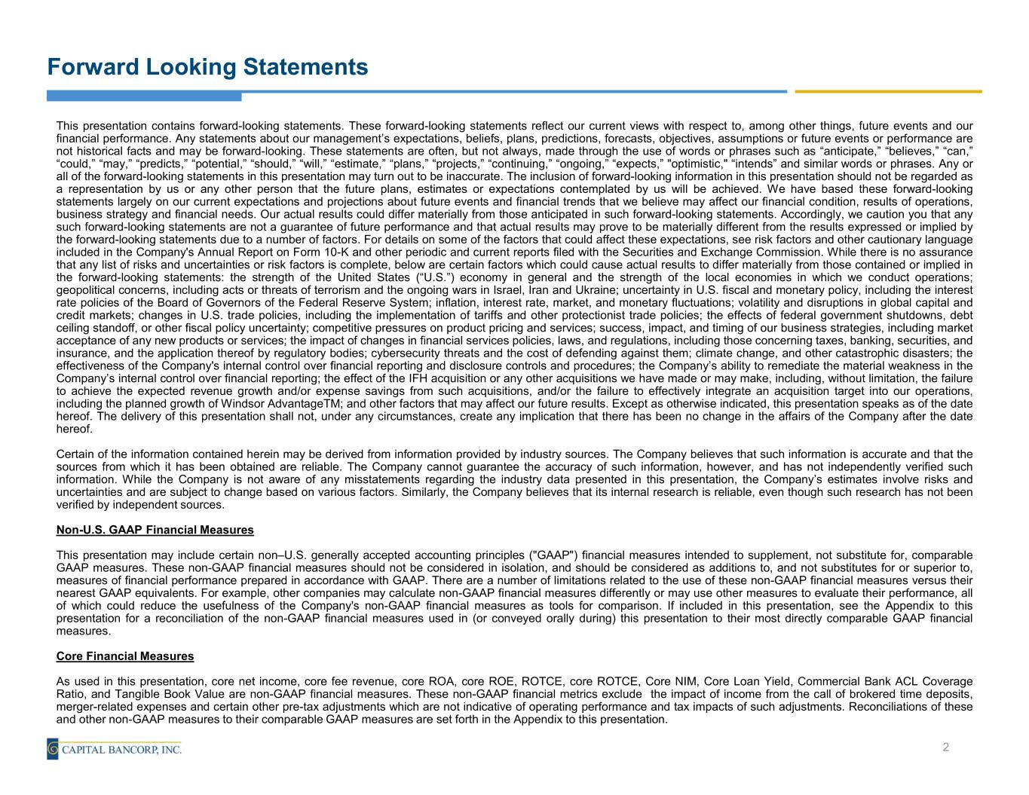
Forward Looking Statements This presentation contains forward-looking statements. These forward-looking statements reflect our current views with respect to, among other things, future events and our financial performance. Any statements about our management’s expectations, beliefs, plans, predictions, forecasts, objectives, assumptions or future events or performance are not historical facts and may be forward-looking. These statements are often, but not always, made through the use of words or phrases such as “anticipate,” “believes,” “can,” “could,” “may,” “predicts,” “potential,” “should,” “will,” “estimate,” “plans,” “projects,” “continuing,” “ongoing,” “expects,” "optimistic," “intends” and similar words or phrases. Any or all of the forward-looking statements in this presentation may turn out to be inaccurate. The inclusion of forward-looking information in this presentation should not be regarded as a representation by us or any other person that the future plans, estimates or expectations contemplated by us will be achieved. We have based these forward-looking statements largely on our current expectations and projections about future events and financial trends that we believe may affect our financial condition, results of operations, business strategy and financial needs. Our actual results could differ materially from those anticipated in such forward-looking statements. Accordingly, we caution you that any such forward-looking statements are not a guarantee of future performance and that actual results may prove to be materially different from the results expressed or implied by the forward-looking statements due to a number of factors. For details on some of the factors that could affect these expectations, see risk factors and other cautionary language included in the Company's Annual Report on Form 10-K and other periodic and current reports filed with the Securities and Exchange Commission. While there is no assurance that any list of risks and uncertainties or risk factors is complete, below are certain factors which could cause actual results to differ materially from those contained or implied in the forward-looking statements: the strength of the United States (“U.S.”) economy in general and the strength of the local economies in which we conduct operations; geopolitical concerns, including acts or threats of terrorism and the ongoing wars in Israel, Iran and Ukraine; uncertainty in U.S. fiscal and monetary policy, including the interest rate policies of the Board of Governors of the Federal Reserve System; inflation, interest rate, market, and monetary fluctuations; volatility and disruptions in global capital and credit markets; changes in U.S. trade policies, including the implementation of tariffs and other protectionist trade policies; the effects of federal government shutdowns, debt ceiling standoff, or other fiscal policy uncertainty; competitive pressures on product pricing and services; success, impact, and timing of our business strategies, including market acceptance of any new products or services; the impact of changes in financial services policies, laws, and regulations, including those concerning taxes, banking, securities, and insurance, and the application thereof by regulatory bodies; cybersecurity threats and the cost of defending against them; climate change, and other catastrophic disasters; the effectiveness of the Company's internal control over financial reporting and disclosure controls and procedures; the Company’s ability to remediate the material weakness in the Company’s internal control over financial reporting; the effect of the IFH acquisition or any other acquisitions we have made or may make, including, without limitation, the failure to achieve the expected revenue growth and/or expense savings from such acquisitions, and/or the failure to effectively integrate an acquisition target into our operations, including the planned growth of Windsor AdvantageTM; and other factors that may affect our future results. Except as otherwise indicated, this presentation speaks as of the date hereof. The delivery of this presentation shall not, under any circumstances, create any implication that there has been no change in the affairs of the Company after the date hereof. Certain of the information contained herein may be derived from information provided by industry sources. The Company believes that such information is accurate and that the sources from which it has been obtained are reliable. The Company cannot guarantee the accuracy of such information, however, and has not independently verified such information. While the Company is not aware of any misstatements regarding the industry data presented in this presentation, the Company’s estimates involve risks and uncertainties and are subject to change based on various factors. Similarly, the Company believes that its internal research is reliable, even though such research has not been verified by independent sources. Non-U.S. GAAP Financial Measures This presentation may include certain non–U.S. generally accepted accounting principles ("GAAP") financial measures intended to supplement, not substitute for, comparable GAAP measures. These non-GAAP financial measures should not be considered in isolation, and should be considered as additions to, and not substitutes for or superior to, measures of financial performance prepared in accordance with GAAP. There are a number of limitations related to the use of these non-GAAP financial measures versus their nearest GAAP equivalents. For example, other companies may calculate non-GAAP financial measures differently or may use other measures to evaluate their performance, all of which could reduce the usefulness of the Company's non-GAAP financial measures as tools for comparison. If included in this presentation, see the Appendix to this presentation for a reconciliation of the non-GAAP financial measures used in (or conveyed orally during) this presentation to their most directly comparable GAAP financial measures. Core Financial Measures As used in this presentation, core net income, core fee revenue, core ROA, core ROE, ROTCE, core ROTCE, Core NIM, Core Loan Yield, Commercial Bank ACL Coverage Ratio, and Tangible Book Value are non-GAAP financial measures. These non-GAAP financial metrics exclude the impact of income from the call of brokered time deposits, merger-related expenses and certain other pre-tax adjustments which are not indicative of operating performance and tax impacts of such adjustments. Reconciliations of these and other non-GAAP measures to their comparable GAAP measures are set forth in the Appendix to this presentation. 2

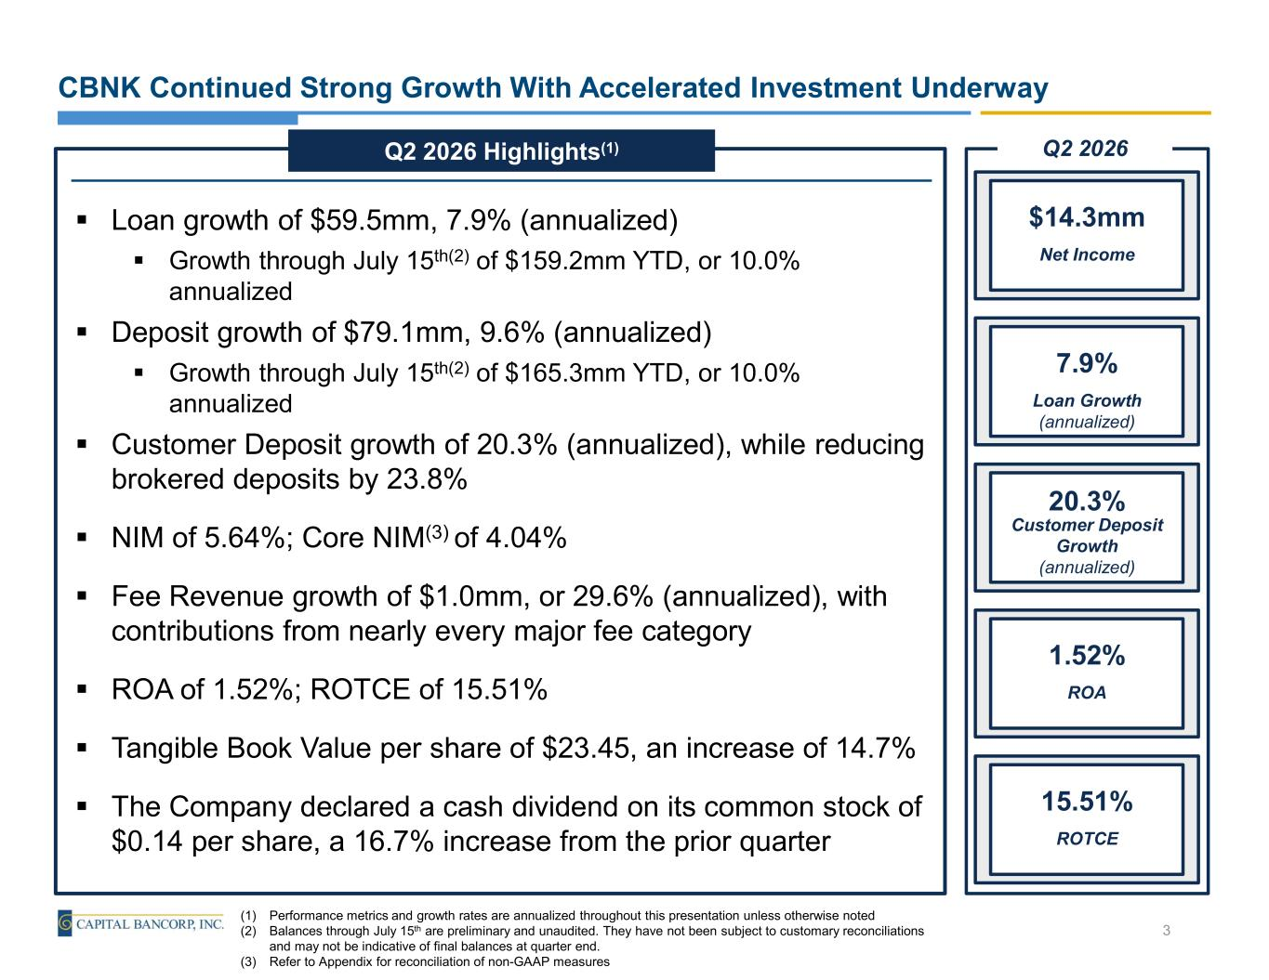
CBNK Continued Strong Growth With Accelerated Investment Underway (1) Performance metrics and growth rates are annualized throughout this presentation unless otherwise noted (2) Balances through July 15th are preliminary and unaudited. They have not been subject to customary reconciliations and may not be indicative of final balances at quarter end. (3) Refer to Appendix for reconciliation of non-GAAP measures ▪ Loan growth of $59.5mm, 7.9% (annualized) ▪ Growth through July 15th(2) of $159.2mm YTD, or 10.0% annualized ▪ Deposit growth of $79.1mm, 9.6% (annualized) ▪ Growth through July 15th(2) of $165.3mm YTD, or 10.0% annualized ▪ Customer Deposit growth of 20.3% (annualized), while reducing brokered deposits by 23.8% ▪ NIM of 5.64%; Core NIM(3) of 4.04% ▪ Fee Revenue growth of $1.0mm, or 29.6% (annualized), with contributions from nearly every major fee category ▪ ROA of 1.52%; ROTCE of 15.51% ▪ Tangible Book Value per share of $23.45, an increase of 14.7% ▪ The Company declared a cash dividend on its common stock of $0.14 per share, a 16.7% increase from the prior quarter Q2 2026 Highlights(1) Net Income $14.3mm Loan Growth (annualized) 7.9% Customer Deposit Growth (annualized) 20.3% ROA 1.52% ROTCE 15.51% Q2 2026 3

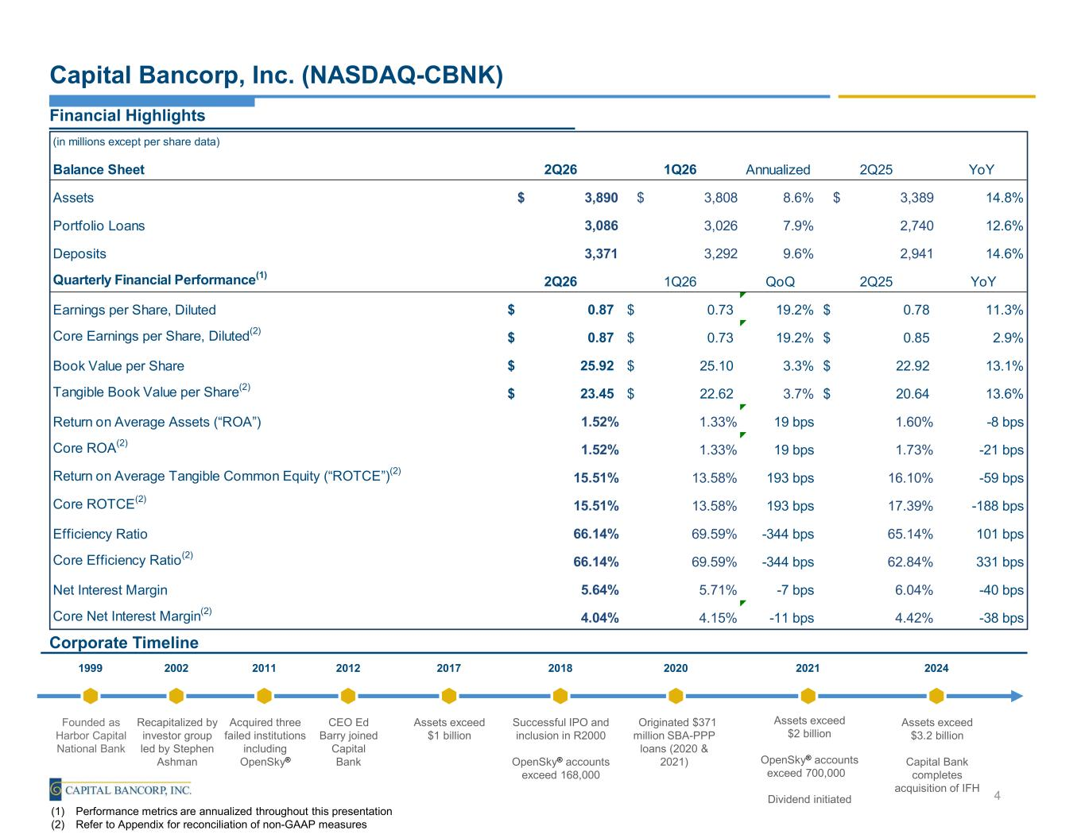
(in millions except per share data) Balance Sheet 2Q26 1Q26 Annualized 2Q25 YoY Assets $ 3,890 $ 3,808 8.6% $ 3,389 14.8% Portfolio Loans 3,086 3,026 7.9% 2,740 12.6% Deposits 3,371 3,292 9.6% 2,941 14.6% Quarterly Financial Performance(1) 2Q26 1Q26 QoQ 2Q25 YoY Earnings per Share, Diluted 0.87$ 0.73$ 19.2% 0.78$ 11.3% Core Earnings per Share, Diluted(2) 0.87$ 0.73$ 19.2% 0.85$ 2.9% Book Value per Share 25.92$ 25.10$ 3.3% 22.92$ 13.1% Tangible Book Value per Share(2) 23.45$ 22.62$ 3.7% 20.64$ 13.6% Return on Average Assets (“ROA”) 1.52% 1.33% 19 bps 1.60% -8 bps Core ROA(2) 1.52% 1.33% 19 bps 1.73% -21 bps Return on Average Tangible Common Equity (“ROTCE”)(2) 15.51% 13.58% 193 bps 16.10% -59 bps Core ROTCE(2) 15.51% 13.58% 193 bps 17.39% -188 bps Efficiency Ratio 66.14% 69.59% -344 bps 65.14% 101 bps Core Efficiency Ratio(2) 66.14% 69.59% -344 bps 62.84% 331 bps Net Interest Margin 5.64% 5.71% -7 bps 6.04% -40 bps Core Net Interest Margin(2) 4.04% 4.15% -11 bps 4.42% -38 bps Capital Bancorp, Inc. (NASDAQ-CBNK) Financial Highlights Corporate Timeline Founded as Harbor Capital National Bank Recapitalized by investor group led by Stephen Ashman Acquired three failed institutions including OpenSky® CEO Ed Barry joined Capital Bank Assets exceed $1 billion Successful IPO and inclusion in R2000 OpenSky® accounts exceed 168,000 1999 2002 2011 2012 2017 2018 Originated $371 million SBA-PPP loans (2020 & 2021) 2020 Assets exceed $2 billion OpenSky® accounts exceed 700,000 Dividend initiated 2021 (1) Performance metrics are annualized throughout this presentation (2) Refer to Appendix for reconciliation of non-GAAP measures Assets exceed $3.2 billion Capital Bank completes acquisition of IFH 2024 4

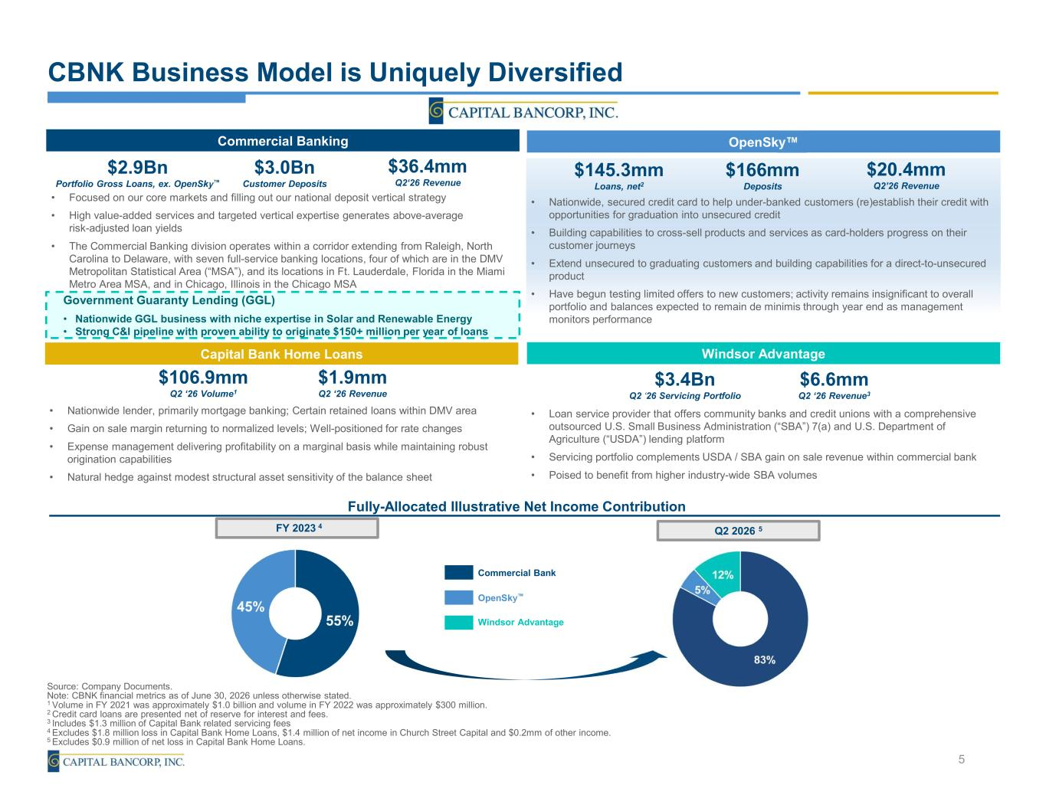
$3.4Bn Q2 ‘26 Servicing Portfolio $6.6mm Q2 ‘26 Revenue3 • Loan service provider that offers community banks and credit unions with a comprehensive outsourced U.S. Small Business Administration (“SBA”) 7(a) and U.S. Department of Agriculture (“USDA”) lending platform • Servicing portfolio complements USDA / SBA gain on sale revenue within commercial bank • Poised to benefit from higher industry-wide SBA volumes CBNK Business Model is Uniquely Diversified Source: Company Documents. Note: CBNK financial metrics as of June 30, 2026 unless otherwise stated. 1 Volume in FY 2021 was approximately $1.0 billion and volume in FY 2022 was approximately $300 million. 2 Credit card loans are presented net of reserve for interest and fees. 3 Includes $1.3 million of Capital Bank related servicing fees 4 Excludes $1.8 million loss in Capital Bank Home Loans, $1.4 million of net income in Church Street Capital and $0.2mm of other income. 5 Excludes $0.9 million of net loss in Capital Bank Home Loans. Commercial Bank OpenSky Windsor Advantage Commercial Banking Government Guaranty Lending (GGL) • Nationwide GGL business with niche expertise in Solar and Renewable Energy • Strong C&I pipeline with proven ability to originate $150+ million per year of loans $2.9Bn Portfolio Gross Loans, ex. OpenSky $3.0Bn Customer Deposits • Focused on our core markets and filling out our national deposit vertical strategy • High value-added services and targeted vertical expertise generates above-average risk-adjusted loan yields • The Commercial Banking division operates within a corridor extending from Raleigh, North Carolina to Delaware, with seven full-service banking locations, four of which are in the DMV Metropolitan Statistical Area (“MSA”), and its locations in Ft. Lauderdale, Florida in the Miami Metro Area MSA, and in Chicago, Illinois in the Chicago MSA $36.4mm Q2‘26 Revenue Fully-Allocated Illustrative Net Income Contribution 5 $106.9mm Q2 ‘26 Volume1 $1.9mm Q2 ‘26 Revenue • Nationwide lender, primarily mortgage banking; Certain retained loans within DMV area • Gain on sale margin returning to normalized levels; Well-positioned for rate changes • Expense management delivering profitability on a marginal basis while maintaining robust origination capabilities • Natural hedge against modest structural asset sensitivity of the balance sheet $166mm Deposits $145.3mm Loans, net2 • Nationwide, secured credit card to help under-banked customers (re)establish their credit with opportunities for graduation into unsecured credit • Building capabilities to cross-sell products and services as card-holders progress on their customer journeys • Extend unsecured to graduating customers and building capabilities for a direct-to-unsecured product • Have begun testing limited offers to new customers; activity remains insignificant to overall portfolio and balances expected to remain de minimis through year end as management monitors performance $20.4mm Q2’26 Revenue Capital Bank Home Loans OpenSky Windsor Advantage FY 2023 4 Q2 2026 5


Financial Information

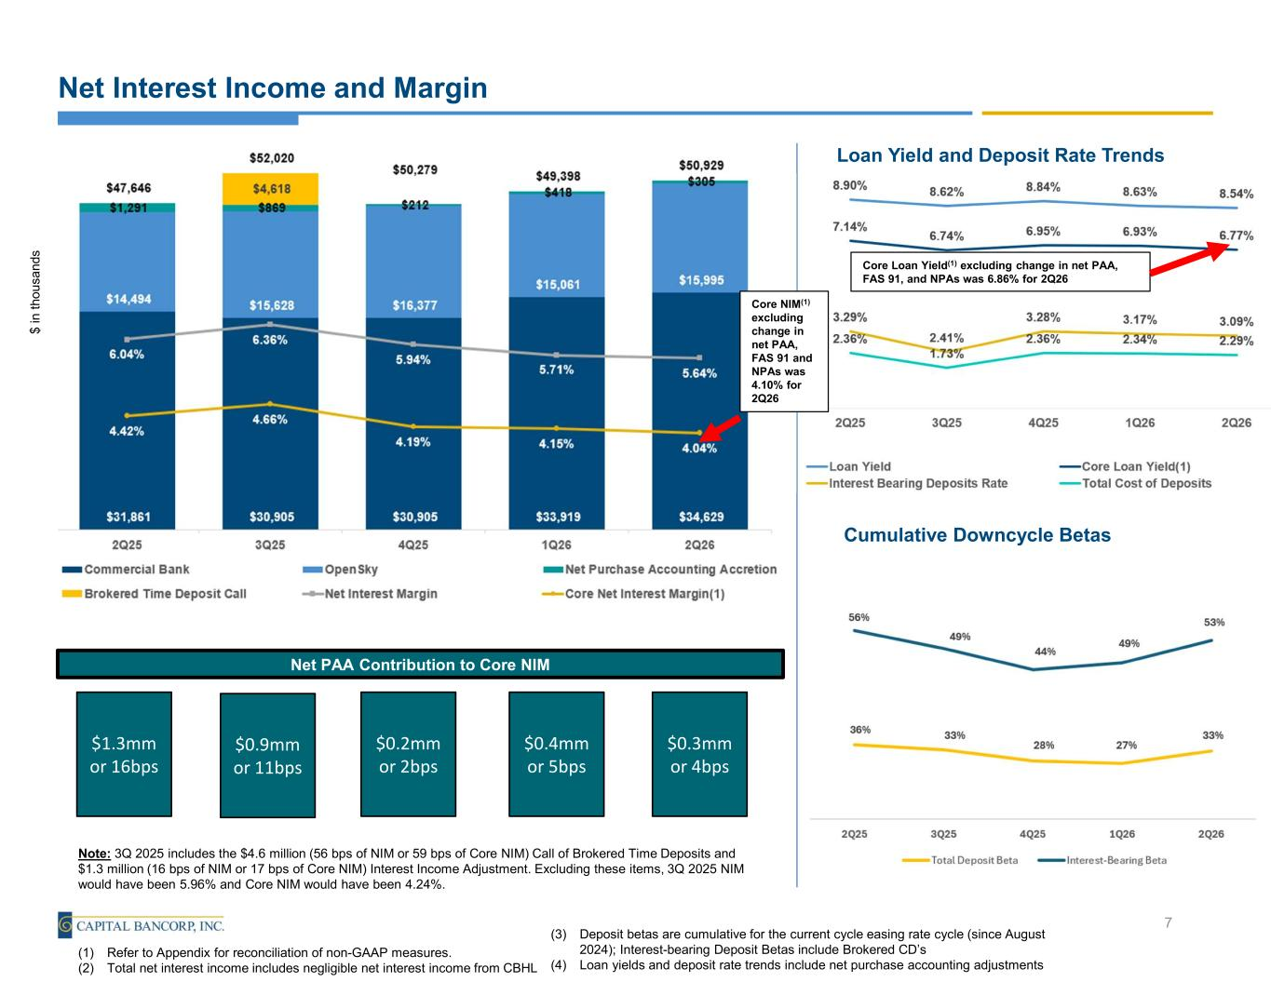
Net Interest Income and Margin $ in t ho u sa nd s 7 (1) Refer to Appendix for reconciliation of non-GAAP measures. (2) Total net interest income includes negligible net interest income from CBHL Loan Yield and Deposit Rate Trends Cumulative Downcycle Betas (3) Deposit betas are cumulative for the current cycle easing rate cycle (since August 2024); Interest-bearing Deposit Betas include Brokered CD’s (4) Loan yields and deposit rate trends include net purchase accounting adjustments Note: 3Q 2025 includes the $4.6 million (56 bps of NIM or 59 bps of Core NIM) Call of Brokered Time Deposits and $1.3 million (16 bps of NIM or 17 bps of Core NIM) Interest Income Adjustment. Excluding these items, 3Q 2025 NIM would have been 5.96% and Core NIM would have been 4.24%. Net PAA Contribution to Core NIM $1.3mm or 16bps $0.9mm or 11bps $0.2mm or 2bps $0.4mm or 5bps $0.3mm or 4bps Core NIM(1) excluding change in net PAA, FAS 91 and NPAs was 4.10% for 2Q26 Core Loan Yield(1) excluding change in net PAA, FAS 91, and NPAs was 6.86% for 2Q26

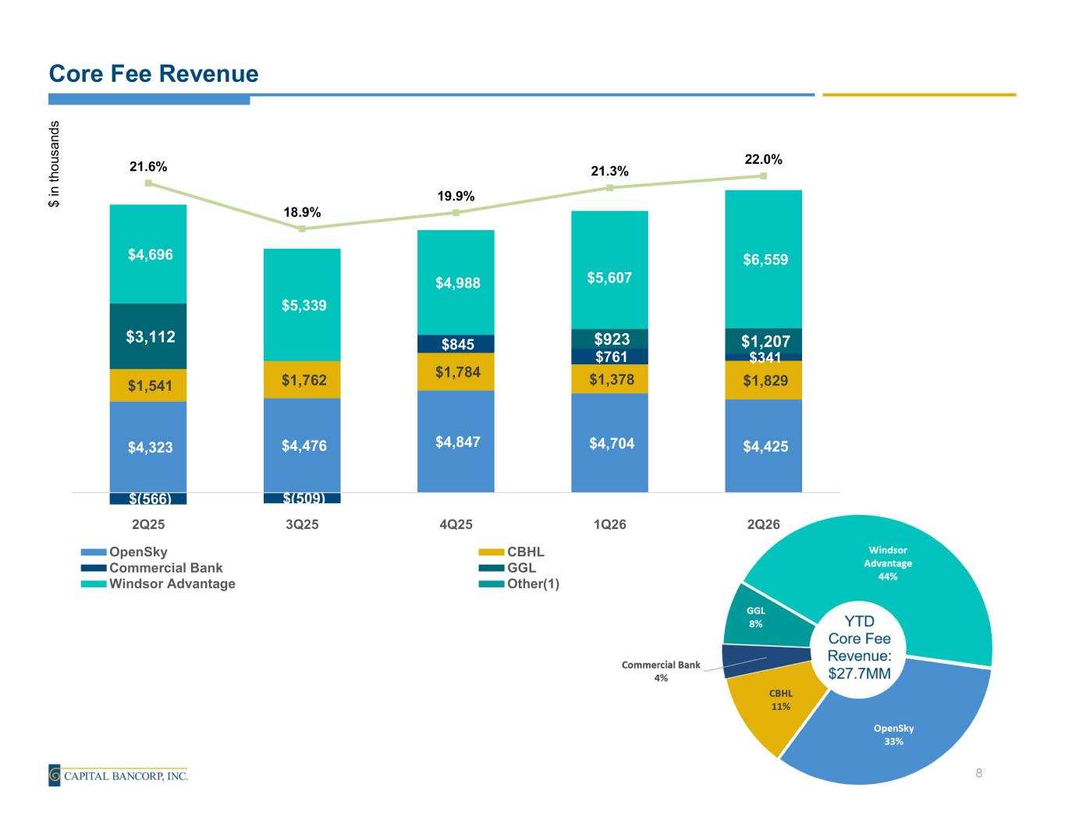
Core Fee Revenue $ in t ho us an d s 8 $4,323 $4,476 $4,847 $4,704 $4,425 $1,541 $1,762 $1,784 $1,378 $1,829 $(566) $(509) $845 $761 $341 $3,112 $923 $1,207 $4,696 $5,339 $4,988 $5,607 $6,559 21.6% 18.9% 19.9% 21.3% 22.0% 2Q25 3Q25 4Q25 1Q26 2Q26 OpenSky CBHL Commercial Bank GGL Windsor Advantage Other(1)

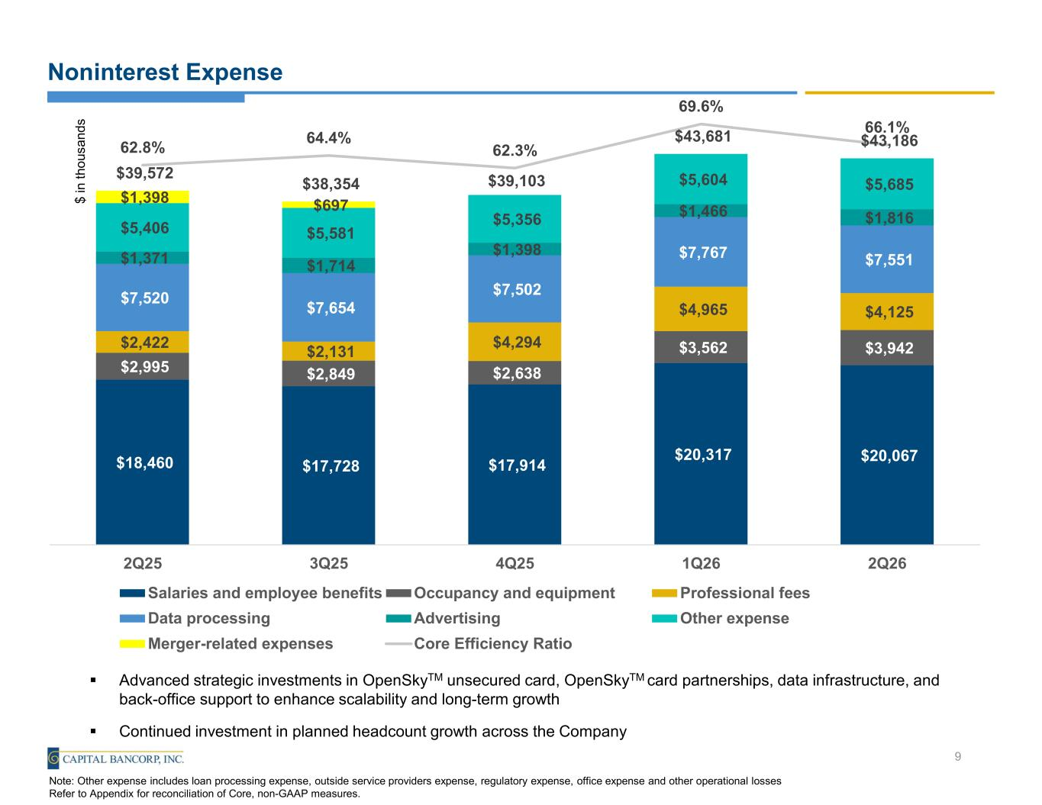
Noninterest Expense $ in t ho us an d s 9 Note: Other expense includes loan processing expense, outside service providers expense, regulatory expense, office expense and other operational losses Refer to Appendix for reconciliation of Core, non-GAAP measures. ▪ Advanced strategic investments in OpenSkyTM unsecured card, OpenSkyTM card partnerships, data infrastructure, and back-office support to enhance scalability and long-term growth ▪ Continued investment in planned headcount growth across the Company $18,460 $17,728 $17,914 $20,317 $20,067 $2,995 $2,849 $2,638 $3,562 $3,942 $2,422 $2,131 $4,294 $4,965 $4,125 $7,520 $7,654 $7,502 $7,767 $7,551 $1,371 $1,714 $1,398 $1,466 $1,816 $5,406 $5,581 $5,356 $5,604 $5,685 $1,398 $697 $39,572 $38,354 $39,103 $43,681 $43,186 62.8% 64.4% 62.3% 69.6% 66.1% 2Q25 3Q25 4Q25 1Q26 2Q26 Salaries and employee benefits Occupancy and equipment Professional fees Data processing Advertising Other expense Merger-related expenses Core Efficiency Ratio

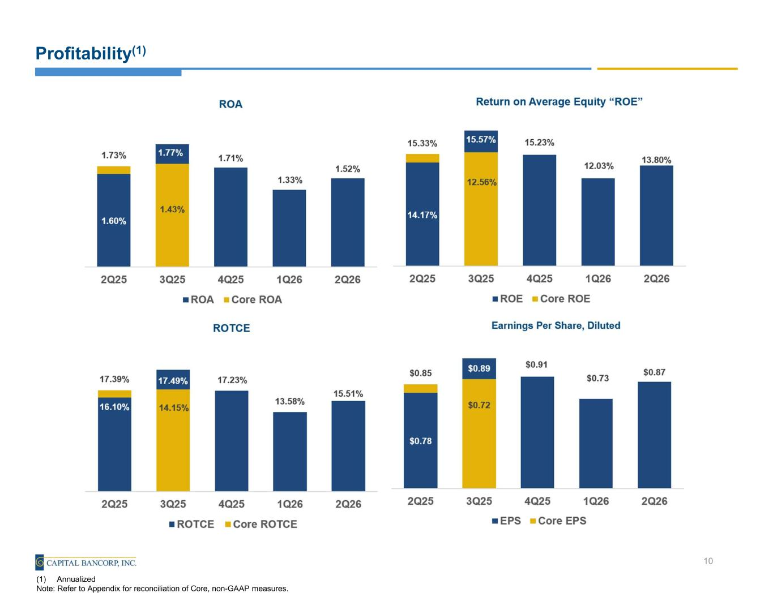
Profitability(1) 10 (1) Annualized Note: Refer to Appendix for reconciliation of Core, non-GAAP measures.

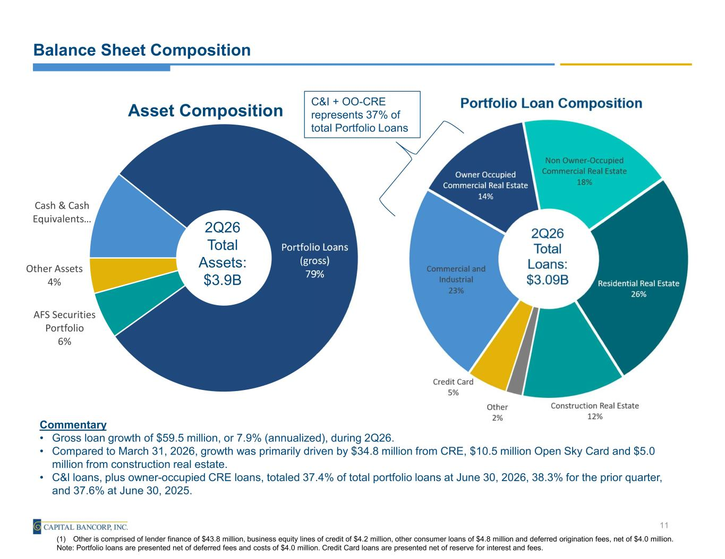
Cash & Cash Equivalents… Portfolio Loans (gross) 79% AFS Securities Portfolio 6% Other Assets 4% Asset Composition 2Q26 Total Assets: $3.9B Balance Sheet Composition Commentary • Gross loan growth of $59.5 million, or 7.9% (annualized), during 2Q26. • Compared to March 31, 2026, growth was primarily driven by $34.8 million from CRE, $10.5 million Open Sky Card and $5.0 million from construction real estate. • C&l loans, plus owner-occupied CRE loans, totaled 37.4% of total portfolio loans at June 30, 2026, 38.3% for the prior quarter, and 37.6% at June 30, 2025. 11 (1) Other is comprised of lender finance of $43.8 million, business equity lines of credit of $4.2 million, other consumer loans of $4.8 million and deferred origination fees, net of $4.0 million. Note: Portfolio loans are presented net of deferred fees and costs of $4.0 million. Credit Card loans are presented net of reserve for interest and fees. C&I + OO-CRE represents 37% of total Portfolio Loans

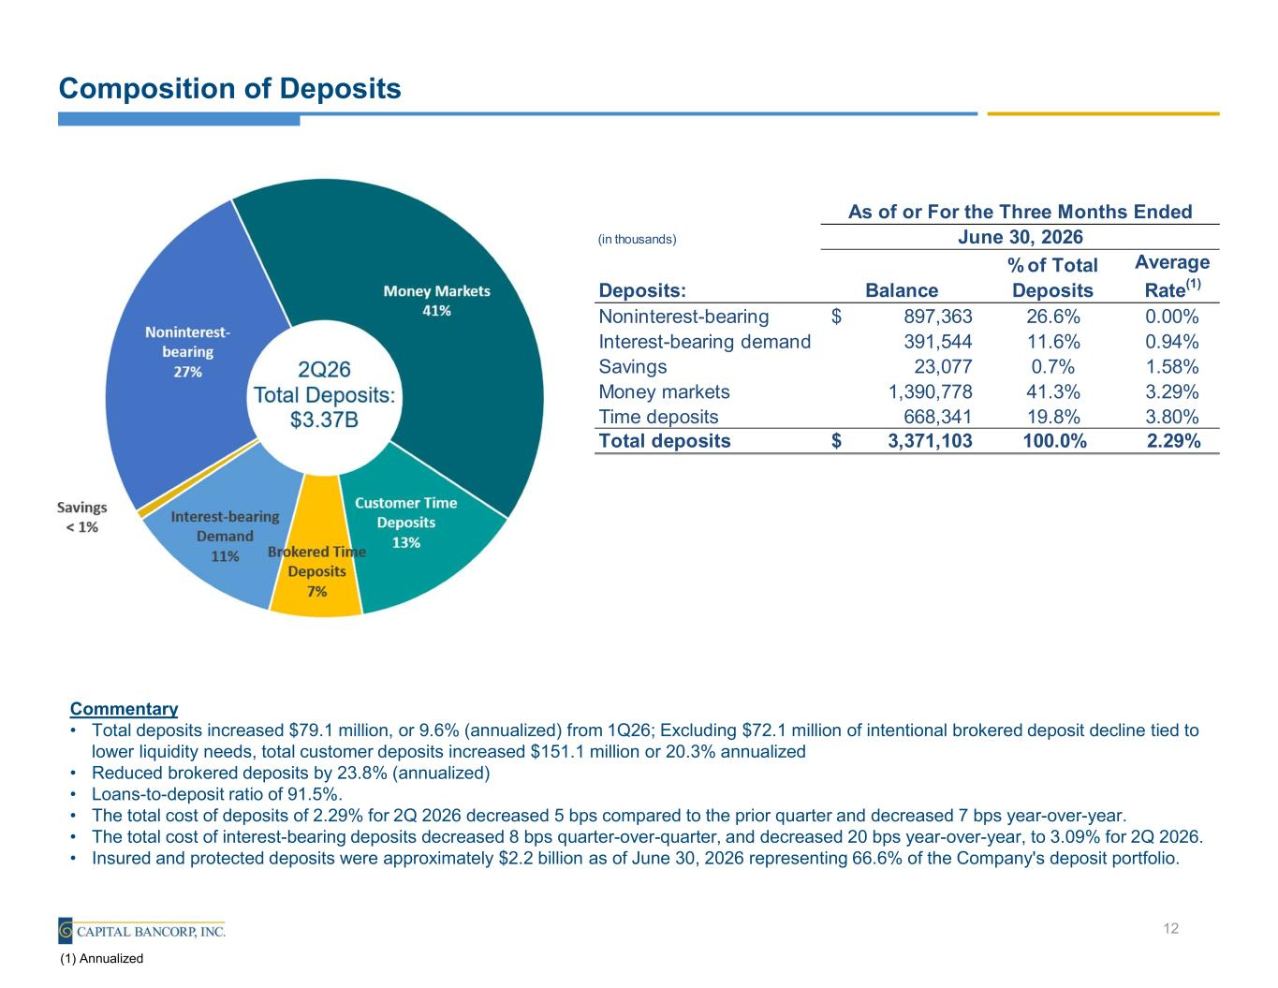
Composition of Deposits Commentary • Total deposits increased $79.1 million, or 9.6% (annualized) from 1Q26; Excluding $72.1 million of intentional brokered deposit decline tied to lower liquidity needs, total customer deposits increased $151.1 million or 20.3% annualized • Reduced brokered deposits by 23.8% (annualized) • Loans-to-deposit ratio of 91.5%. • The total cost of deposits of 2.29% for 2Q 2026 decreased 5 bps compared to the prior quarter and decreased 7 bps year-over-year. • The total cost of interest-bearing deposits decreased 8 bps quarter-over-quarter, and decreased 20 bps year-over-year, to 3.09% for 2Q 2026. • Insured and protected deposits were approximately $2.2 billion as of June 30, 2026 representing 66.6% of the Company's deposit portfolio. 12 (1) Annualized (in thousands) Deposits: Balance % of Total Deposits Average Rate(1) Noninterest-bearing 897,363$ 26.6% 0.00% Interest-bearing demand 391,544 11.6% 0.94% Savings 23,077 0.7% 1.58% Money markets 1,390,778 41.3% 3.29% Time deposits 668,341 19.8% 3.80% Total deposits 3,371,103$ 100.0% 2.29% As of or For the Three Months Ended June 30, 2026

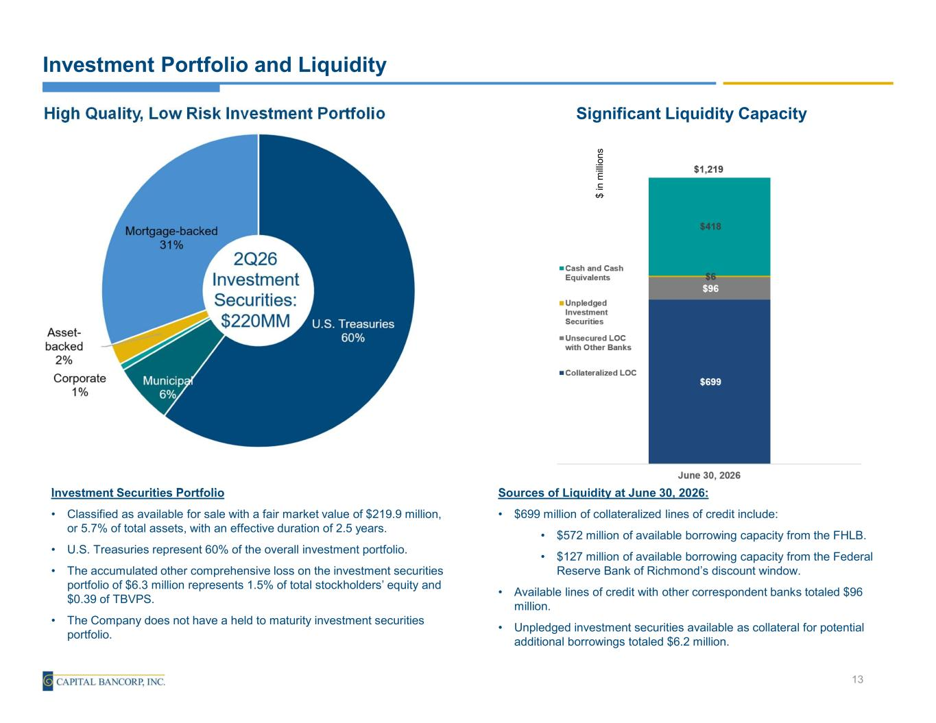
Investment Portfolio and Liquidity Investment Securities Portfolio • Classified as available for sale with a fair market value of $219.9 million, or 5.7% of total assets, with an effective duration of 2.5 years. • U.S. Treasuries represent 60% of the overall investment portfolio. • The accumulated other comprehensive loss on the investment securities portfolio of $6.3 million represents 1.5% of total stockholders’ equity and $0.39 of TBVPS. • The Company does not have a held to maturity investment securities portfolio. 13 High Quality, Low Risk Investment Portfolio Sources of Liquidity at June 30, 2026: • $699 million of collateralized lines of credit include: • $572 million of available borrowing capacity from the FHLB. • $127 million of available borrowing capacity from the Federal Reserve Bank of Richmond’s discount window. • Available lines of credit with other correspondent banks totaled $96 million. • Unpledged investment securities available as collateral for potential additional borrowings totaled $6.2 million. Significant Liquidity Capacity $ in m ill io n s

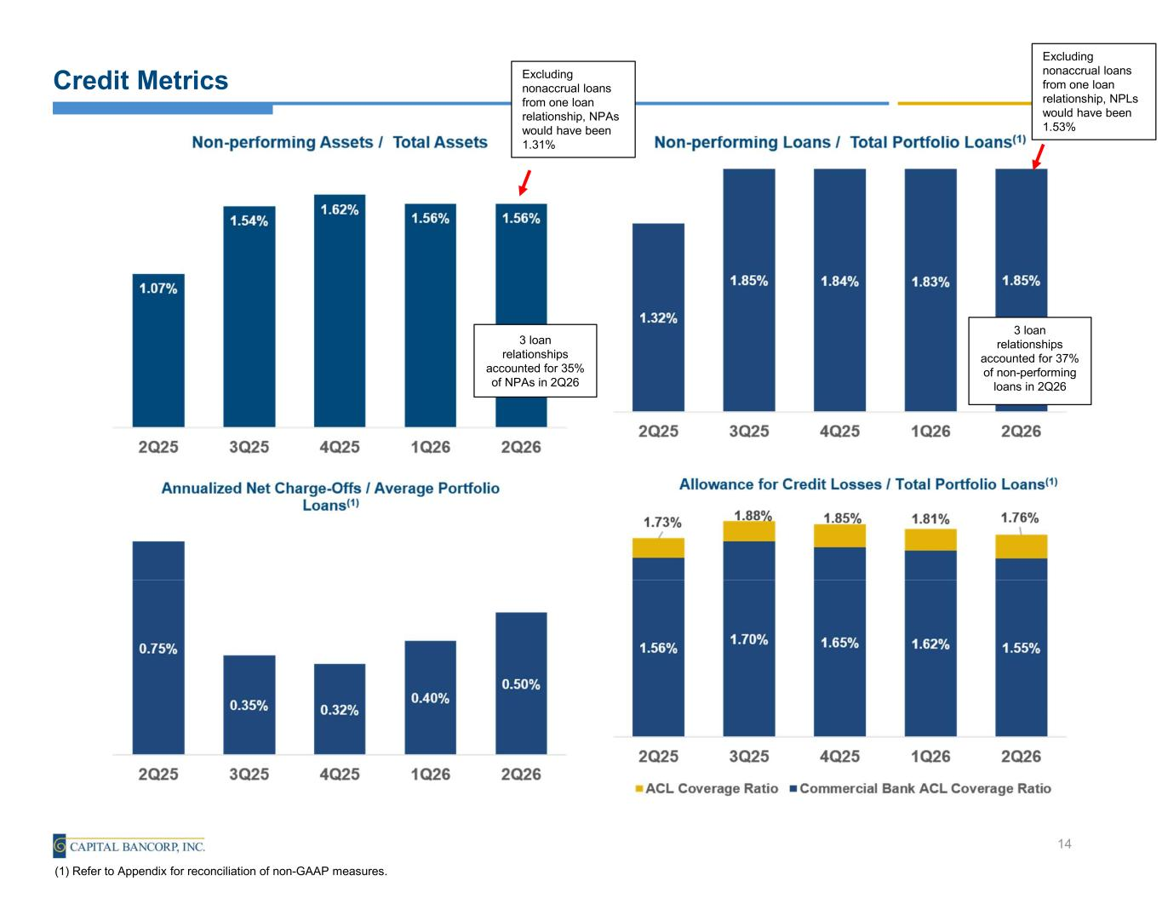
Credit Metrics 14 (1) Refer to Appendix for reconciliation of non-GAAP measures. 3 loan relationships accounted for 37% of non-performing loans in 2Q26 3 loan relationships accounted for 35% of NPAs in 2Q26 Excluding nonaccrual loans from one loan relationship, NPAs would have been 1.31% Excluding nonaccrual loans from one loan relationship, NPLs would have been 1.53%

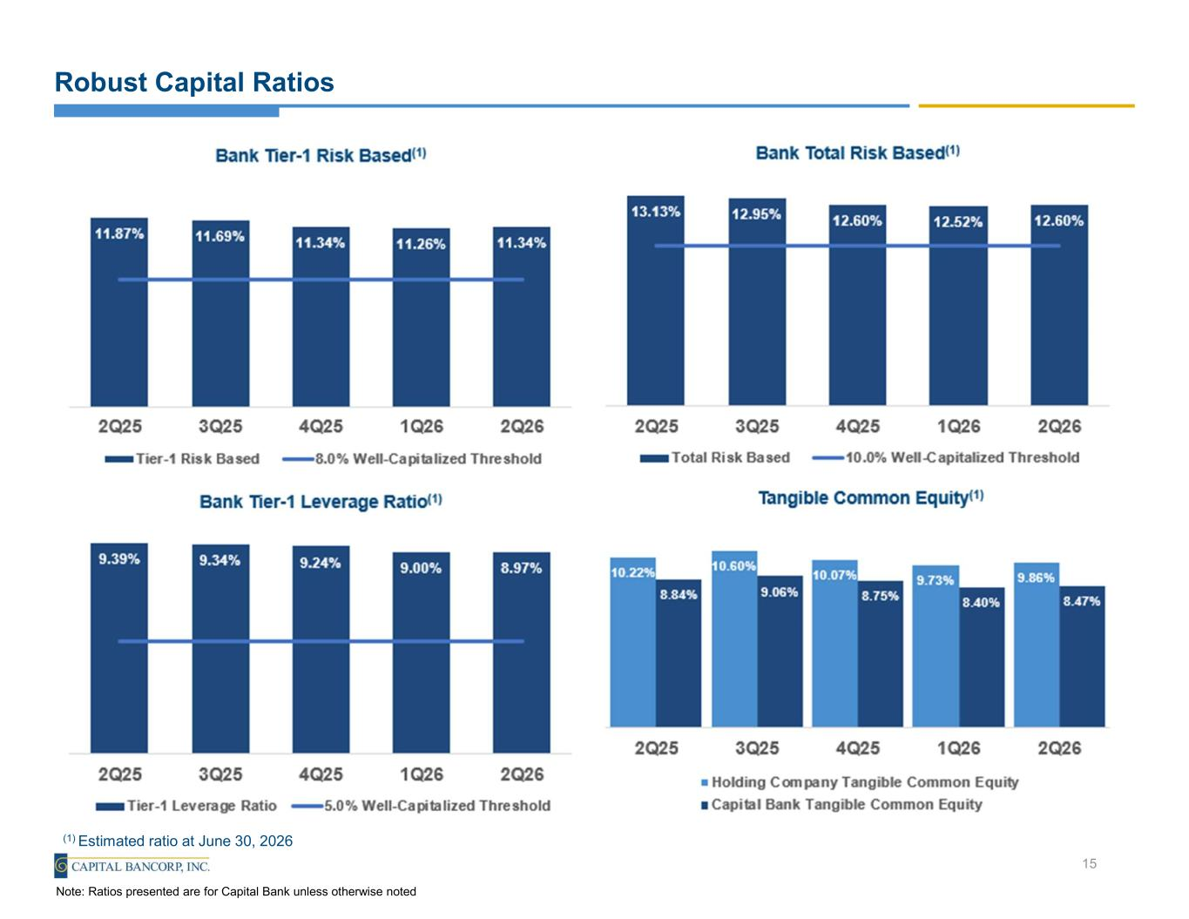
Robust Capital Ratios 15 Note: Ratios presented are for Capital Bank unless otherwise noted (1) Estimated ratio at June 30, 2026

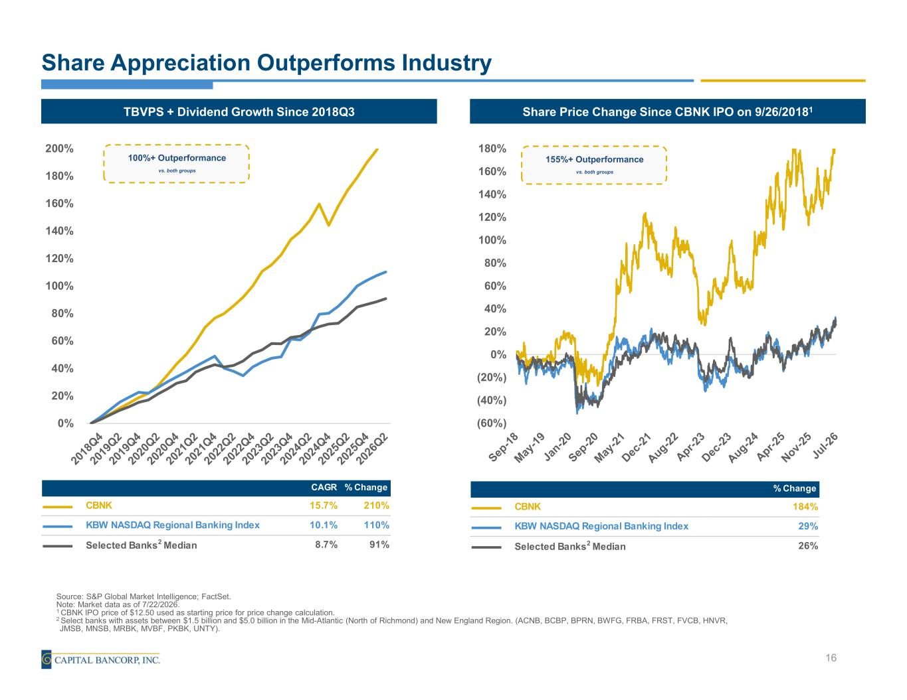
Share Appreciation Outperforms Industry 16 Share Price Change Since CBNK IPO on 9/26/20181TBVPS + Dividend Growth Since 2018Q3 100%+ Outperformance vs. both groups 155%+ Outperformance vs. both groups Source: S&P Global Market Intelligence; FactSet. Note: Market data as of 7/22/2026. 1 CBNK IPO price of $12.50 used as starting price for price change calculation. 2 Select banks with assets between $1.5 billion and $5.0 billion in the Mid-Atlantic (North of Richmond) and New England Region. (ACNB, BCBP, BPRN, BWFG, FRBA, FRST, FVCB, HNVR, JMSB, MNSB, MRBK, MVBF, PKBK, UNTY). 0% 20% 40% 60% 80% 100% 120% 140% 160% 180% 200% CAGR % Change CBNK 15.7% 210% KBW NASDAQ Regional Banking Index 10.1% 110% Selected Banks2 Median 8.7% 91% 58.48% (60%) (40%) (20%) 0% 20% 40% 60% 80% 100% 120% 140% 160% 180% % Change CBNK 184% KBW NASDAQ Regional Banking Index 29% Selected Banks2 Median 26%


Jake Dalaya Chief Financial Officer (301)-637-5118 NASDAQ: CBNK


Non-U.S. GAAP Financial Measures

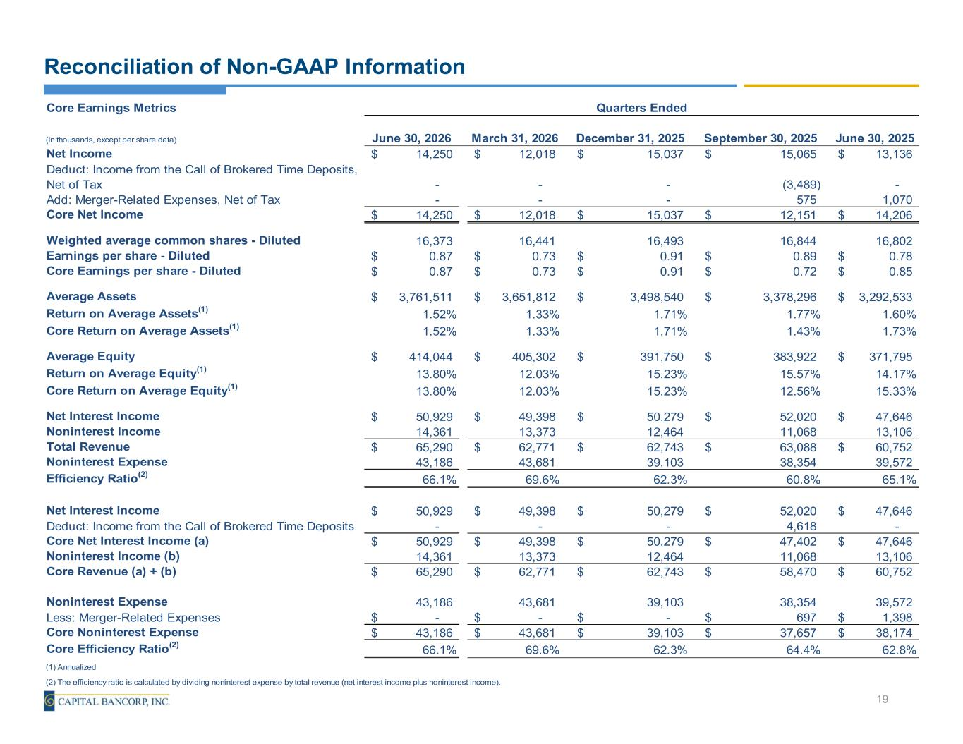
Core Earnings Metrics (in thousands, except per share data) June 30, 2026 March 31, 2026 December 31, 2025 September 30, 2025 June 30, 2025 Net Income 14,250$ 12,018$ 15,037$ 15,065$ 13,136$ Deduct: Income from the Call of Brokered Time Deposits, Net of Tax - - - (3,489) - Add: Merger-Related Expenses, Net of Tax - - - 575 1,070 Core Net Income 14,250$ 12,018$ 15,037$ 12,151$ 14,206$ Weighted average common shares - Diluted 16,373 16,441 16,493 16,844 16,802 Earnings per share - Diluted 0.87$ 0.73$ 0.91$ 0.89$ 0.78$ Core Earnings per share - Diluted 0.87$ 0.73$ 0.91$ 0.72$ 0.85$ Average Assets 3,761,511$ 3,651,812$ 3,498,540$ 3,378,296$ 3,292,533$ Return on Average Assets(1) 1.52% 1.33% 1.71% 1.77% 1.60% Core Return on Average Assets(1) 1.52% 1.33% 1.71% 1.43% 1.73% Average Equity 414,044$ 405,302$ 391,750$ 383,922$ 371,795$ Return on Average Equity(1) 13.80% 12.03% 15.23% 15.57% 14.17% Core Return on Average Equity(1) 13.80% 12.03% 15.23% 12.56% 15.33% Net Interest Income 50,929$ 49,398$ 50,279$ 52,020$ 47,646$ Noninterest Income 14,361 13,373 12,464 11,068 13,106 Total Revenue 65,290$ 62,771$ 62,743$ 63,088$ 60,752$ Noninterest Expense 43,186 43,681 39,103 38,354 39,572 Efficiency Ratio(2) 66.1% 69.6% 62.3% 60.8% 65.1% Net Interest Income 50,929$ 49,398$ 50,279$ 52,020$ 47,646$ Deduct: Income from the Call of Brokered Time Deposits - - - 4,618 - Core Net Interest Income (a) 50,929$ 49,398$ 50,279$ 47,402$ 47,646$ Noninterest Income (b) 14,361 13,373 12,464 11,068 13,106 Core Revenue (a) + (b) 65,290$ 62,771$ 62,743$ 58,470$ 60,752$ Noninterest Expense 43,186 43,681 39,103 38,354 39,572 Less: Merger-Related Expenses -$ -$ -$ 697$ 1,398$ Core Noninterest Expense 43,186$ 43,681$ 39,103$ 37,657$ 38,174$ Core Efficiency Ratio(2) 66.1% 69.6% 62.3% 64.4% 62.8% (1) Annualized (2) The efficiency ratio is calculated by dividing noninterest expense by total revenue (net interest income plus noninterest income). Quarters Ended Reconciliation of Non-GAAP Information 19

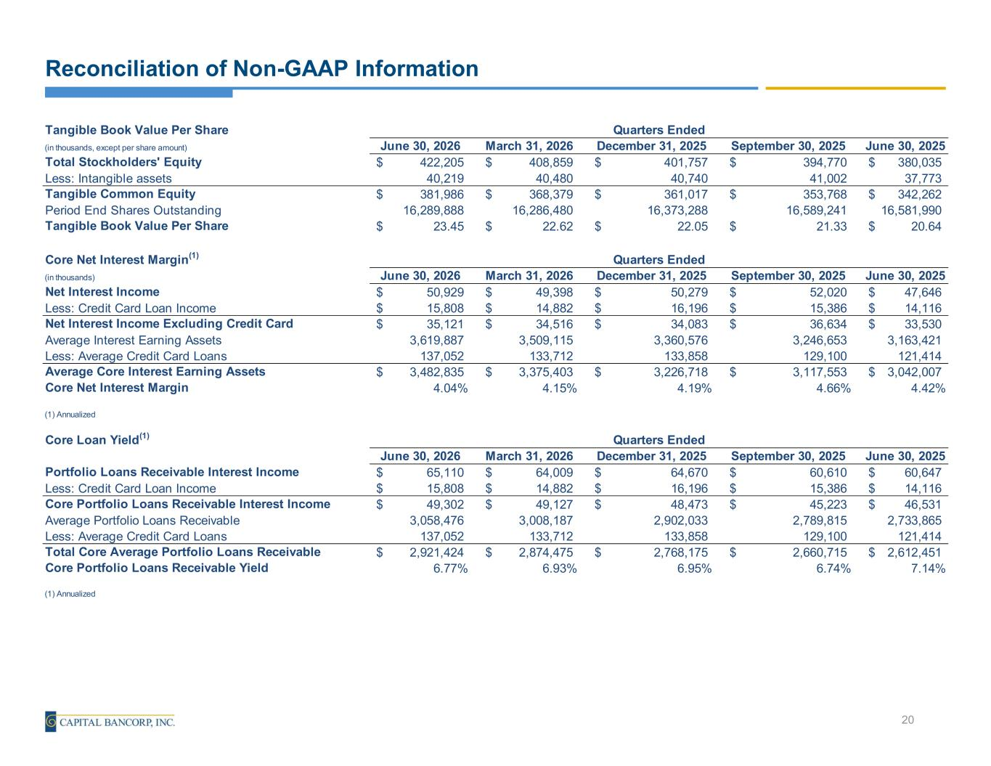
Reconciliation of Non-GAAP Information 20 Tangible Book Value Per Share (in thousands, except per share amount) June 30, 2026 March 31, 2026 December 31, 2025 September 30, 2025 June 30, 2025 Total Stockholders' Equity 422,205$ 408,859$ 401,757$ 394,770$ 380,035$ Less: Intangible assets 40,219 40,480 40,740 41,002 37,773 Tangible Common Equity 381,986$ 368,379$ 361,017$ 353,768$ 342,262$ Period End Shares Outstanding 16,289,888 16,286,480 16,373,288 16,589,241 16,581,990 Tangible Book Value Per Share 23.45$ 22.62$ 22.05$ 21.33$ 20.64$ Core Net Interest Margin(1) (in thousands) June 30, 2026 March 31, 2026 December 31, 2025 September 30, 2025 June 30, 2025 Net Interest Income 50,929$ 49,398$ 50,279$ 52,020$ 47,646$ Less: Credit Card Loan Income 15,808$ 14,882$ 16,196$ 15,386$ 14,116$ Net Interest Income Excluding Credit Card 35,121$ 34,516$ 34,083$ 36,634$ 33,530$ Average Interest Earning Assets 3,619,887 3,509,115 3,360,576 3,246,653 3,163,421 Less: Average Credit Card Loans 137,052 133,712 133,858 129,100 121,414 Average Core Interest Earning Assets 3,482,835$ 3,375,403$ 3,226,718$ 3,117,553$ 3,042,007$ Core Net Interest Margin 4.04% 4.15% 4.19% 4.66% 4.42% (1) Annualized Core Loan Yield(1) June 30, 2026 March 31, 2026 December 31, 2025 September 30, 2025 June 30, 2025 Portfolio Loans Receivable Interest Income 65,110$ 64,009$ 64,670$ 60,610$ 60,647$ Less: Credit Card Loan Income 15,808$ 14,882$ 16,196$ 15,386$ 14,116$ Core Portfolio Loans Receivable Interest Income 49,302$ 49,127$ 48,473$ 45,223$ 46,531$ Average Portfolio Loans Receivable 3,058,476 3,008,187 2,902,033 2,789,815 2,733,865 Less: Average Credit Card Loans 137,052 133,712 133,858 129,100 121,414 Total Core Average Portfolio Loans Receivable 2,921,424$ 2,874,475$ 2,768,175$ 2,660,715$ 2,612,451$ Core Portfolio Loans Receivable Yield 6.77% 6.93% 6.95% 6.74% 7.14% (1) Annualized Quarters Ended Quarters Ended Quarters Ended

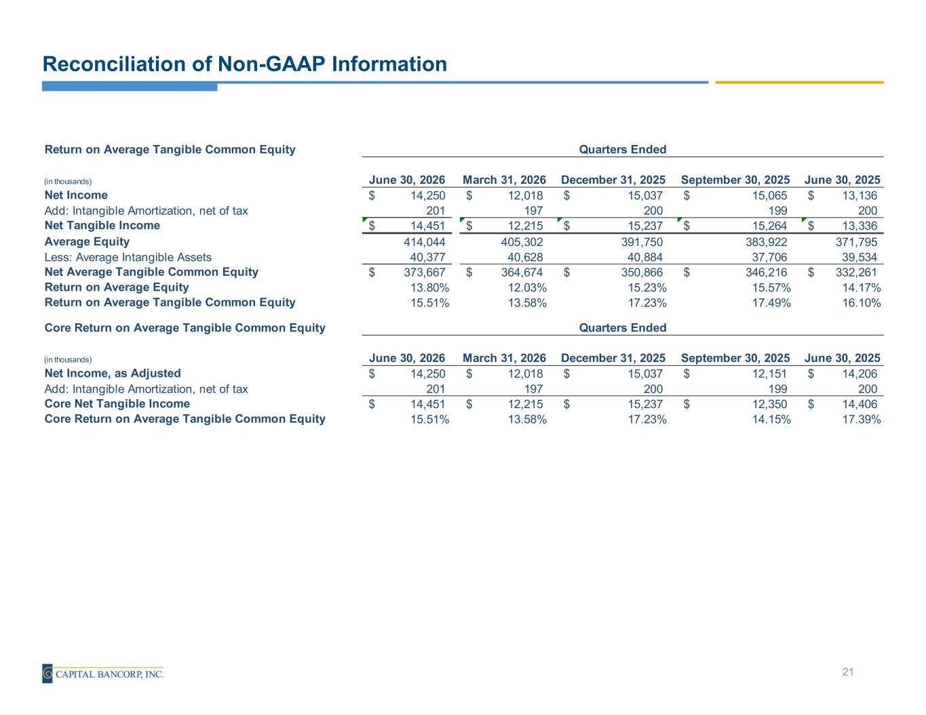
Reconciliation of Non-GAAP Information 21 Return on Average Tangible Common Equity (in thousands) June 30, 2026 March 31, 2026 December 31, 2025 September 30, 2025 June 30, 2025 Net Income 14,250$ 12,018$ 15,037$ 15,065$ 13,136$ Add: Intangible Amortization, net of tax 201 197 200 199 200 Net Tangible Income 14,451$ 12,215$ 15,237$ 15,264$ 13,336$ Average Equity 414,044 405,302 391,750 383,922 371,795 Less: Average Intangible Assets 40,377 40,628 40,884 37,706 39,534 Net Average Tangible Common Equity 373,667$ 364,674$ 350,866$ 346,216$ 332,261$ Return on Average Equity 13.80% 12.03% 15.23% 15.57% 14.17% Return on Average Tangible Common Equity 15.51% 13.58% 17.23% 17.49% 16.10% Core Return on Average Tangible Common Equity (in thousands) June 30, 2026 March 31, 2026 December 31, 2025 September 30, 2025 June 30, 2025 Net Income, as Adjusted 14,250$ 12,018$ 15,037$ 12,151$ 14,206$ Add: Intangible Amortization, net of tax 201 197 200 199 200 Core Net Tangible Income 14,451$ 12,215$ 15,237$ 12,350$ 14,406$ Core Return on Average Tangible Common Equity 15.51% 13.58% 17.23% 14.15% 17.39% Quarters Ended Quarters Ended

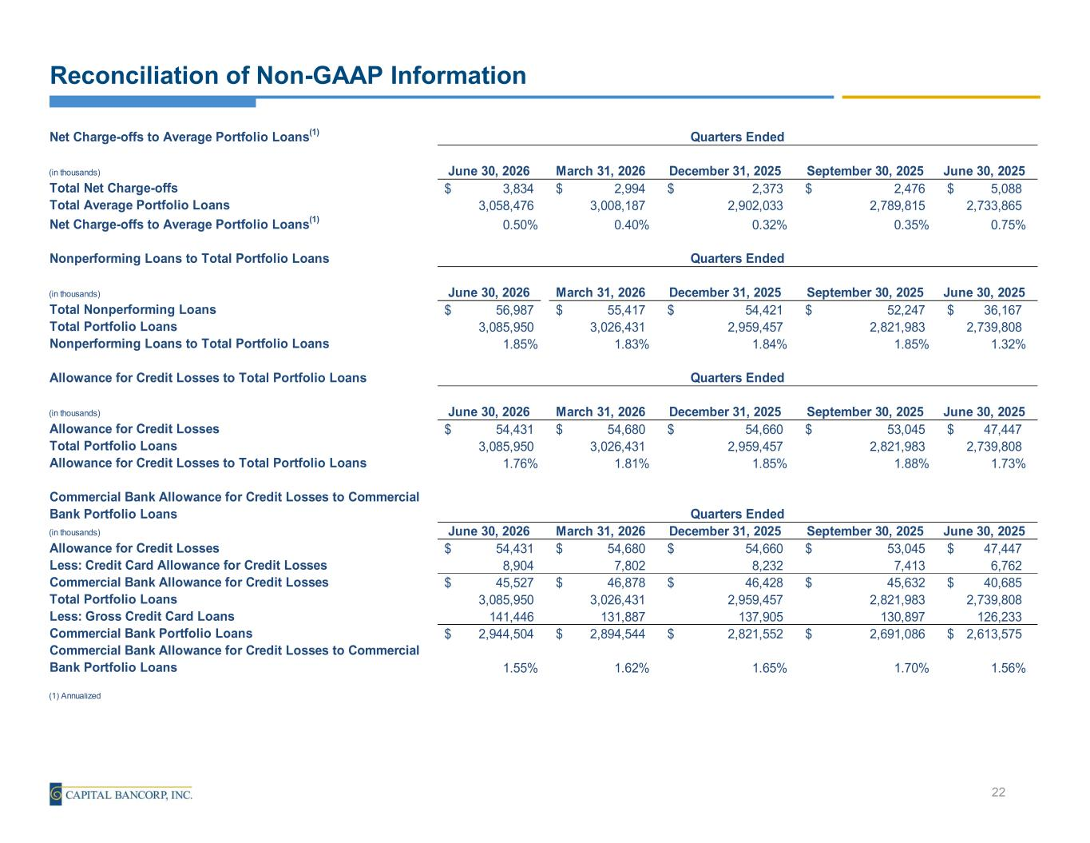
Net Charge-offs to Average Portfolio Loans(1) (in thousands) June 30, 2026 March 31, 2026 December 31, 2025 September 30, 2025 June 30, 2025 Total Net Charge-offs 3,834$ 2,994$ 2,373$ 2,476$ 5,088$ Total Average Portfolio Loans 3,058,476 3,008,187 2,902,033 2,789,815 2,733,865 Net Charge-offs to Average Portfolio Loans(1) 0.50% 0.40% 0.32% 0.35% 0.75% Nonperforming Loans to Total Portfolio Loans (in thousands) June 30, 2026 March 31, 2026 December 31, 2025 September 30, 2025 June 30, 2025 Total Nonperforming Loans 56,987$ 55,417$ 54,421$ 52,247$ 36,167$ Total Portfolio Loans 3,085,950 3,026,431 2,959,457 2,821,983 2,739,808 Nonperforming Loans to Total Portfolio Loans 1.85% 1.83% 1.84% 1.85% 1.32% Allowance for Credit Losses to Total Portfolio Loans (in thousands) June 30, 2026 March 31, 2026 December 31, 2025 September 30, 2025 June 30, 2025 Allowance for Credit Losses 54,431$ 54,680$ 54,660$ 53,045$ 47,447$ Total Portfolio Loans 3,085,950 3,026,431 2,959,457 2,821,983 2,739,808 Allowance for Credit Losses to Total Portfolio Loans 1.76% 1.81% 1.85% 1.88% 1.73% Commercial Bank Allowance for Credit Losses to Commercial Bank Portfolio Loans (in thousands) June 30, 2026 March 31, 2026 December 31, 2025 September 30, 2025 June 30, 2025 Allowance for Credit Losses 54,431$ 54,680$ 54,660$ 53,045$ 47,447$ Less: Credit Card Allowance for Credit Losses 8,904 7,802 8,232 7,413 6,762 Commercial Bank Allowance for Credit Losses 45,527$ 46,878$ 46,428$ 45,632$ 40,685$ Total Portfolio Loans 3,085,950 3,026,431 2,959,457 2,821,983 2,739,808 Less: Gross Credit Card Loans 141,446 131,887 137,905 130,897 126,233 Commercial Bank Portfolio Loans 2,944,504$ 2,894,544$ 2,821,552$ 2,691,086$ 2,613,575$ Commercial Bank Allowance for Credit Losses to Commercial Bank Portfolio Loans 1.55% 1.62% 1.65% 1.70% 1.56% (1) Annualized Quarters Ended Quarters Ended Quarters Ended Quarters Ended Reconciliation of Non-GAAP Information 22

