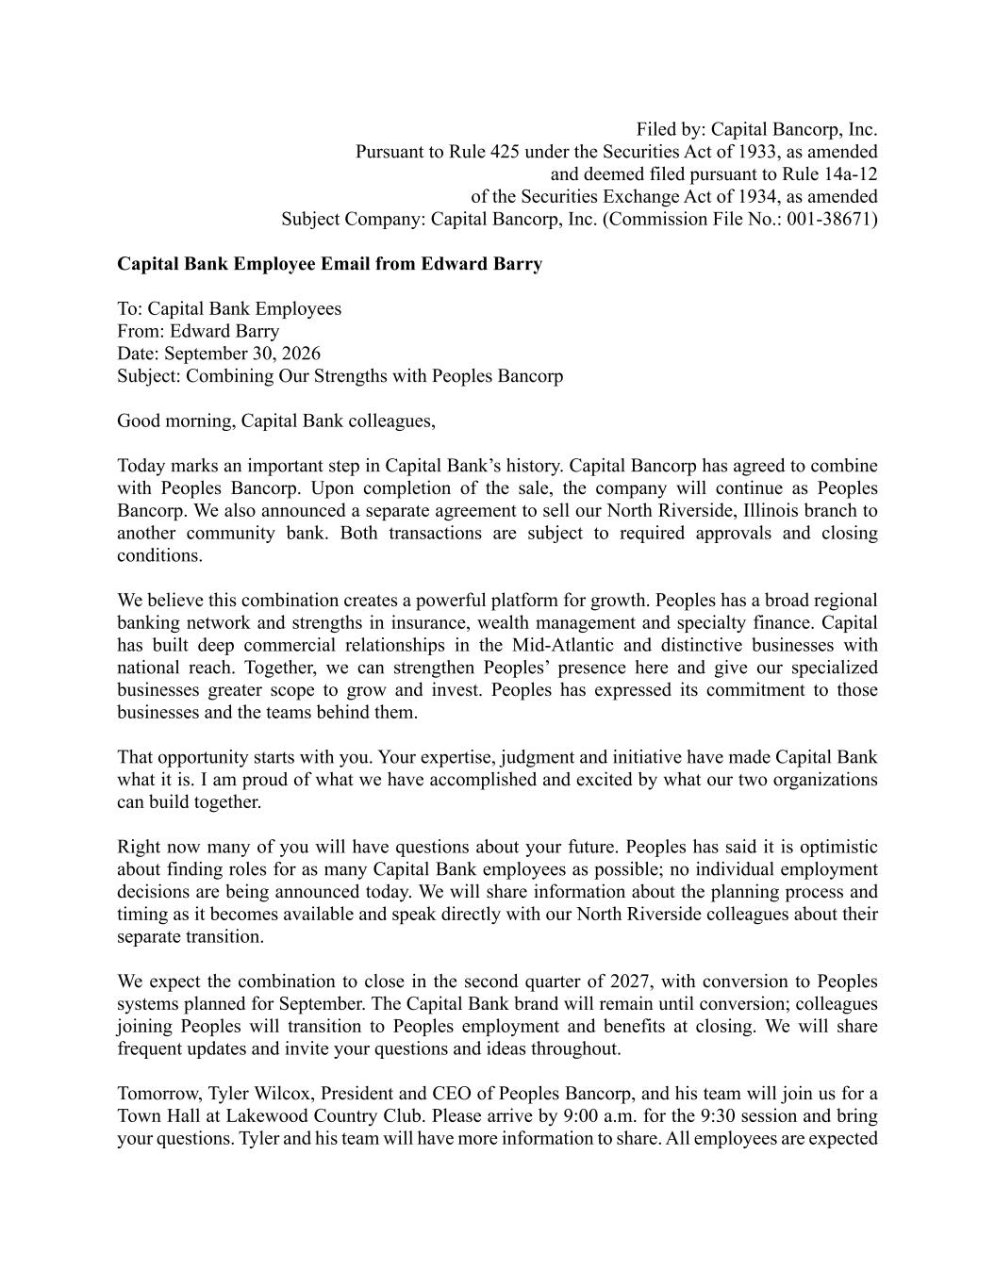
Filed by: Capital Bancorp, Inc. Pursuant to Rule 425 under the Securities Act of 1933, as amended and deemed filed pursuant to Rule 14a-12 of the Securities Exchange Act of 1934, as amended Subject Company: Capital Bancorp, Inc. (Commission File No.: 001-38671) Capital Bank Employee Email from Edward Barry To: Capital Bank Employees From: Edward Barry Date: September 30, 2026 Subject: Combining Our Strengths with Peoples Bancorp Good morning, Capital Bank colleagues, Today marks an important step in Capital Bank’s history. Capital Bancorp has agreed to combine with Peoples Bancorp. Upon completion of the sale, the company will continue as Peoples Bancorp. We also announced a separate agreement to sell our North Riverside, Illinois branch to another community bank. Both transactions are subject to required approvals and closing conditions. We believe this combination creates a powerful platform for growth. Peoples has a broad regional banking network and strengths in insurance, wealth management and specialty finance. Capital has built deep commercial relationships in the Mid-Atlantic and distinctive businesses with national reach. Together, we can strengthen Peoples’ presence here and give our specialized businesses greater scope to grow and invest. Peoples has expressed its commitment to those businesses and the teams behind them. That opportunity starts with you. Your expertise, judgment and initiative have made Capital Bank what it is. I am proud of what we have accomplished and excited by what our two organizations can build together. Right now many of you will have questions about your future. Peoples has said it is optimistic about finding roles for as many Capital Bank employees as possible; no individual employment decisions are being announced today. We will share information about the planning process and timing as it becomes available and speak directly with our North Riverside colleagues about their separate transition. We expect the combination to close in the second quarter of 2027, with conversion to Peoples systems planned for September. The Capital Bank brand will remain until conversion; colleagues joining Peoples will transition to Peoples employment and benefits at closing. We will share frequent updates and invite your questions and ideas throughout. Tomorrow, Tyler Wilcox, President and CEO of Peoples Bancorp, and his team will join us for a Town Hall at Lakewood Country Club. Please arrive by 9:00 a.m. for the 9:30 session and bring your questions. Tyler and his team will have more information to share. All employees are expected

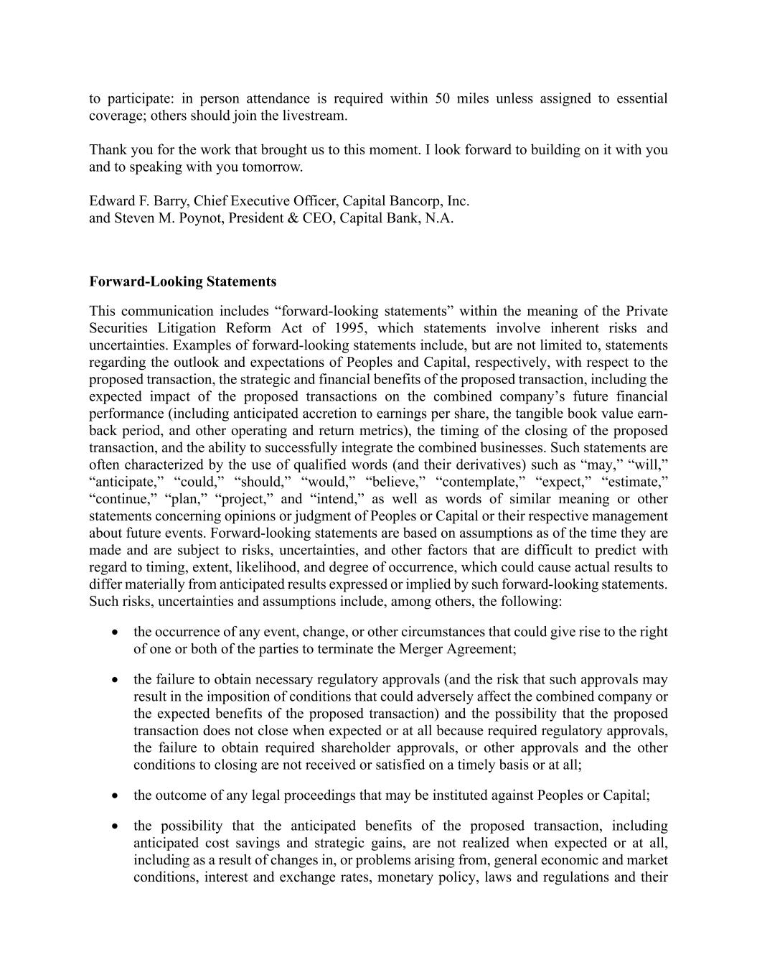
to participate: in person attendance is required within 50 miles unless assigned to essential coverage; others should join the livestream. Thank you for the work that brought us to this moment. I look forward to building on it with you and to speaking with you tomorrow. Edward F. Barry, Chief Executive Officer, Capital Bancorp, Inc. and Steven M. Poynot, President & CEO, Capital Bank, N.A. Forward-Looking Statements This communication includes “forward-looking statements” within the meaning of the Private Securities Litigation Reform Act of 1995, which statements involve inherent risks and uncertainties. Examples of forward-looking statements include, but are not limited to, statements regarding the outlook and expectations of Peoples and Capital, respectively, with respect to the proposed transaction, the strategic and financial benefits of the proposed transaction, including the expected impact of the proposed transactions on the combined company’s future financial performance (including anticipated accretion to earnings per share, the tangible book value earn- back period, and other operating and return metrics), the timing of the closing of the proposed transaction, and the ability to successfully integrate the combined businesses. Such statements are often characterized by the use of qualified words (and their derivatives) such as “may,” “will,” “anticipate,” “could,” “should,” “would,” “believe,” “contemplate,” “expect,” “estimate,” “continue,” “plan,” “project,” and “intend,” as well as words of similar meaning or other statements concerning opinions or judgment of Peoples or Capital or their respective management about future events. Forward-looking statements are based on assumptions as of the time they are made and are subject to risks, uncertainties, and other factors that are difficult to predict with regard to timing, extent, likelihood, and degree of occurrence, which could cause actual results to differ materially from anticipated results expressed or implied by such forward-looking statements. Such risks, uncertainties and assumptions include, among others, the following: • the occurrence of any event, change, or other circumstances that could give rise to the right of one or both of the parties to terminate the Merger Agreement; • the failure to obtain necessary regulatory approvals (and the risk that such approvals may result in the imposition of conditions that could adversely affect the combined company or the expected benefits of the proposed transaction) and the possibility that the proposed transaction does not close when expected or at all because required regulatory approvals, the failure to obtain required shareholder approvals, or other approvals and the other conditions to closing are not received or satisfied on a timely basis or at all; • the outcome of any legal proceedings that may be instituted against Peoples or Capital; • the possibility that the anticipated benefits of the proposed transaction, including anticipated cost savings and strategic gains, are not realized when expected or at all, including as a result of changes in, or problems arising from, general economic and market conditions, interest and exchange rates, monetary policy, laws and regulations and their

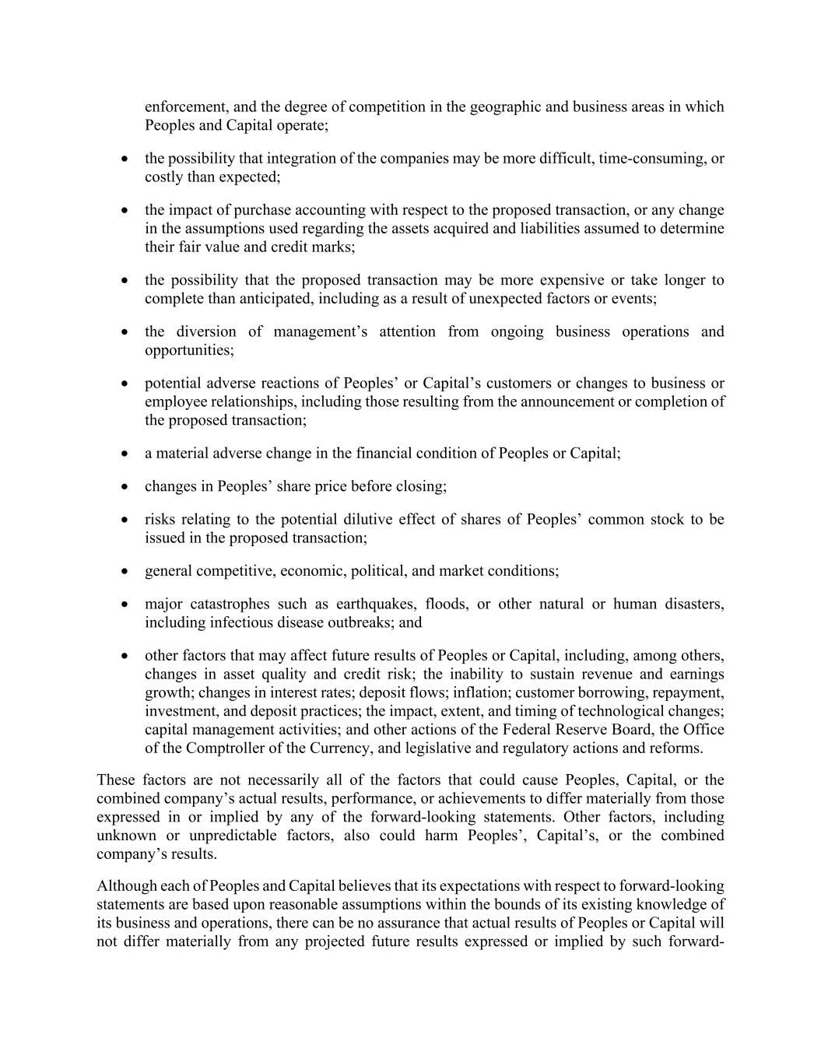
enforcement, and the degree of competition in the geographic and business areas in which Peoples and Capital operate; • the possibility that integration of the companies may be more difficult, time-consuming, or costly than expected; • the impact of purchase accounting with respect to the proposed transaction, or any change in the assumptions used regarding the assets acquired and liabilities assumed to determine their fair value and credit marks; • the possibility that the proposed transaction may be more expensive or take longer to complete than anticipated, including as a result of unexpected factors or events; • the diversion of management’s attention from ongoing business operations and opportunities; • potential adverse reactions of Peoples’ or Capital’s customers or changes to business or employee relationships, including those resulting from the announcement or completion of the proposed transaction; • a material adverse change in the financial condition of Peoples or Capital; • changes in Peoples’ share price before closing; • risks relating to the potential dilutive effect of shares of Peoples’ common stock to be issued in the proposed transaction; • general competitive, economic, political, and market conditions; • major catastrophes such as earthquakes, floods, or other natural or human disasters, including infectious disease outbreaks; and • other factors that may affect future results of Peoples or Capital, including, among others, changes in asset quality and credit risk; the inability to sustain revenue and earnings growth; changes in interest rates; deposit flows; inflation; customer borrowing, repayment, investment, and deposit practices; the impact, extent, and timing of technological changes; capital management activities; and other actions of the Federal Reserve Board, the Office of the Comptroller of the Currency, and legislative and regulatory actions and reforms. These factors are not necessarily all of the factors that could cause Peoples, Capital, or the combined company’s actual results, performance, or achievements to differ materially from those expressed in or implied by any of the forward-looking statements. Other factors, including unknown or unpredictable factors, also could harm Peoples’, Capital’s, or the combined company’s results. Although each of Peoples and Capital believes that its expectations with respect to forward-looking statements are based upon reasonable assumptions within the bounds of its existing knowledge of its business and operations, there can be no assurance that actual results of Peoples or Capital will not differ materially from any projected future results expressed or implied by such forward-

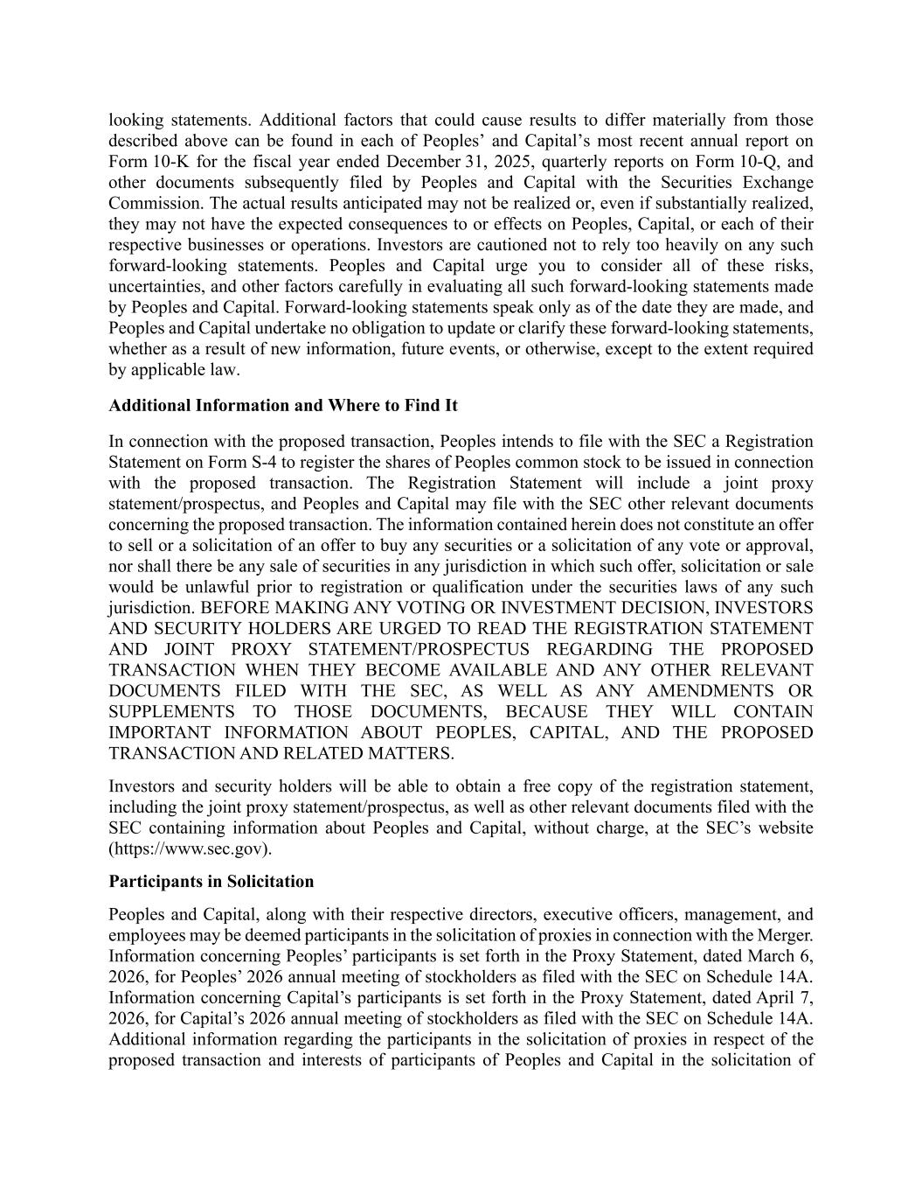
looking statements. Additional factors that could cause results to differ materially from those described above can be found in each of Peoples’ and Capital’s most recent annual report on Form 10-K for the fiscal year ended December 31, 2025, quarterly reports on Form 10-Q, and other documents subsequently filed by Peoples and Capital with the Securities Exchange Commission. The actual results anticipated may not be realized or, even if substantially realized, they may not have the expected consequences to or effects on Peoples, Capital, or each of their respective businesses or operations. Investors are cautioned not to rely too heavily on any such forward-looking statements. Peoples and Capital urge you to consider all of these risks, uncertainties, and other factors carefully in evaluating all such forward-looking statements made by Peoples and Capital. Forward-looking statements speak only as of the date they are made, and Peoples and Capital undertake no obligation to update or clarify these forward-looking statements, whether as a result of new information, future events, or otherwise, except to the extent required by applicable law. Additional Information and Where to Find It In connection with the proposed transaction, Peoples intends to file with the SEC a Registration Statement on Form S-4 to register the shares of Peoples common stock to be issued in connection with the proposed transaction. The Registration Statement will include a joint proxy statement/prospectus, and Peoples and Capital may file with the SEC other relevant documents concerning the proposed transaction. The information contained herein does not constitute an offer to sell or a solicitation of an offer to buy any securities or a solicitation of any vote or approval, nor shall there be any sale of securities in any jurisdiction in which such offer, solicitation or sale would be unlawful prior to registration or qualification under the securities laws of any such jurisdiction. BEFORE MAKING ANY VOTING OR INVESTMENT DECISION, INVESTORS AND SECURITY HOLDERS ARE URGED TO READ THE REGISTRATION STATEMENT AND JOINT PROXY STATEMENT/PROSPECTUS REGARDING THE PROPOSED TRANSACTION WHEN THEY BECOME AVAILABLE AND ANY OTHER RELEVANT DOCUMENTS FILED WITH THE SEC, AS WELL AS ANY AMENDMENTS OR SUPPLEMENTS TO THOSE DOCUMENTS, BECAUSE THEY WILL CONTAIN IMPORTANT INFORMATION ABOUT PEOPLES, CAPITAL, AND THE PROPOSED TRANSACTION AND RELATED MATTERS. Investors and security holders will be able to obtain a free copy of the registration statement, including the joint proxy statement/prospectus, as well as other relevant documents filed with the SEC containing information about Peoples and Capital, without charge, at the SEC’s website (https://www.sec.gov). Participants in Solicitation Peoples and Capital, along with their respective directors, executive officers, management, and employees may be deemed participants in the solicitation of proxies in connection with the Merger. Information concerning Peoples’ participants is set forth in the Proxy Statement, dated March 6, 2026, for Peoples’ 2026 annual meeting of stockholders as filed with the SEC on Schedule 14A. Information concerning Capital’s participants is set forth in the Proxy Statement, dated April 7, 2026, for Capital’s 2026 annual meeting of stockholders as filed with the SEC on Schedule 14A. Additional information regarding the participants in the solicitation of proxies in respect of the proposed transaction and interests of participants of Peoples and Capital in the solicitation of


proxies in respect of the Merger will be included in the registration statement and joint proxy statement/prospectus to be filed with the SEC. Free copies of these documents, when available, may be obtained as described in the preceding paragraph.

